UNITED STATES
SECURITIES AND EXCHANGE COMMISSION
WASHINGTON, D.C. 20549

FORM 8-K

CURRENT REPORT
Pursuant to Section 13 or 15(d) of the Securities Exchange Act of 1934
Date of Report (Date of earliest event reported): August 13, 2026

EIKON THERAPEUTICS, INC.
(Exact name of Registrant as Specified in Its Charter)

Delaware |  |  | 001-43085 | 84-2807586
(State or Other Jurisdiction  of Incorporation) |  |  | (Commission File Number) | (IRS Employer  Identification No.)
230 Harriet Tubman Way
Millbrae, California |  |  |  | 94030
(Address of Principal Executive Offices) |  |  |  | (Zip Code)

Registrant’s Telephone Number, Including Area Code: (341) 777-0566

Not Applicable
(Former Name or Former Address, if Changed Since Last Report)

Check the appropriate box below if the Form 8-K filing is intended to simultaneously satisfy the filing obligation of the registrant under any of the following provisions:
☐Written communications pursuant to Rule 425 under the Securities Act (17 CFR 230.425)
☐Soliciting material pursuant to Rule 14a-12 under the Exchange Act (17 CFR 240.14a-12)
☐Pre-commencement communications pursuant to Rule 14d-2(b) under the Exchange Act (17 CFR 240.14d-2(b))
☐Pre-commencement communications pursuant to Rule 13e-4(c) under the Exchange Act (17 CFR 240.13e-4(c))
Securities registered pursuant to Section 12(b) of the Act:
Title of each class |  | Trading  Symbol(s) |  | Name of each exchange on which registered
Common Stock, $0.0001 par value per share |  | EIKN |  | The Nasdaq Stock Market LLC
Indicate by check mark whether the registrant is an emerging growth company as defined in Rule 405 of the Securities Act of 1933 (§ 230.405 of this chapter) or Rule 12b-2 of the Securities Exchange Act of 1934 (§ 240.12b-2 of this chapter).
Emerging growth company ☒
If an emerging growth company, indicate by check mark if the registrant has elected not to use the extended transition period for complying with any new or revised financial accounting standards provided pursuant to Section 13(a) of the Exchange Act. ☐

Item 7.01 Regulation FD Disclosure.

On August 13, 2026, Eikon Therapeutics, Inc. updated its corporate presentation. A copy of the updated presentation is furnished as Exhibit 99.1 to this Current Report on Form 8-K and is incorporated herein by reference.
The information in Item 7.01, including Exhibit 99.1, is being “furnished” and shall not be deemed to be “filed” for purposes of Section 18 of the Securities Exchange Act of 1934, as amended (the “Exchange Act”), or otherwise subject to the liabilities of that section or Section 11 and 12(a)(2) of the Securities Act of 1933, as amended (the “Securities Act”). The information in Item 7.01, including Exhibit 99.1, shall not be incorporated by reference into any registration statement or other document pursuant to the Securities Act or into any filing or other document pursuant to the Exchange Act, except as otherwise expressly stated in any such filing.

Item 9.01 Financial Statements and Exhibits.
(d) Exhibits

Exhibit  Number |  | Description
99.1 |  | Eikon Therapeutics, Inc. Corporate Presentation.
104 |  | Cover Page Interactive Data File (embedded within the Inline XBRL document).

SIGNATURES
Pursuant to the requirements of the Securities Exchange Act of 1934, the registrant has duly caused this report to be signed on its behalf by the undersigned hereunto duly authorized.
 |  |  | EIKON THERAPEUTICS, INC.
Date: | August 13, 2026 | By: | /s/ Alfred Bowie, Ph.D.
Alfred Bowie, Ph.D.
Chief Financial Officer

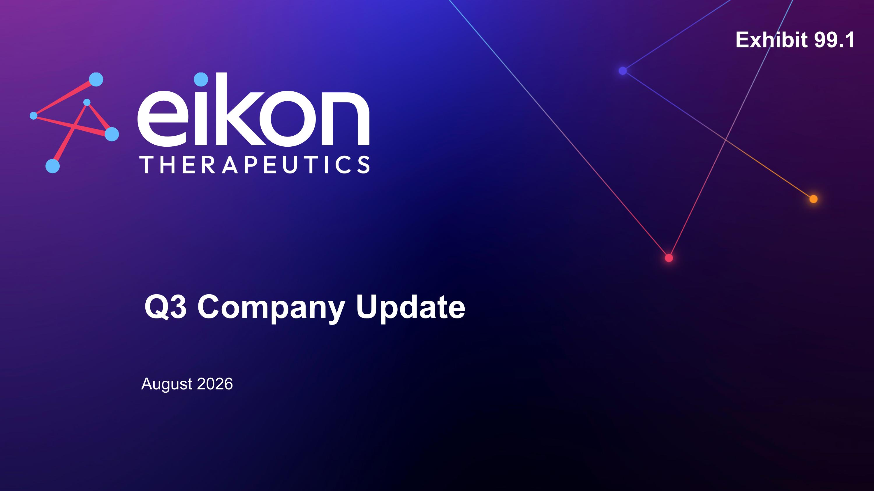
Q3 Company Update August 2026 Exhibit 99.1

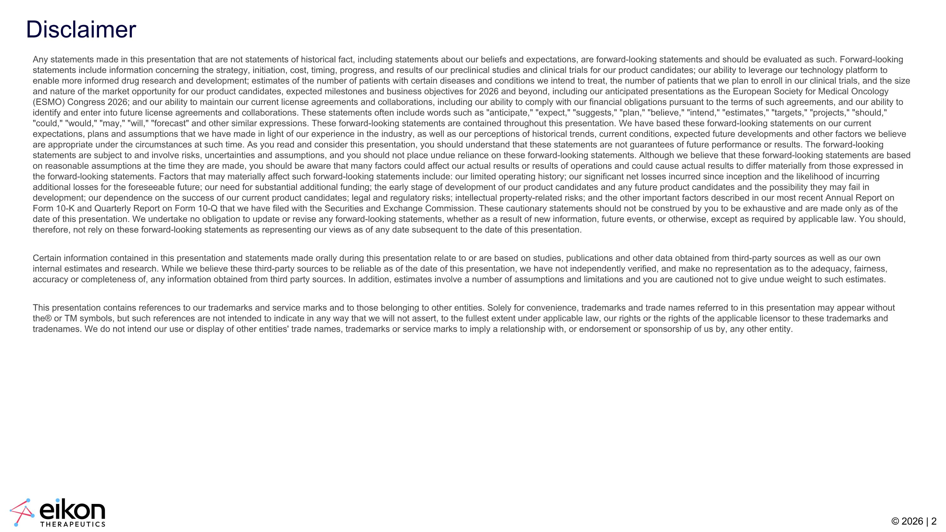
Disclaimer Any statements made in this presentation that are not statements of historical fact, including statements about our beliefs and expectations, are forward-looking statements and should be evaluated as such. Forward-looking statements include information concerning the strategy, initiation, cost, timing, progress, and results of our preclinical studies and clinical trials for our product candidates; our ability to leverage our technology platform to enable more informed drug research and development; estimates of the number of patients with certain diseases and conditions we intend to treat, the number of patients that we plan to enroll in our clinical trials, and the size and nature of the market opportunity for our product candidates, expected milestones and business objectives for 2026 and beyond, including our anticipated presentations as the European Society for Medical Oncology (ESMO) Congress 2026; and our ability to maintain our current license agreements and collaborations, including our ability to comply with our financial obligations pursuant to the terms of such agreements, and our ability to identify and enter into future license agreements and collaborations. These statements often include words such as "anticipate," "expect," "suggests," "plan," "believe," "intend," "estimates," "targets," "projects," "should," "could," "would," "may," "will," "forecast" and other similar expressions. These forward-looking statements are contained throughout this presentation. We have based these forward-looking statements on our current expectations, plans and assumptions that we have made in light of our experience in the industry, as well as our perceptions of historical trends, current conditions, expected future developments and other factors we believe are appropriate under the circumstances at such time. As you read and consider this presentation, you should understand that these statements are not guarantees of future performance or results. The forward-looking statements are subject to and involve risks, uncertainties and assumptions, and you should not place undue reliance on these forward-looking statements. Although we believe that these forward-looking statements are based on reasonable assumptions at the time they are made, you should be aware that many factors could affect our actual results or results of operations and could cause actual results to differ materially from those expressed in the forward-looking statements. Factors that may materially affect such forward-looking statements include: our limited operating history; our significant net losses incurred since inception and the likelihood of incurring additional losses for the foreseeable future; our need for substantial additional funding; the early stage of development of our product candidates and any future product candidates and the possibility they may fail in development; our dependence on the success of our current product candidates; legal and regulatory risks; intellectual property-related risks; and the other important factors described in our most recent Annual Report on Form 10-K and Quarterly Report on Form 10-Q that we have filed with the Securities and Exchange Commission. These cautionary statements should not be construed by you to be exhaustive and are made only as of the date of this presentation. We undertake no obligation to update or revise any forward-looking statements, whether as a result of new information, future events, or otherwise, except as required by applicable law. You should, therefore, not rely on these forward-looking statements as representing our views as of any date subsequent to the date of this presentation. Certain information contained in this presentation and statements made orally during this presentation relate to or are based on studies, publications and other data obtained from third-party sources as well as our own internal estimates and research. While we believe these third-party sources to be reliable as of the date of this presentation, we have not independently verified, and make no representation as to the adequacy, fairness, accuracy or completeness of, any information obtained from third party sources. In addition, estimates involve a number of assumptions and limitations and you are cautioned not to give undue weight to such estimates. This presentation contains references to our trademarks and service marks and to those belonging to other entities. Solely for convenience, trademarks and trade names referred to in this presentation may appear without the® or TM symbols, but such references are not intended to indicate in any way that we will not assert, to the fullest extent under applicable law, our rights or the rights of the applicable licensor to these trademarks and tradenames. We do not intend our use or display of other entities' trade names, trademarks or service marks to imply a relationship with, or endorsement or sponsorship of us by, any other entity.

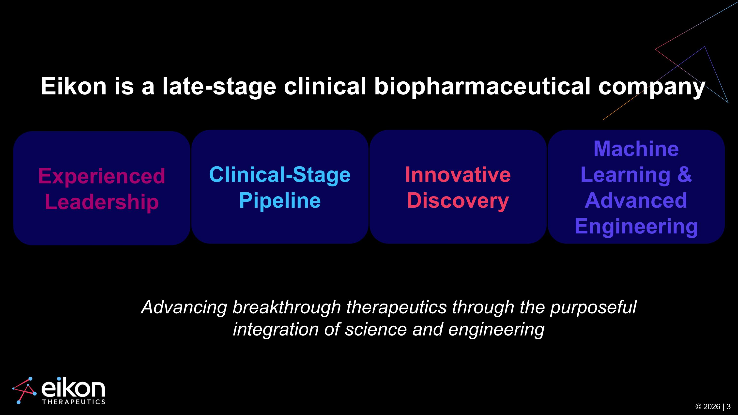
Advancing breakthrough therapeutics through the purposeful integration of science and engineering © 2026 | 3 Innovative Discovery Machine Learning & Advanced Engineering Experienced Leadership Clinical-Stage Pipeline Eikon is a late-stage clinical biopharmaceutical company

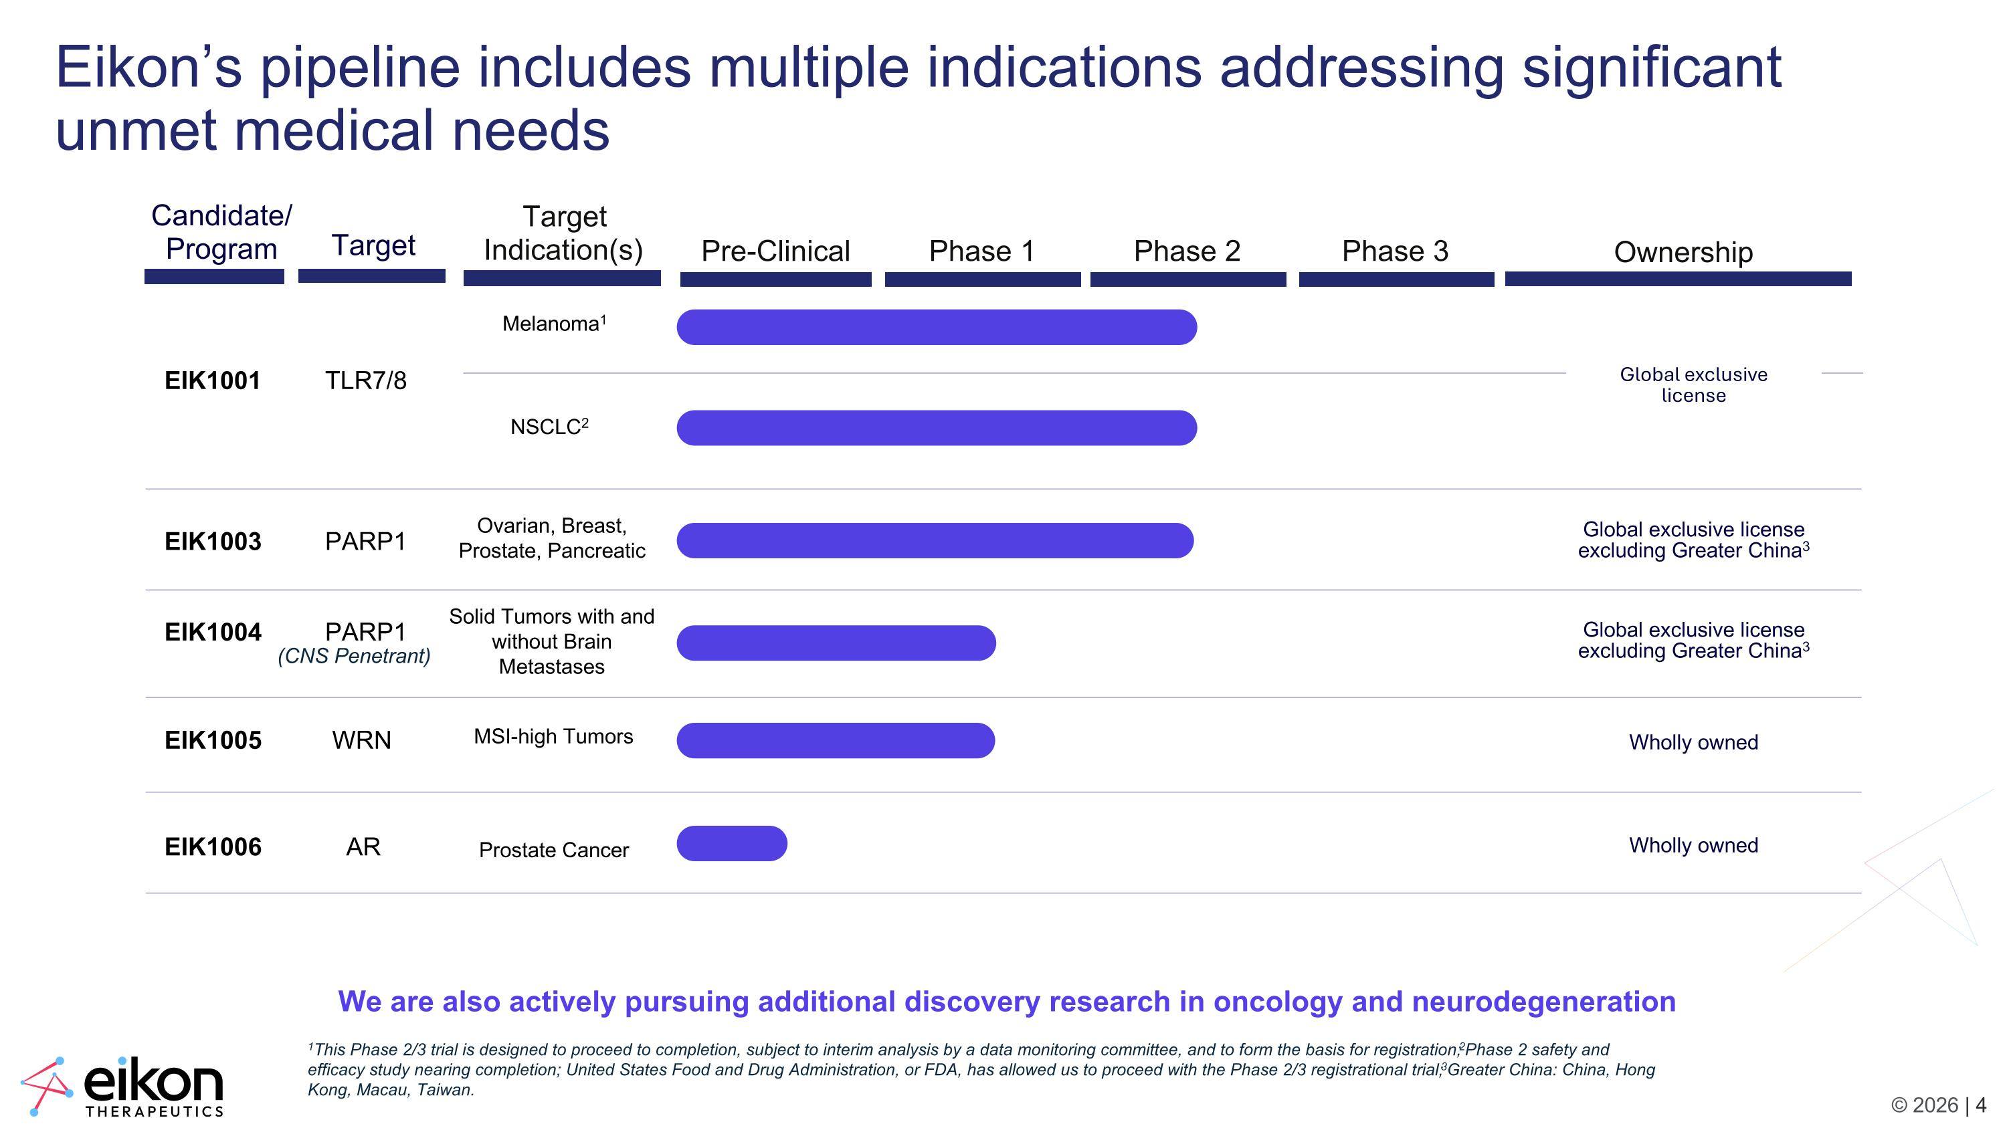
1This Phase 2/3 trial is designed to proceed to completion, subject to interim analysis by a data monitoring committee, and to form the basis for registration; 2Phase 2 safety and efficacy study nearing completion; United States Food and Drug Administration, or FDA, has allowed us to proceed with the Phase 2/3 registrational trial; 3Greater China: China, Hong Kong, Macau, Taiwan. Eikon’s pipeline includes multiple indications addressing significant unmet medical needs We are also actively pursuing additional discovery research in oncology and neurodegeneration Melanoma1 NSCLC2 EIK1005 WRN EIK1003 PARP1 EIK1001 TLR7/8 Candidate/ Program Pre-Clinical Phase 1 Phase 2 Phase 3 Target Indication(s) Ownership EIK1004 PARP1 (CNS Penetrant) Wholly owned Ovarian, Breast, Prostate, Pancreatic Solid Tumors with and without Brain Metastases MSI-high Tumors Global exclusive license excluding Greater China3 Global exclusive license excluding Greater China3 Target EIK1006 AR Wholly owned Prostate Cancer Global exclusive license

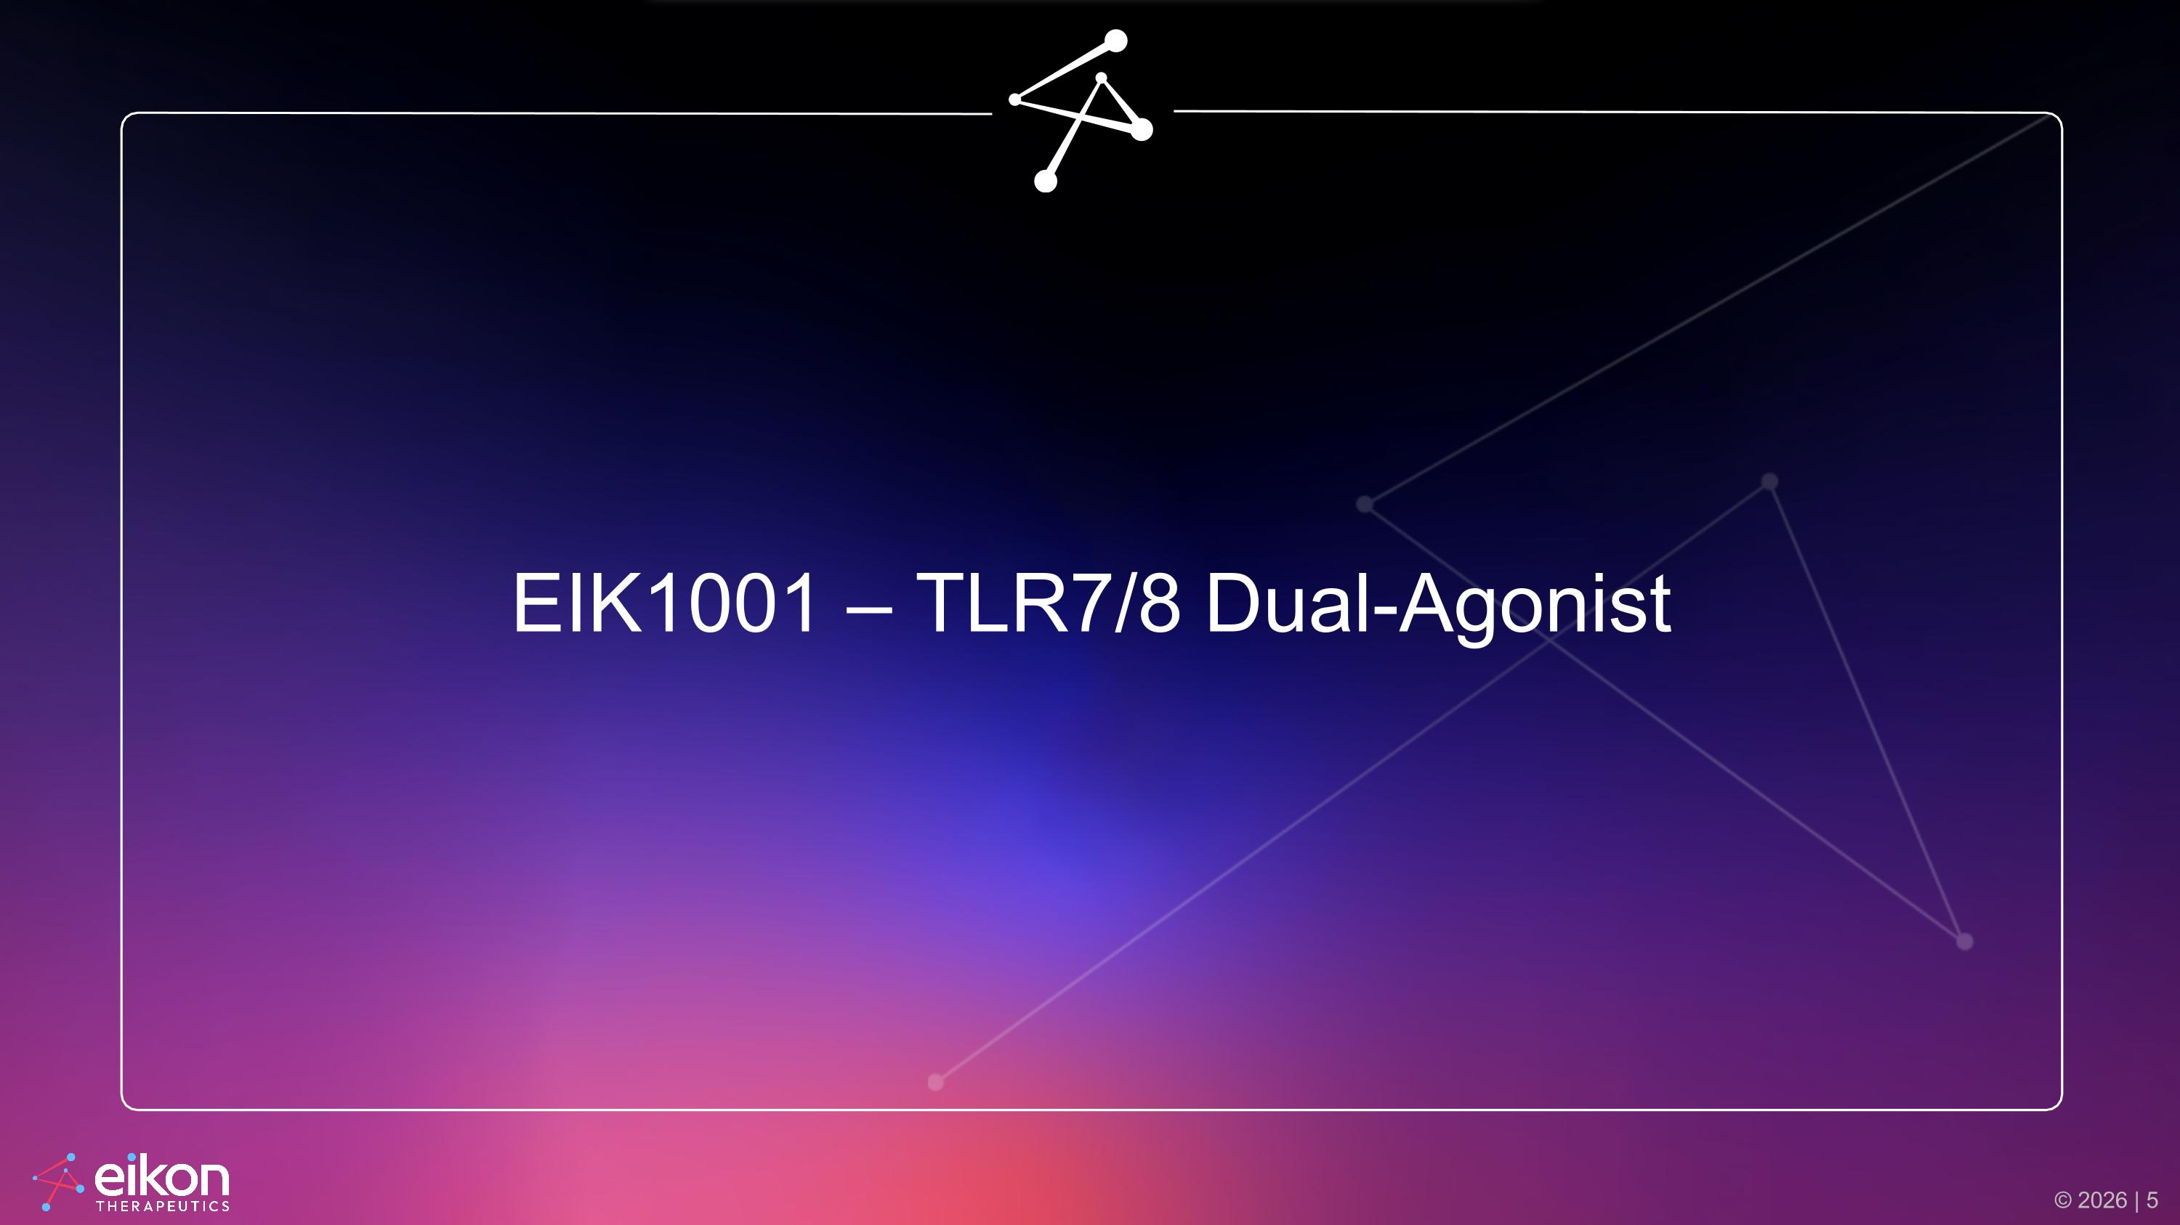
EIK1001 – TLR7/8 Dual-Agonist

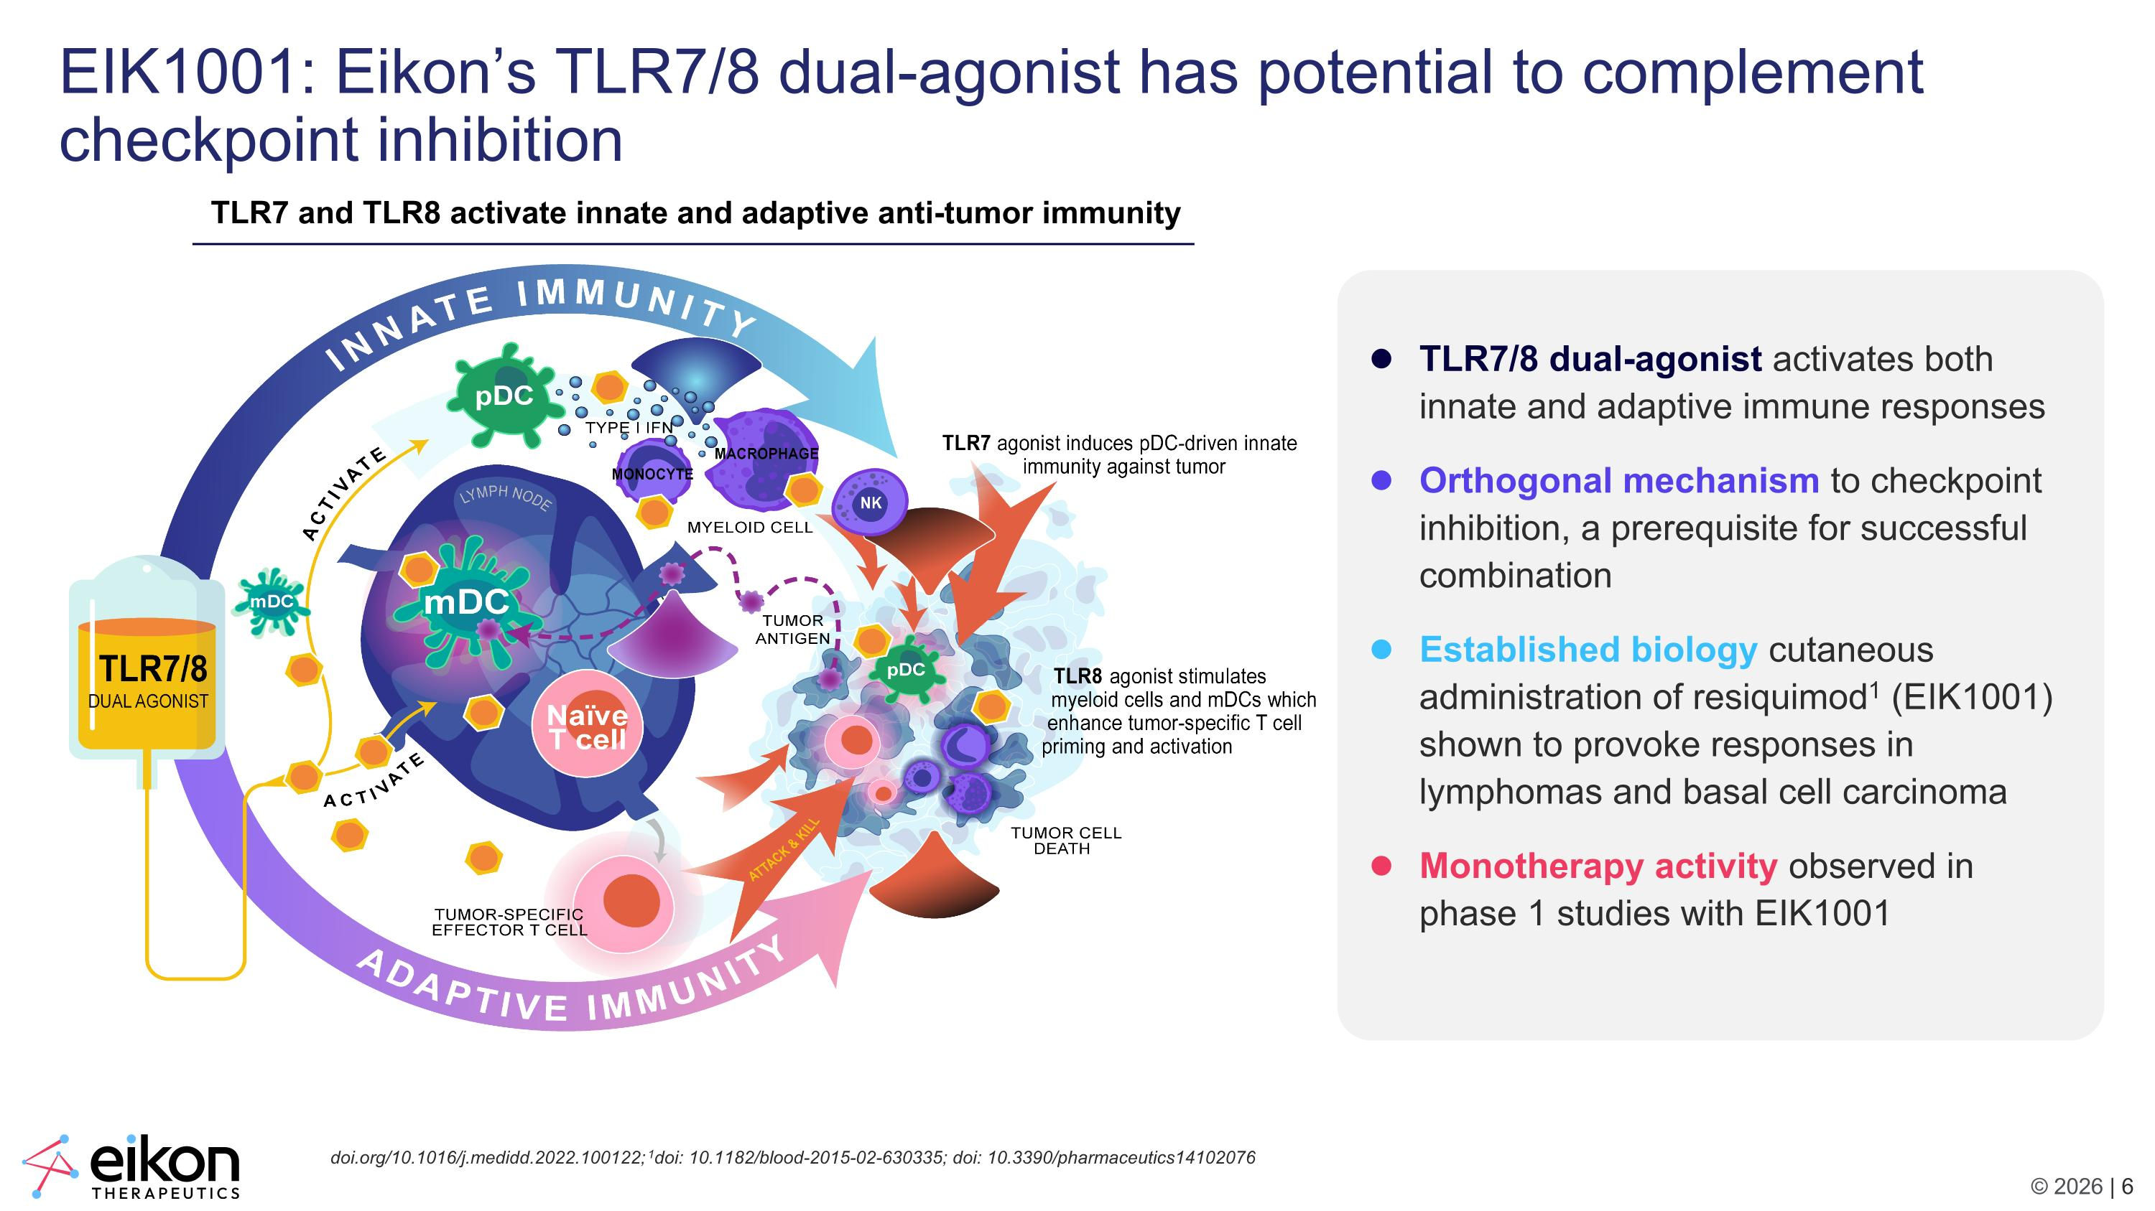
EIK1001: Eikon’s TLR7/8 dual-agonist has potential to complement checkpoint inhibition TLR7 and TLR8 activate innate and adaptive anti-tumor immunity TLR7/8 dual-agonist activates both innate and adaptive immune responses Orthogonal mechanism to checkpoint inhibition, a prerequisite for successful combination Established biology cutaneous administration of resiquimod1 (EIK1001) shown to provoke responses in lymphomas and basal cell carcinoma Monotherapy activity observed in phase 1 studies with EIK1001 doi.org/10.1016/j.medidd.2022.100122; 1doi: 10.1182/blood-2015-02-630335; doi: 10.3390/pharmaceutics14102076

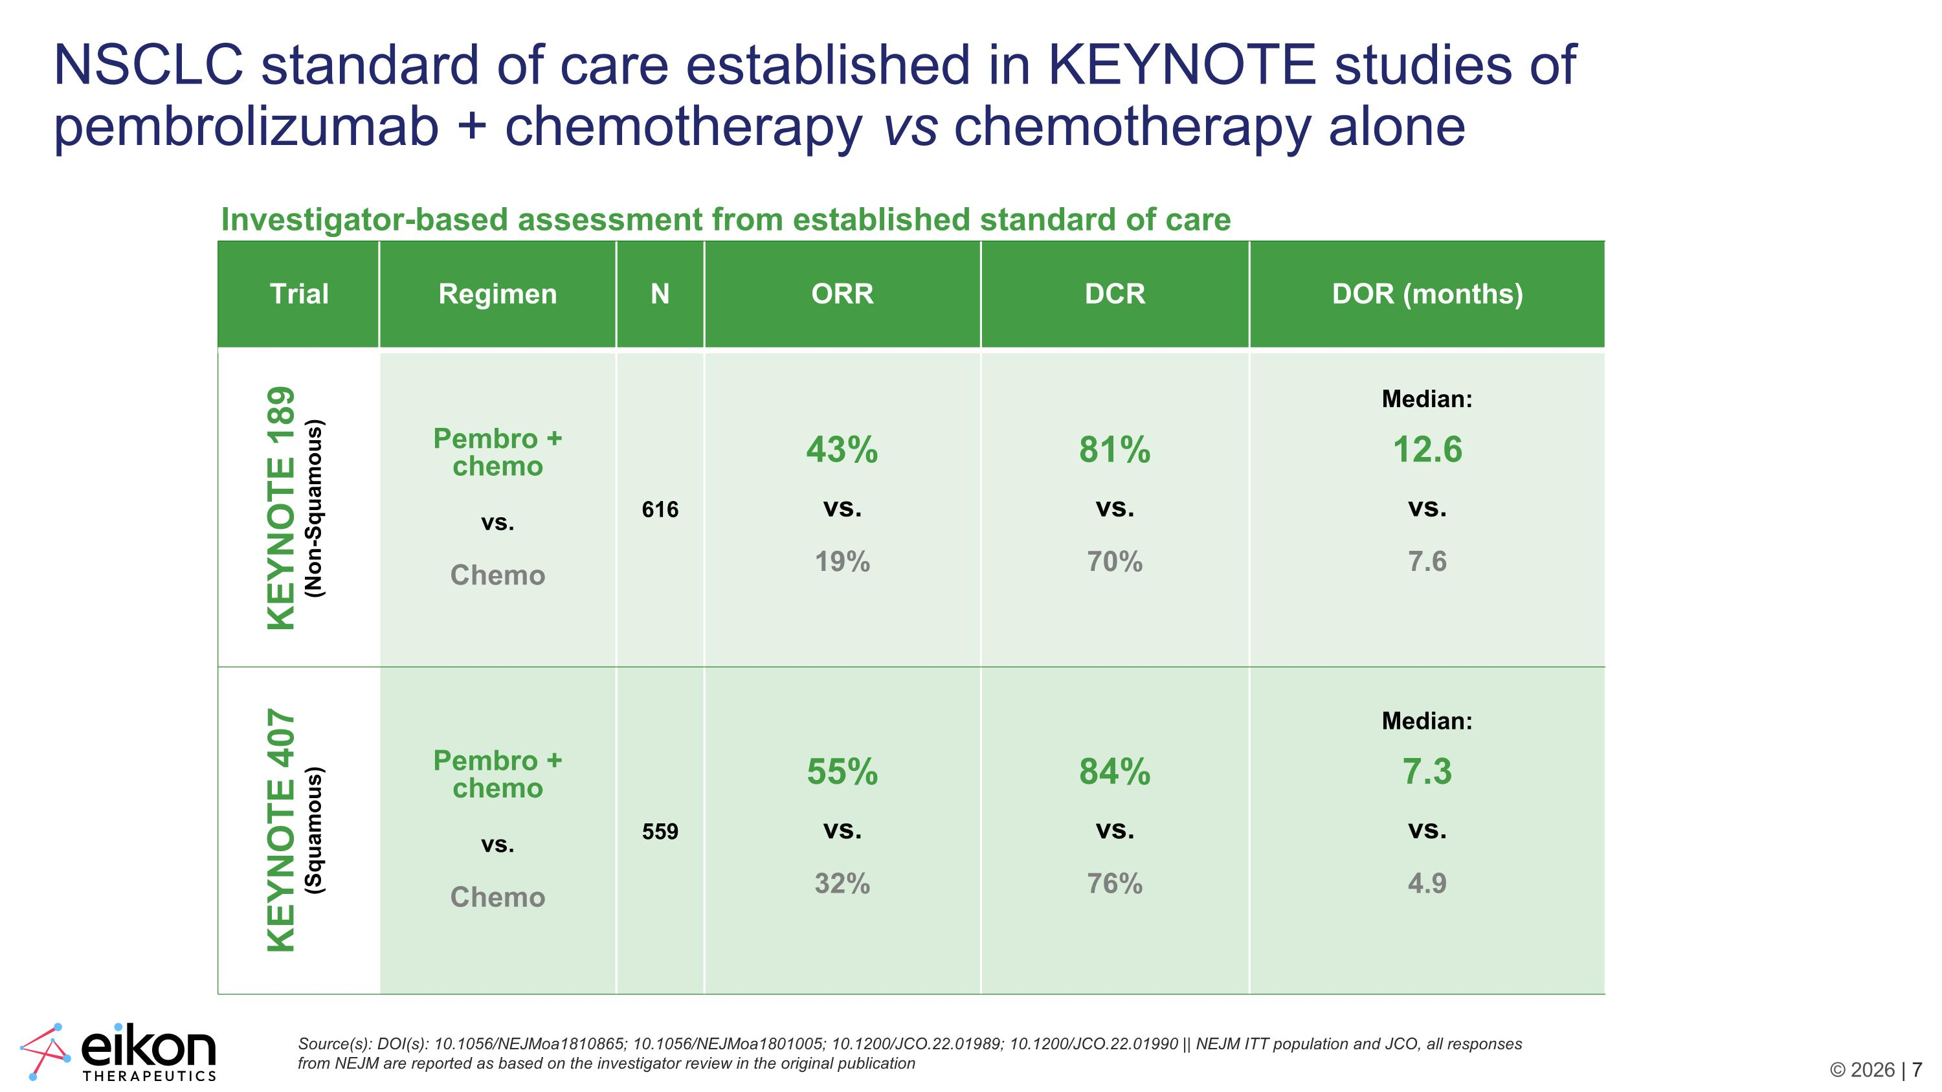
NSCLC standard of care established in KEYNOTE studies of pembrolizumab + chemotherapy vs chemotherapy alone Source(s): DOI(s): 10.1056/NEJMoa1810865; 10.1056/NEJMoa1801005; 10.1200/JCO.22.01989; 10.1200/JCO.22.01990 || NEJM ITT population and JCO, all responses from NEJM are reported as based on the investigator review in the original publication Trial​ Regimen​ N​ ORR​ DCR DOR (months) KEYNOTE 189 (Non-Squamous) Pembro + chemo vs. Chemo 616 43% vs. 19% 81% vs. 70% Median: 12.6 vs. 7.6 KEYNOTE 407 (Squamous) Pembro + chemo vs. Chemo 559 55% vs. 32% 84% vs. 76% Median: 7.3 vs. 4.9 Investigator-based assessment from established standard of care

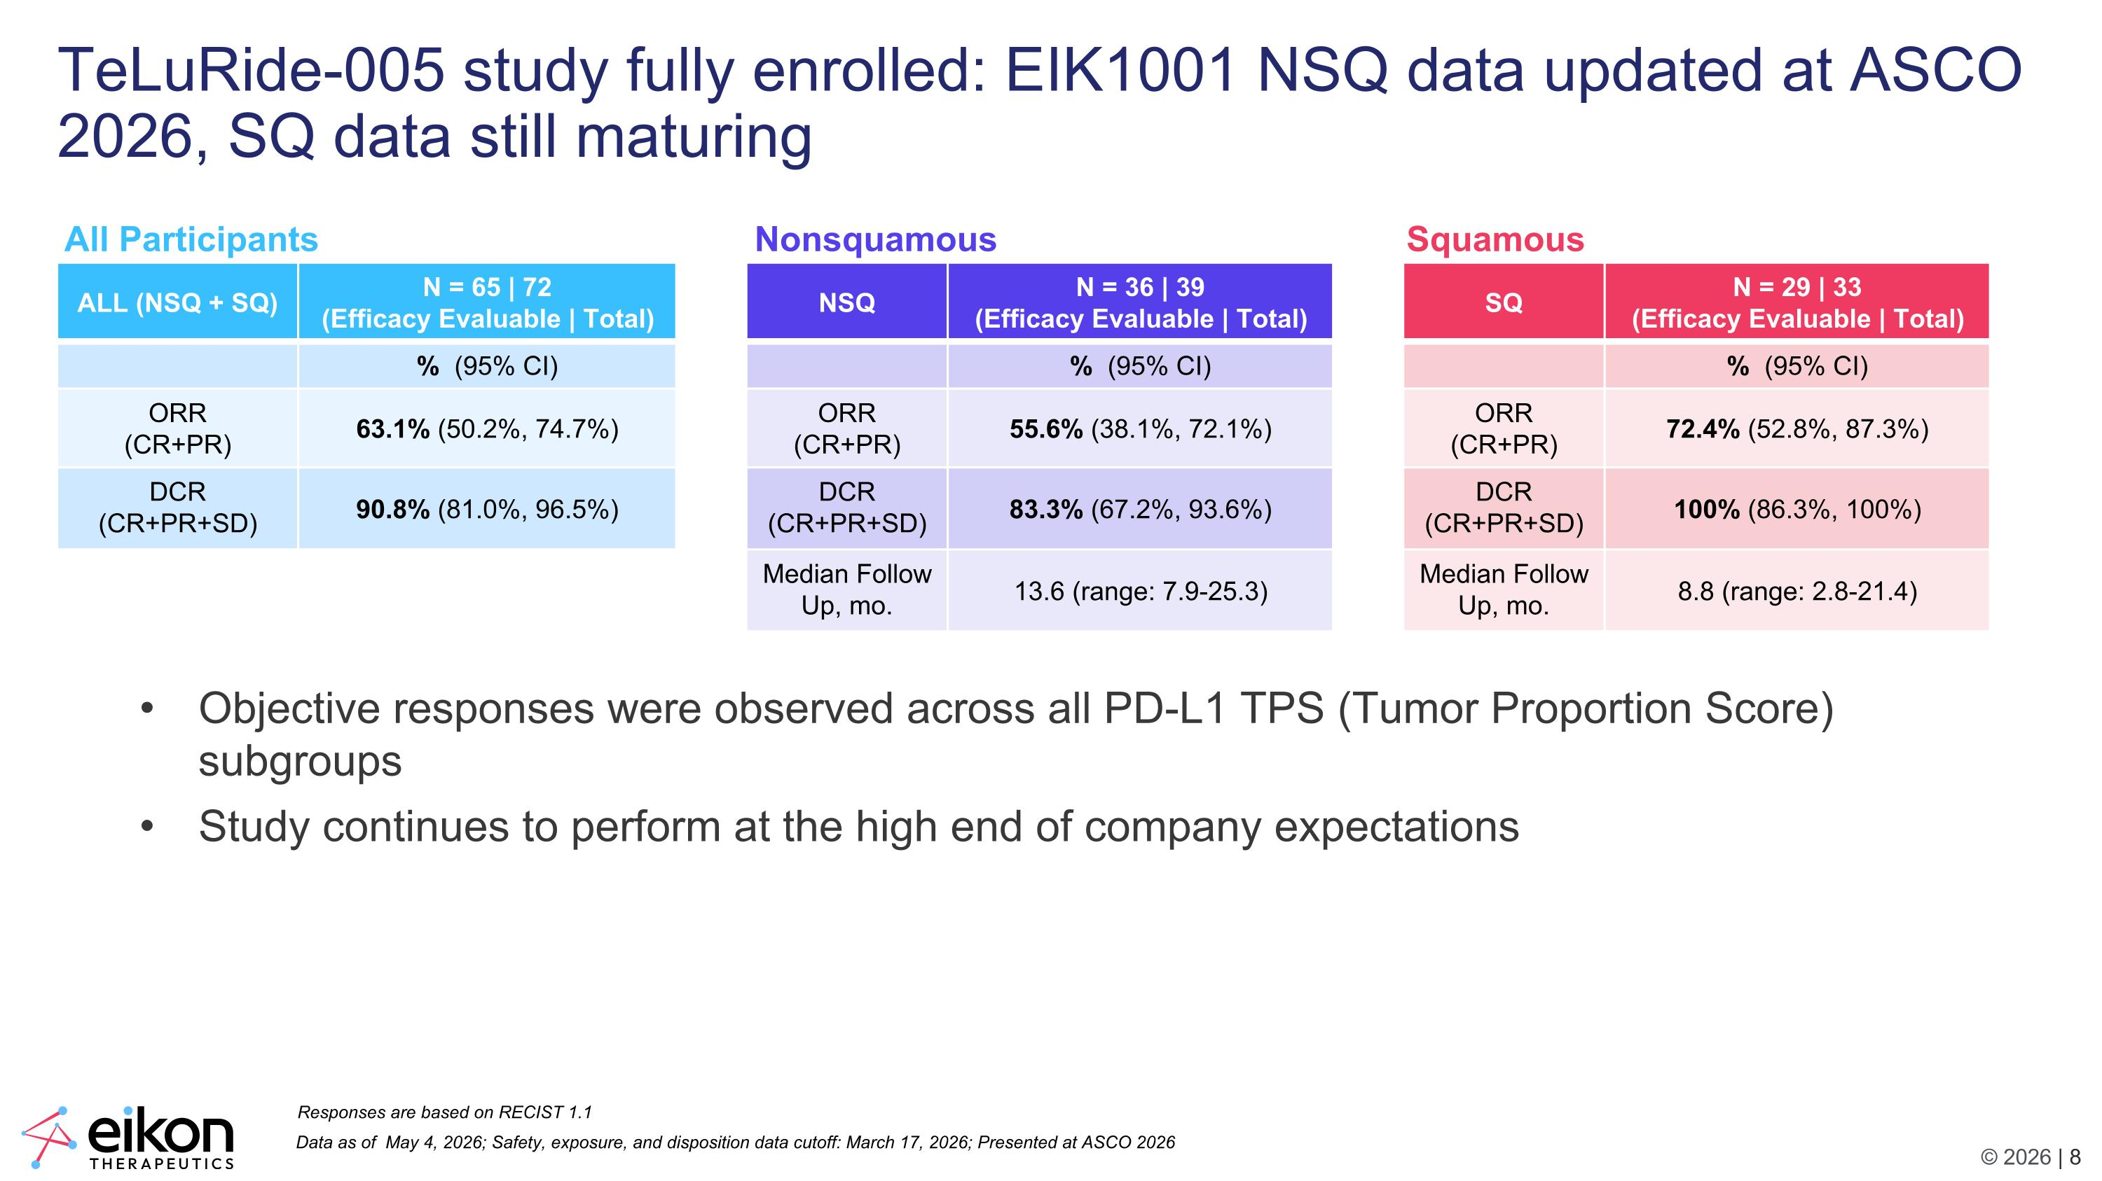
Data as of May 4, 2026; Safety, exposure, and disposition data cutoff: March 17, 2026; Presented at ASCO 2026 ALL (NSQ + SQ) N = 65 | 72 (Efficacy Evaluable | Total) % (95% CI) ORR (CR+PR) 63.1% (50.2%, 74.7%) DCR (CR+PR+SD) 90.8% (81.0%, 96.5%) Responses are based on RECIST 1.1 TeLuRide-005 study fully enrolled: EIK1001 NSQ data updated at ASCO 2026, SQ data still maturing NSQ N = 36 | 39 (Efficacy Evaluable | Total) % (95% CI) ORR (CR+PR) 55.6% (38.1%, 72.1%) DCR (CR+PR+SD) 83.3% (67.2%, 93.6%) Median Follow Up, mo. 13.6 (range: 7.9-25.3) SQ N = 29 | 33 (Efficacy Evaluable | Total) % (95% CI) ORR (CR+PR) 72.4% (52.8%, 87.3%) DCR (CR+PR+SD) 100% (86.3%, 100%) Median Follow Up, mo. 8.8 (range: 2.8-21.4) Objective responses were observed across all PD-L1 TPS (Tumor Proportion Score) subgroups Study continues to perform at the high end of company expectations All Participants Nonsquamous Squamous

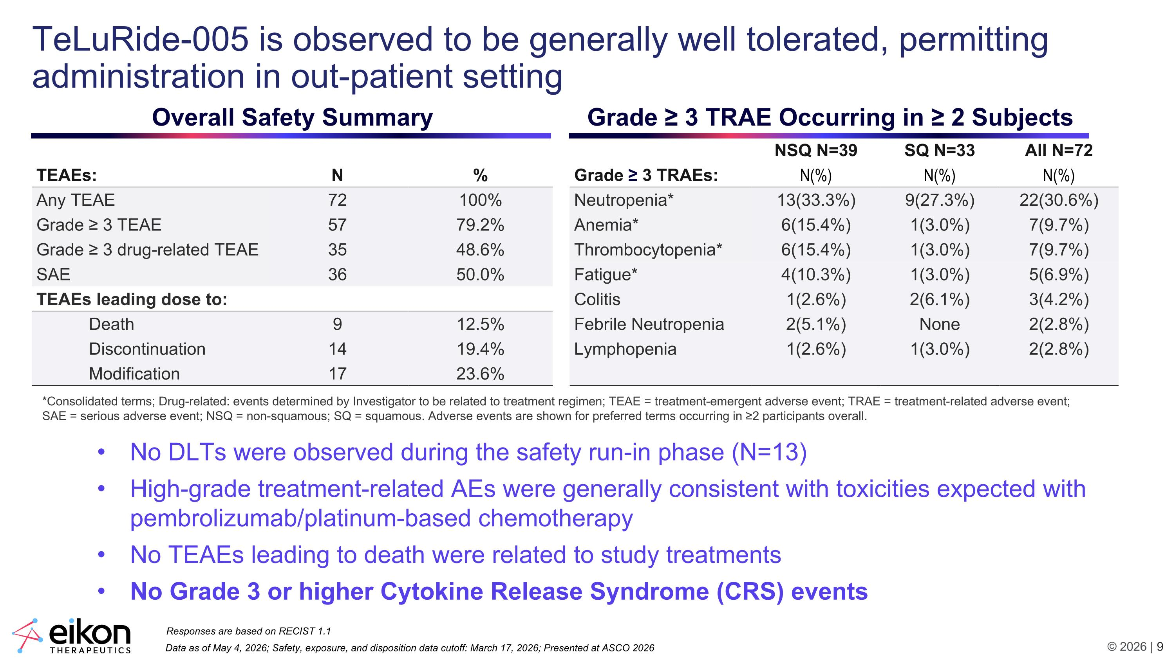
Data as of May 4, 2026; Safety, exposure, and disposition data cutoff: March 17, 2026; Presented at ASCO 2026 Responses are based on RECIST 1.1 TeLuRide-005 is observed to be generally well tolerated, permitting administration in out-patient setting *Consolidated terms; Drug-related: events determined by Investigator to be related to treatment regimen; TEAE = treatment-emergent adverse event; TRAE = treatment-related adverse event; SAE = serious adverse event; NSQ = non-squamous; SQ = squamous. Adverse events are shown for preferred terms occurring in ≥2 participants overall. No DLTs were observed during the safety run-in phase (N=13) High-grade treatment-related AEs were generally consistent with toxicities expected with pembrolizumab/platinum-based chemotherapy No TEAEs leading to death were related to study treatments No Grade 3 or higher Cytokine Release Syndrome (CRS) events NSQ N=39 SQ N=33 All N=72 Grade ≥ 3 TRAEs: N(%) N(%) N(%) Neutropenia* 13(33.3%) 9(27.3%) 22(30.6%) Anemia* 6(15.4%) 1(3.0%) 7(9.7%) Thrombocytopenia* 6(15.4%) 1(3.0%) 7(9.7%) Fatigue* 4(10.3%) 1(3.0%) 5(6.9%) Colitis 1(2.6%) 2(6.1%) 3(4.2%) Febrile Neutropenia 2(5.1%) None 2(2.8%) Lymphopenia 1(2.6%) 1(3.0%) 2(2.8%) Grade ≥ 3 TRAE Occurring in ≥ 2 Subjects TEAEs: N % Any TEAE 72 100% Grade ≥ 3 TEAE 57 79.2% Grade ≥ 3 drug-related TEAE 35 48.6% SAE 36 50.0% TEAEs leading dose to: Death 9 12.5% Discontinuation 14 19.4% Modification 17 23.6% Overall Safety Summary

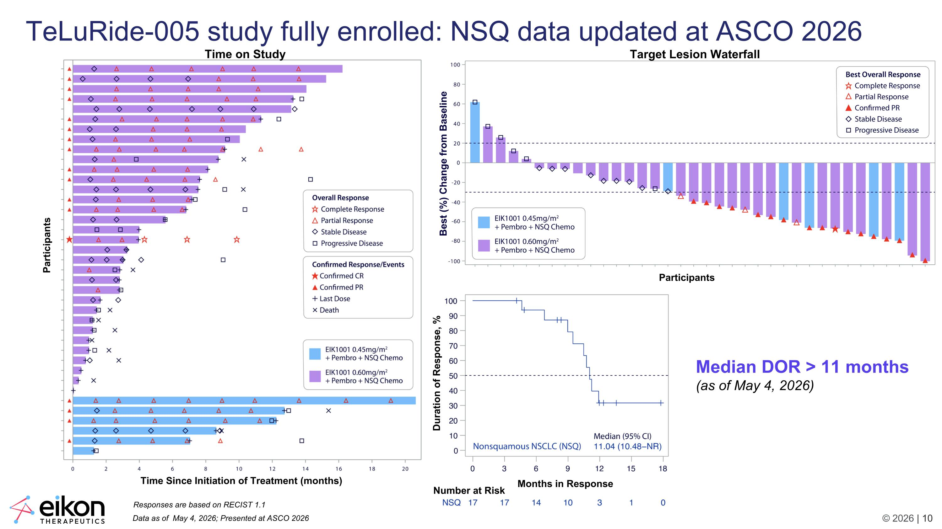
Data as of May 4, 2026; Presented at ASCO 2026 Responses are based on RECIST 1.1 TeLuRide-005 study fully enrolled: NSQ data updated at ASCO 2026 Time on Study Participants Time Since Initiation of Treatment (months) Target Lesion Waterfall Participants Best (%) Change from Baseline Months in Response Duration of Response, % Number at Risk Median DOR > 11 months (as of May 4, 2026)

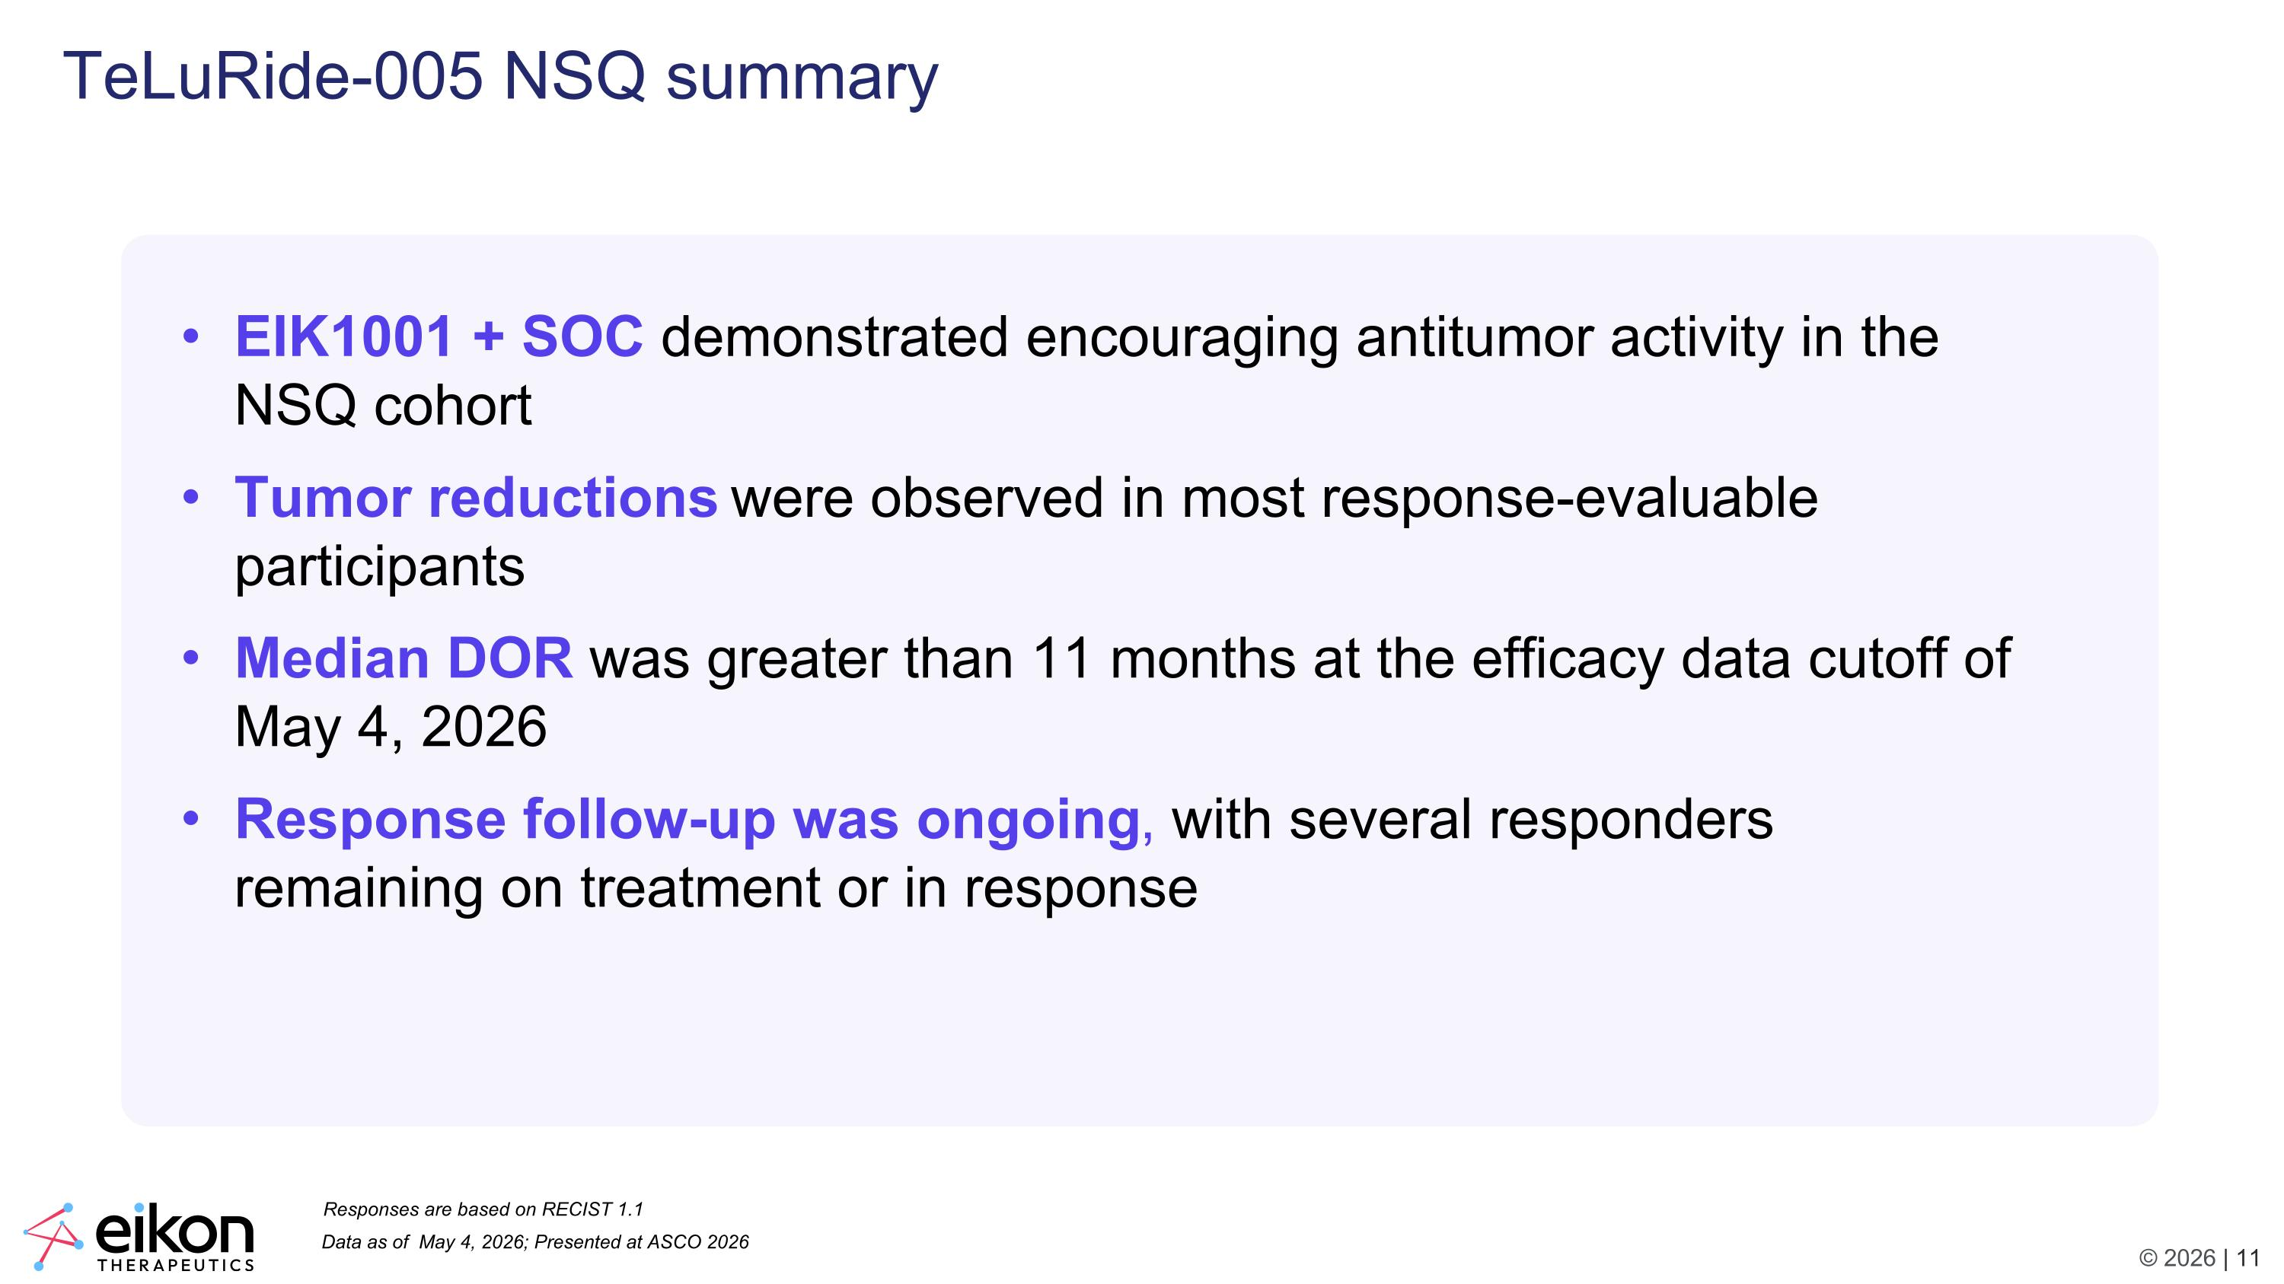
Data as of May 4, 2026; Presented at ASCO 2026 Responses are based on RECIST 1.1 TeLuRide-005 NSQ summary EIK1001 + SOC demonstrated encouraging antitumor activity in the NSQ cohort Tumor reductions were observed in most response-evaluable participants Median DOR was greater than 11 months at the efficacy data cutoff of May 4, 2026 Response follow-up was ongoing, with several responders remaining on treatment or in response

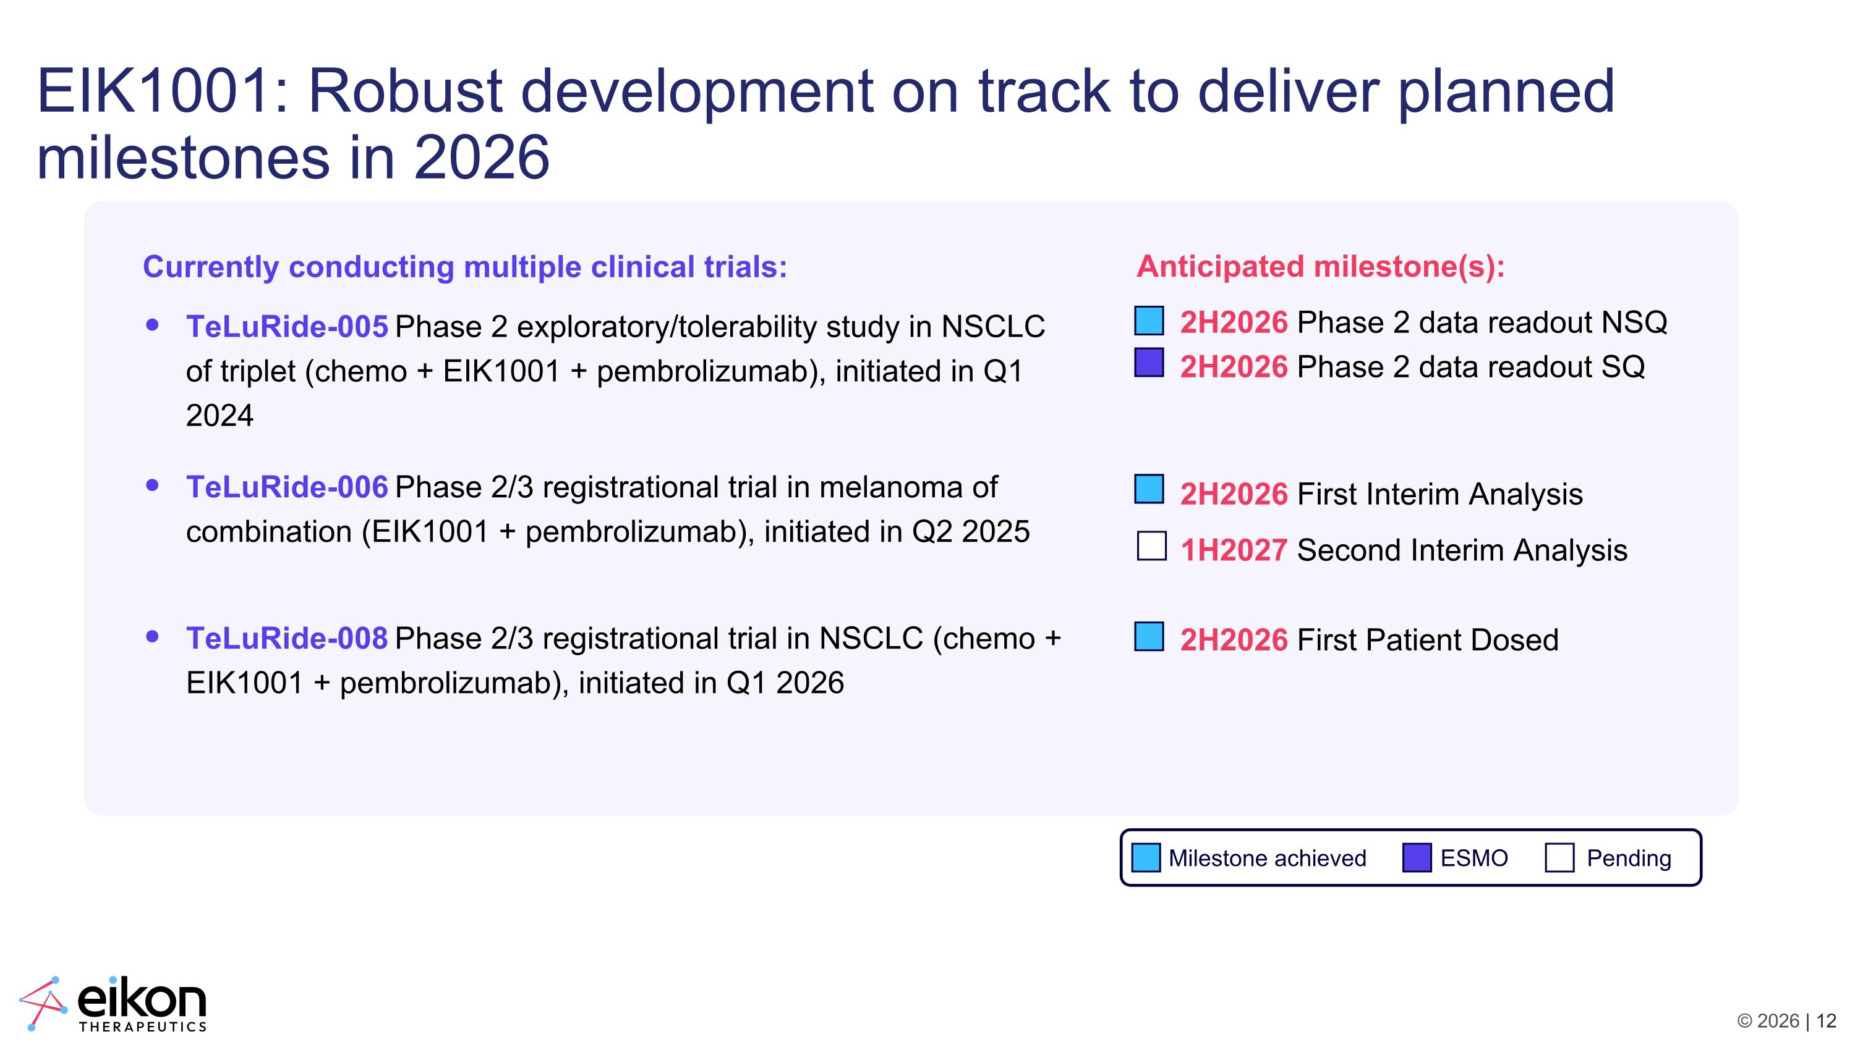
EIK1001: Robust development on track to deliver planned milestones in 2026 Currently conducting multiple clinical trials: TeLuRide-005 Phase 2 exploratory/tolerability study in NSCLC of triplet (chemo + EIK1001 + pembrolizumab), initiated in Q1 2024 TeLuRide-006 Phase 2/3 registrational trial in melanoma of combination (EIK1001 + pembrolizumab), initiated in Q2 2025 TeLuRide-008 Phase 2/3 registrational trial in NSCLC (chemo + EIK1001 + pembrolizumab), initiated in Q1 2026 Anticipated milestone(s): 2H2026 Phase 2 data readout NSQ 2H2026 Phase 2 data readout SQ 2H2026 First Interim Analysis 1H2027 Second Interim Analysis 2H2026 First Patient Dosed Milestone achieved ESMO Pending

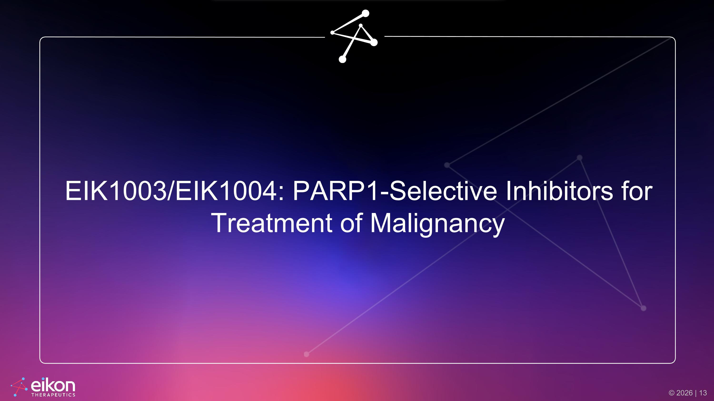
EIK1003/EIK1004: PARP1-Selective Inhibitors for Treatment of Malignancy

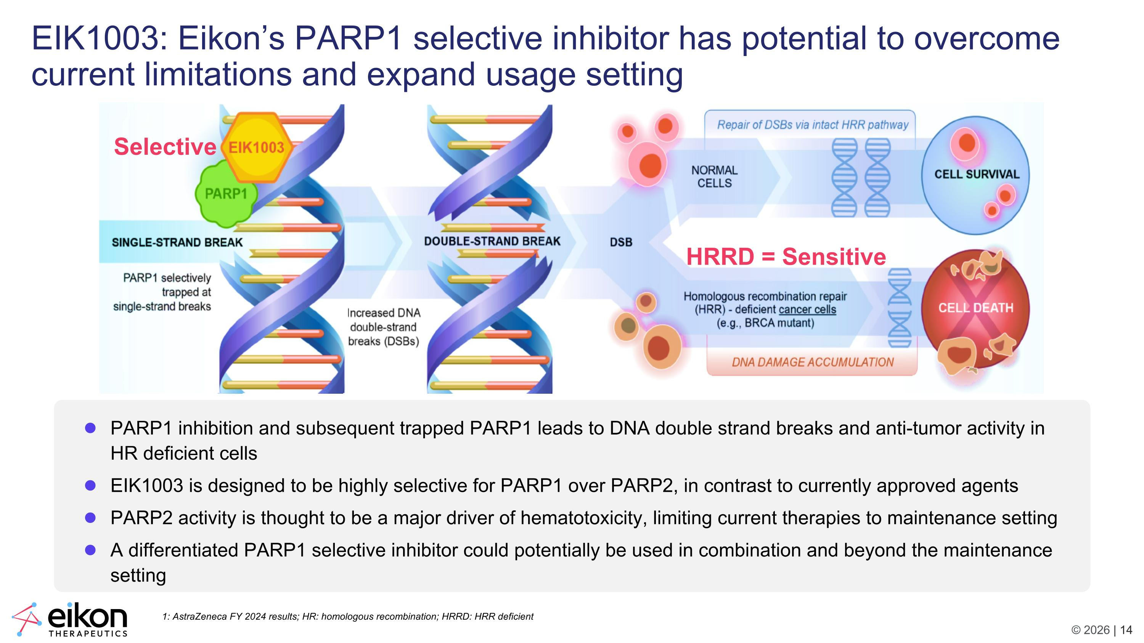
HRRD = Sensitive Selective EIK1003: Eikon’s PARP1 selective inhibitor has potential to overcome current limitations and expand usage setting PARP1 inhibition and subsequent trapped PARP1 leads to DNA double strand breaks and anti-tumor activity in HR deficient cells EIK1003 is designed to be highly selective for PARP1 over PARP2, in contrast to currently approved agents PARP2 activity is thought to be a major driver of hematotoxicity, limiting current therapies to maintenance setting A differentiated PARP1 selective inhibitor could potentially be used in combination and beyond the maintenance setting 1: AstraZeneca FY 2024 results; HR: homologous recombination; HRRD: HRR deficient

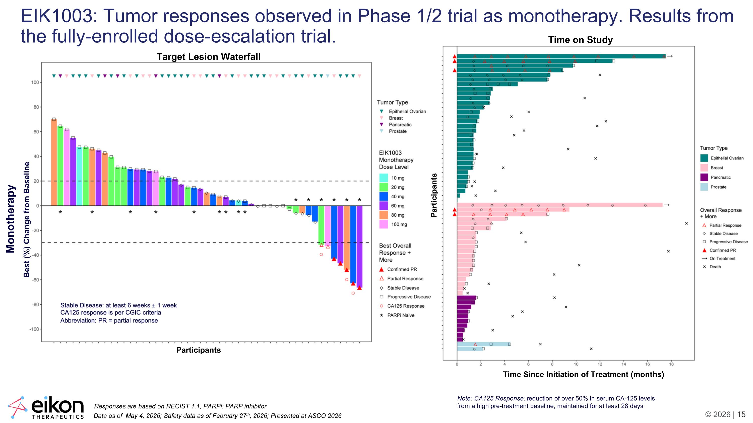
Target Lesion Waterfall Participants Best (%) Change from Baseline EIK1003: Tumor responses observed in Phase 1/2 trial as monotherapy. Results from the fully-enrolled dose-escalation trial. Note: CA125 Response: reduction of over 50% in serum CA-125 levels from a high pre-treatment baseline, maintained for at least 28 days Data as of May 4, 2026; Safety data as of February 27th, 2026; Presented at ASCO 2026 Responses are based on RECIST 1.1, PARPi: PARP inhibitor Monotherapy Time on Study Participants Time Since Initiation of Treatment (months)

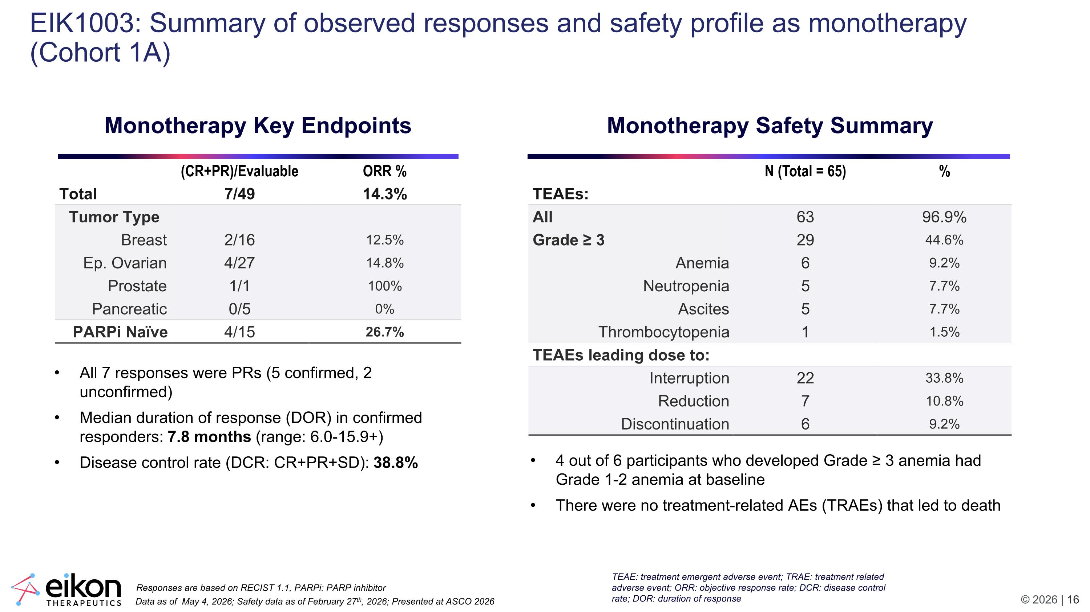
EIK1003: Summary of observed responses and safety profile as monotherapy (Cohort 1A) (CR+PR)/Evaluable ORR % Total 7/49 14.3% Tumor Type Breast 2/16 12.5% Ep. Ovarian 4/27 14.8% Prostate 1/1 100% Pancreatic 0/5 0% PARPi Naïve 4/15 26.7% Monotherapy Key Endpoints Data as of May 4, 2026; Safety data as of February 27th, 2026; Presented at ASCO 2026 Responses are based on RECIST 1.1, PARPi: PARP inhibitor N (Total = 65) % TEAEs: All 63 96.9% Grade ≥ 3 29 44.6% Anemia 6 9.2% Neutropenia 5 7.7% Ascites 5 7.7% Thrombocytopenia 1 1.5% TEAEs leading dose to: Interruption 22 33.8% Reduction 7 10.8% Discontinuation 6 9.2% Monotherapy Safety Summary 4 out of 6 participants who developed Grade ≥ 3 anemia had Grade 1-2 anemia at baseline There were no treatment-related AEs (TRAEs) that led to death All 7 responses were PRs (5 confirmed, 2 unconfirmed) Median duration of response (DOR) in confirmed responders: 7.8 months (range: 6.0-15.9+) Disease control rate (DCR: CR+PR+SD): 38.8% TEAE: treatment emergent adverse event; TRAE: treatment related adverse event; ORR: objective response rate; DCR: disease control rate; DOR: duration of response

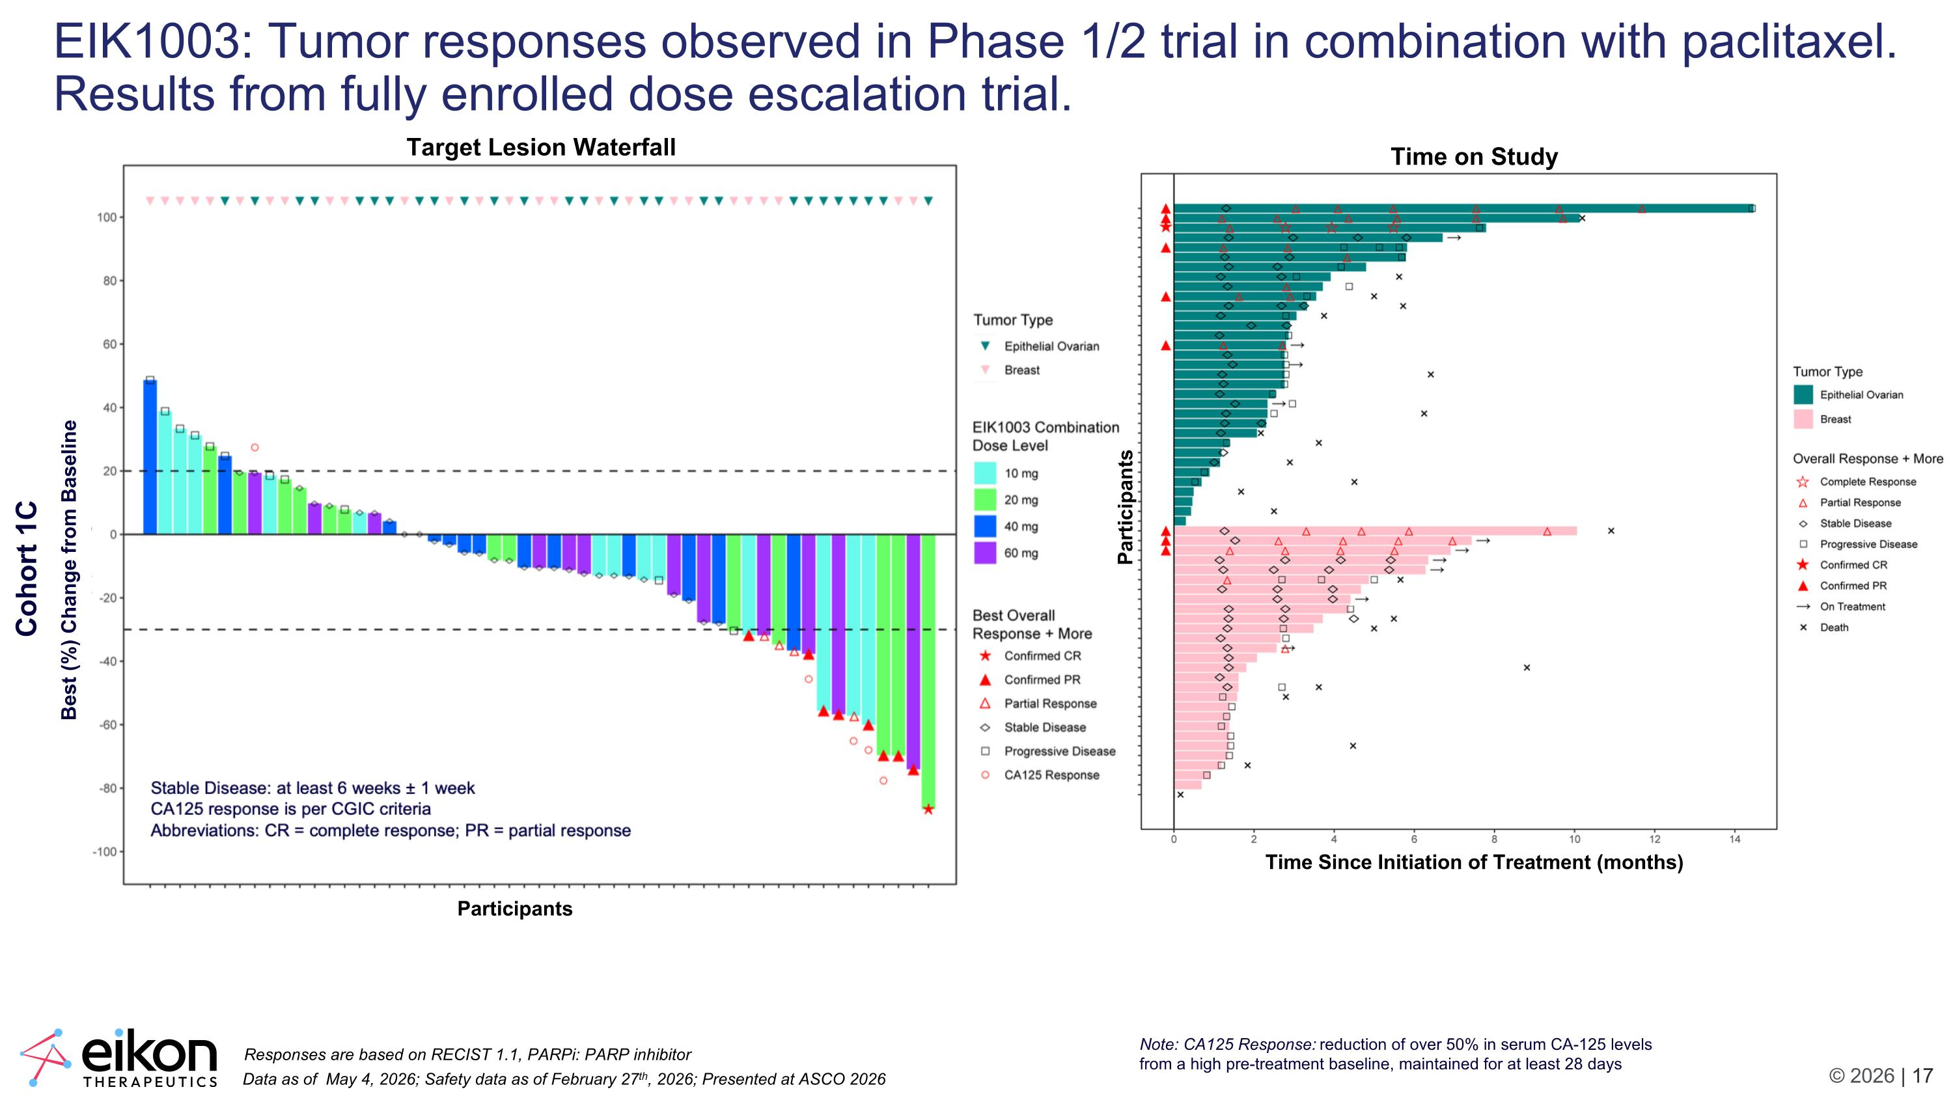
EIK1003: Tumor responses observed in Phase 1/2 trial in combination with paclitaxel. Results from fully enrolled dose escalation trial. Note: CA125 Response: reduction of over 50% in serum CA-125 levels from a high pre-treatment baseline, maintained for at least 28 days Data as of May 4, 2026; Safety data as of February 27th, 2026; Presented at ASCO 2026 Responses are based on RECIST 1.1, PARPi: PARP inhibitor Participants Best (%) Change from Baseline Cohort 1C Target Lesion Waterfall Time on Study Participants Time Since Initiation of Treatment (months)

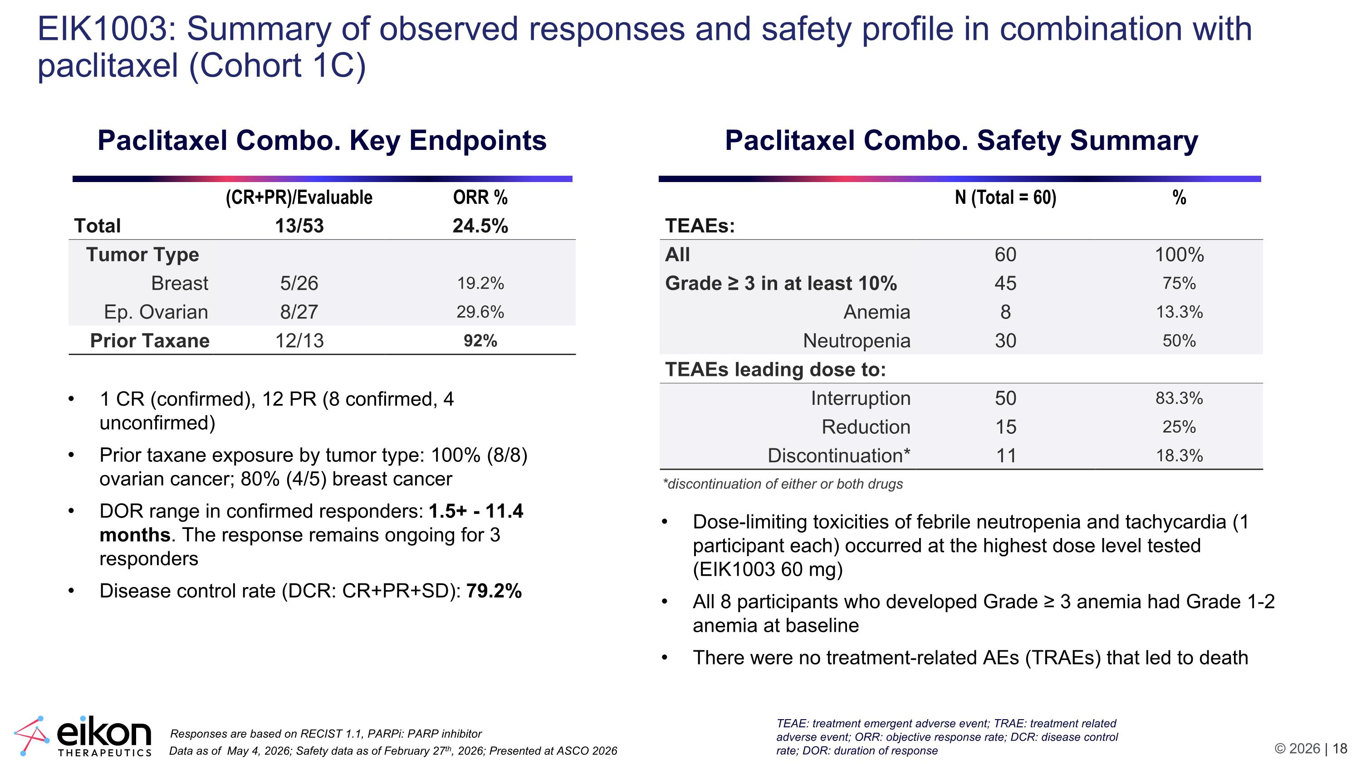
EIK1003: Summary of observed responses and safety profile in combination with paclitaxel (Cohort 1C) (CR+PR)/Evaluable ORR % Total 13/53 24.5% Tumor Type Breast 5/26 19.2% Ep. Ovarian 8/27 29.6% Prior Taxane 12/13 92% Paclitaxel Combo. Key Endpoints Data as of May 4, 2026; Safety data as of February 27th, 2026; Presented at ASCO 2026 Responses are based on RECIST 1.1, PARPi: PARP inhibitor N (Total = 60) % TEAEs: All 60 100% Grade ≥ 3 in at least 10% 45 75% Anemia 8 13.3% Neutropenia 30 50% TEAEs leading dose to: Interruption 50 83.3% Reduction 15 25% Discontinuation* 11 18.3% Paclitaxel Combo. Safety Summary Dose-limiting toxicities of febrile neutropenia and tachycardia (1 participant each) occurred at the highest dose level tested (EIK1003 60 mg) All 8 participants who developed Grade ≥ 3 anemia had Grade 1-2 anemia at baseline There were no treatment-related AEs (TRAEs) that led to death 1 CR (confirmed), 12 PR (8 confirmed, 4 unconfirmed) Prior taxane exposure by tumor type: 100% (8/8) ovarian cancer; 80% (4/5) breast cancer DOR range in confirmed responders: 1.5+ - 11.4 months. The response remains ongoing for 3 responders Disease control rate (DCR: CR+PR+SD): 79.2% *discontinuation of either or both drugs TEAE: treatment emergent adverse event; TRAE: treatment related adverse event; ORR: objective response rate; DCR: disease control rate; DOR: duration of response

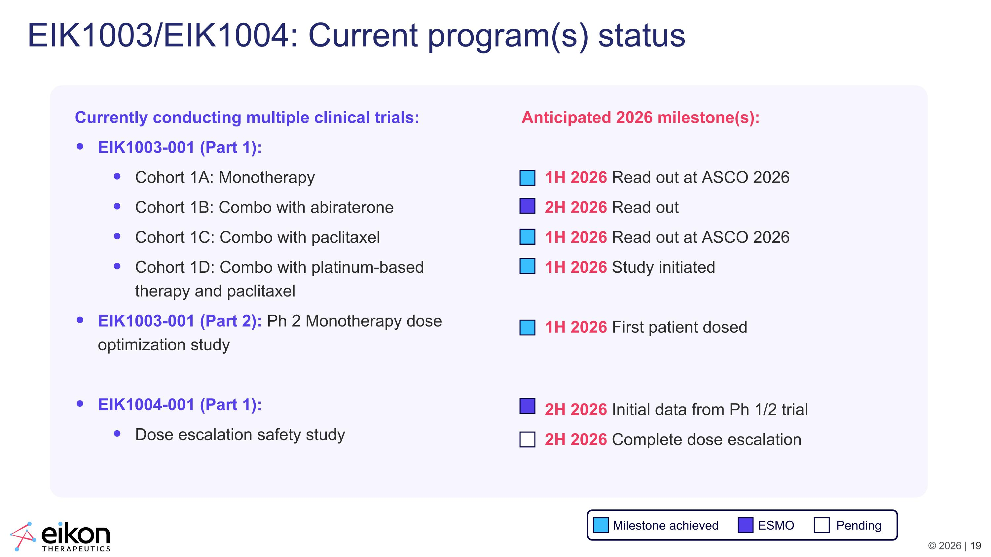
EIK1003/EIK1004: Current program(s) status Currently conducting multiple clinical trials: EIK1003-001 (Part 1): Cohort 1A: Monotherapy Cohort 1B: Combo with abiraterone Cohort 1C: Combo with paclitaxel Cohort 1D: Combo with platinum-based therapy and paclitaxel EIK1003-001 (Part 2): Ph 2 Monotherapy dose optimization study EIK1004-001 (Part 1): Dose escalation safety study Anticipated 2026 milestone(s): 1H 2026 Read out at ASCO 2026 2H 2026 Read out 1H 2026 Read out at ASCO 2026 1H 2026 Study initiated 1H 2026 First patient dosed 2H 2026 Initial data from Ph 1/2 trial 2H 2026 Complete dose escalation Milestone achieved ESMO Pending

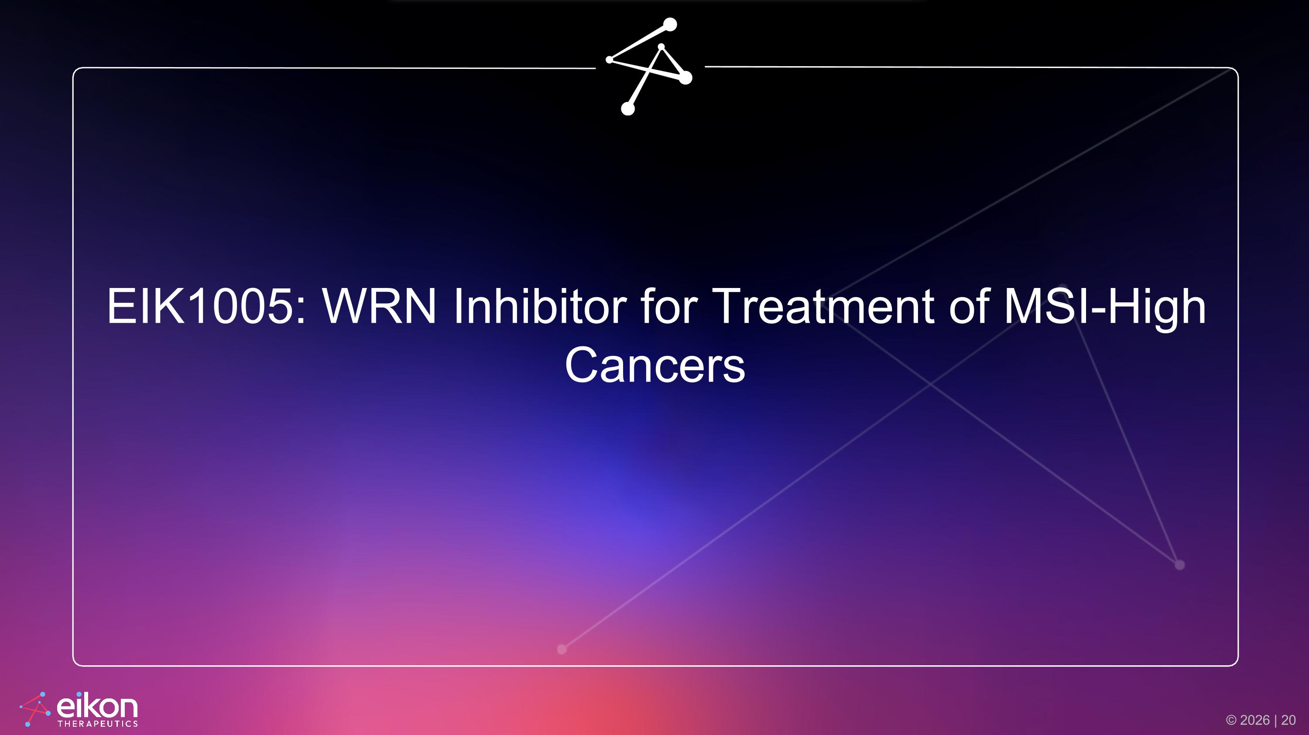
EIK1005: WRN Inhibitor for Treatment of MSI-High Cancers

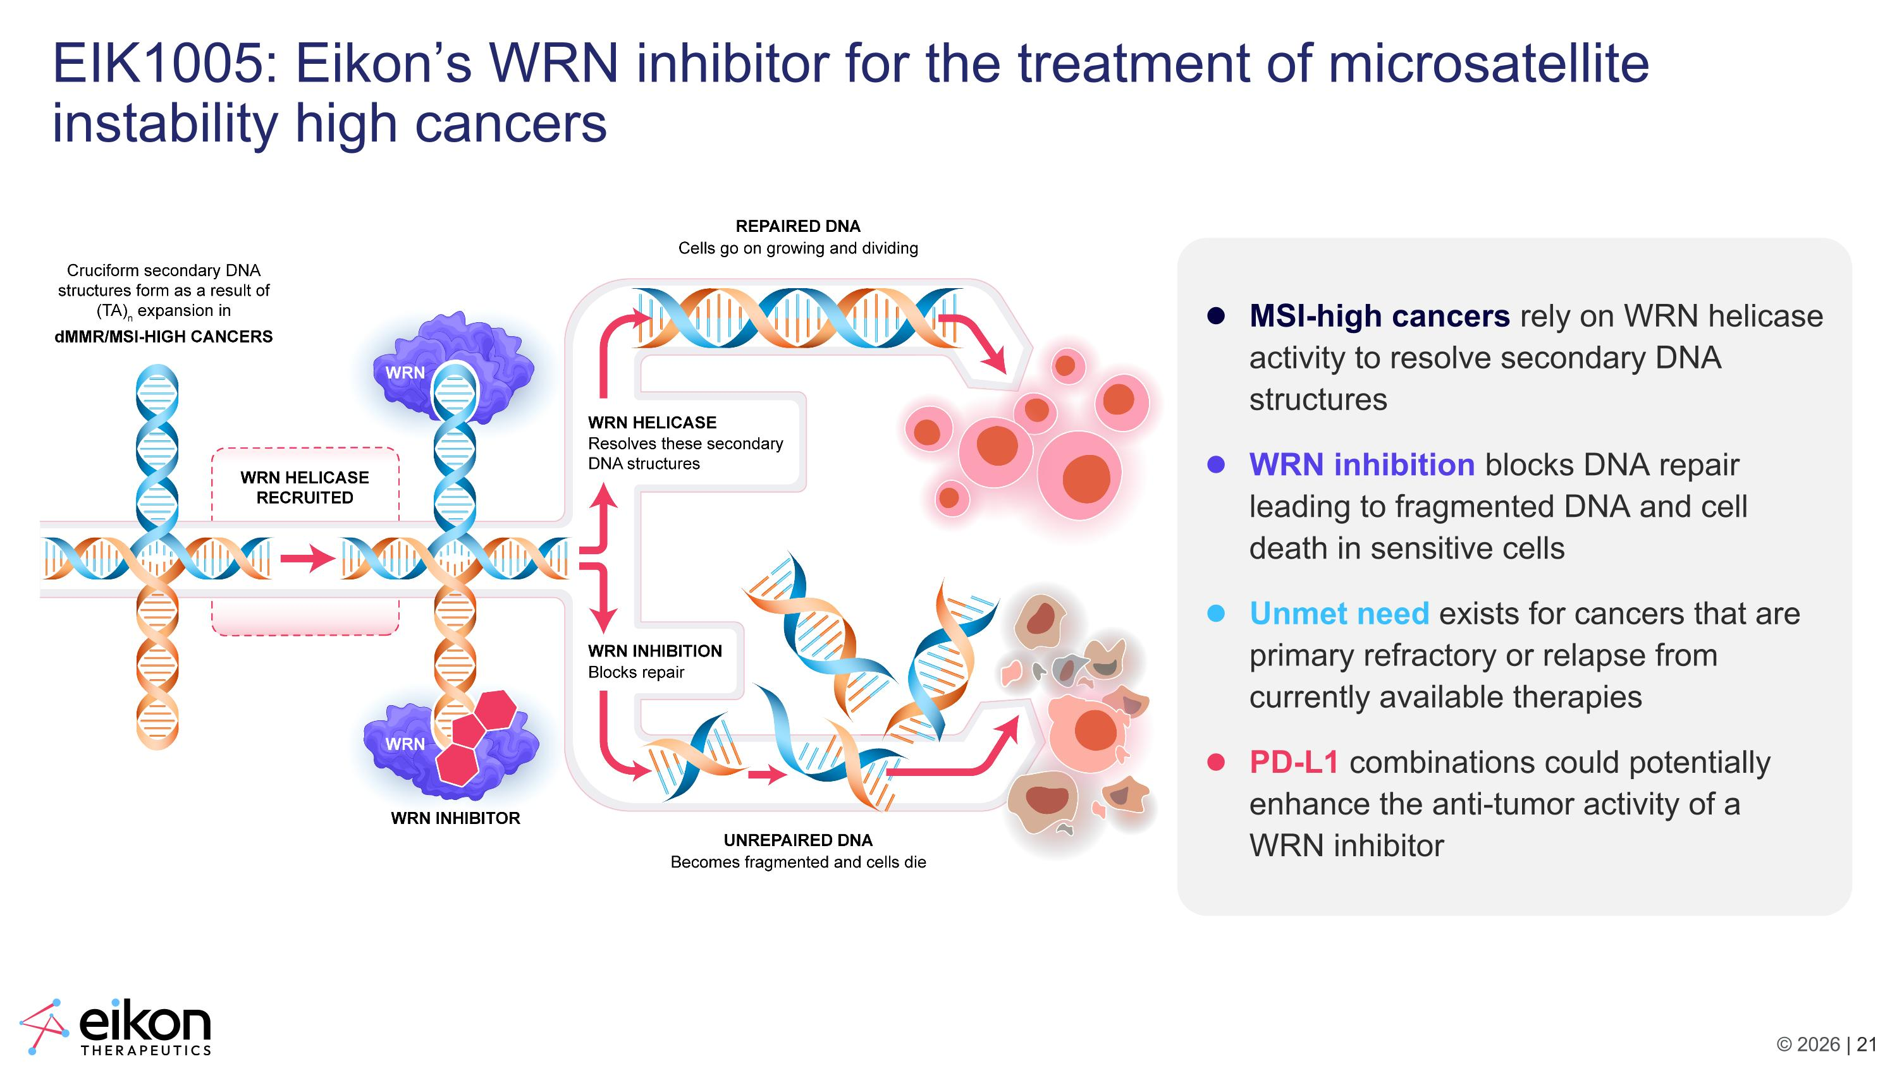
EIK1005: Eikon’s WRN inhibitor for the treatment of microsatellite instability high cancers MSI-high cancers rely on WRN helicase activity to resolve secondary DNA structures WRN inhibition blocks DNA repair leading to fragmented DNA and cell death in sensitive cells Unmet need exists for cancers that are primary refractory or relapse from currently available therapies PD-L1 combinations could potentially enhance the anti-tumor activity of a WRN inhibitor

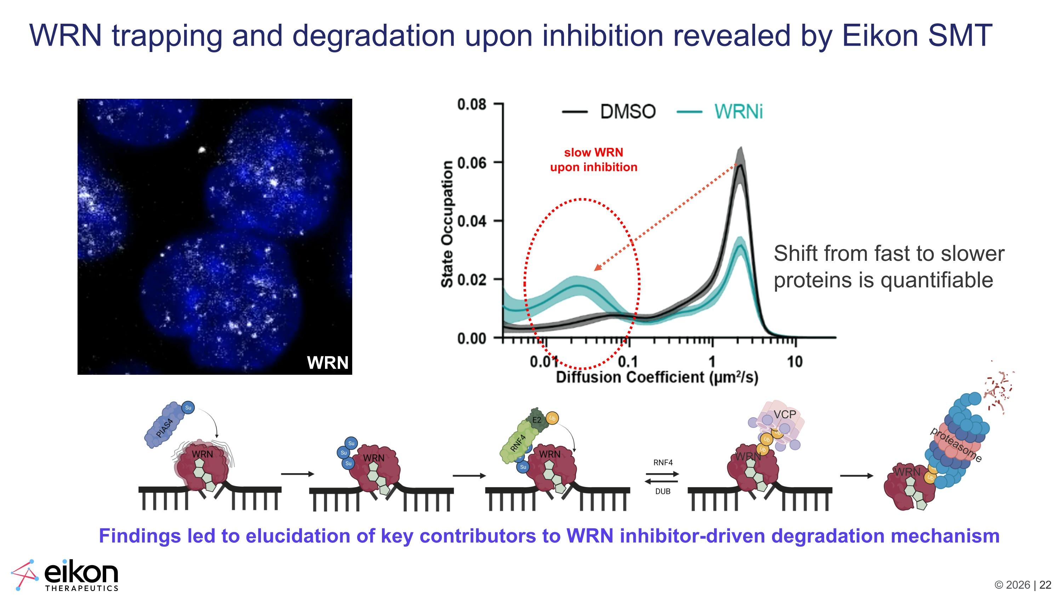
WRN trapping and degradation upon inhibition revealed by Eikon SMT VCP proteasome WRN WRN Findings led to elucidation of key contributors to WRN inhibitor-driven degradation mechanism slow WRN upon inhibition Shift from fast to slower proteins is quantifiable WRN

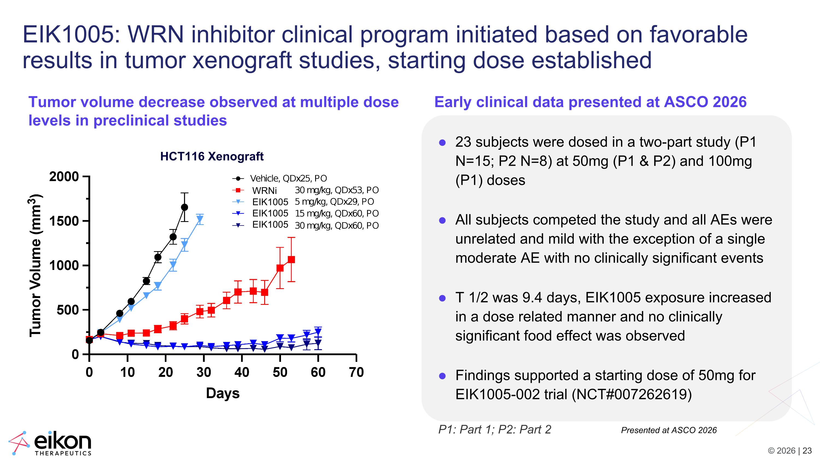
EIK1005: WRN inhibitor clinical program initiated based on favorable results in tumor xenograft studies, starting dose established 23 subjects were dosed in a two-part study (P1 N=15; P2 N=8) at 50mg (P1 & P2) and 100mg (P1) doses All subjects competed the study and all AEs were unrelated and mild with the exception of a single moderate AE with no clinically significant events T 1/2 was 9.4 days, EIK1005 exposure increased in a dose related manner and no clinically significant food effect was observed Findings supported a starting dose of 50mg for EIK1005-002 trial (NCT#007262619) Tumor volume decrease observed at multiple dose levels in preclinical studies Early clinical data presented at ASCO 2026 HCT116 Xenograft WRNi EIK1005?EIK1005 EIK1005 P1: Part 1; P2: Part 2 Presented at ASCO 2026

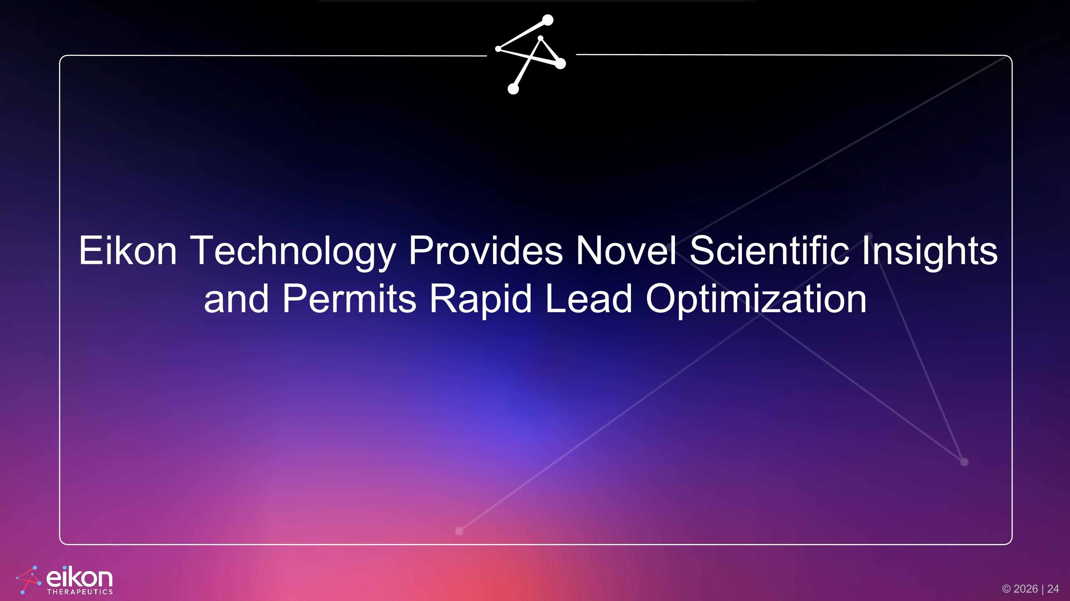
Eikon Technology Provides Novel Scientific Insights and Permits Rapid Lead Optimization

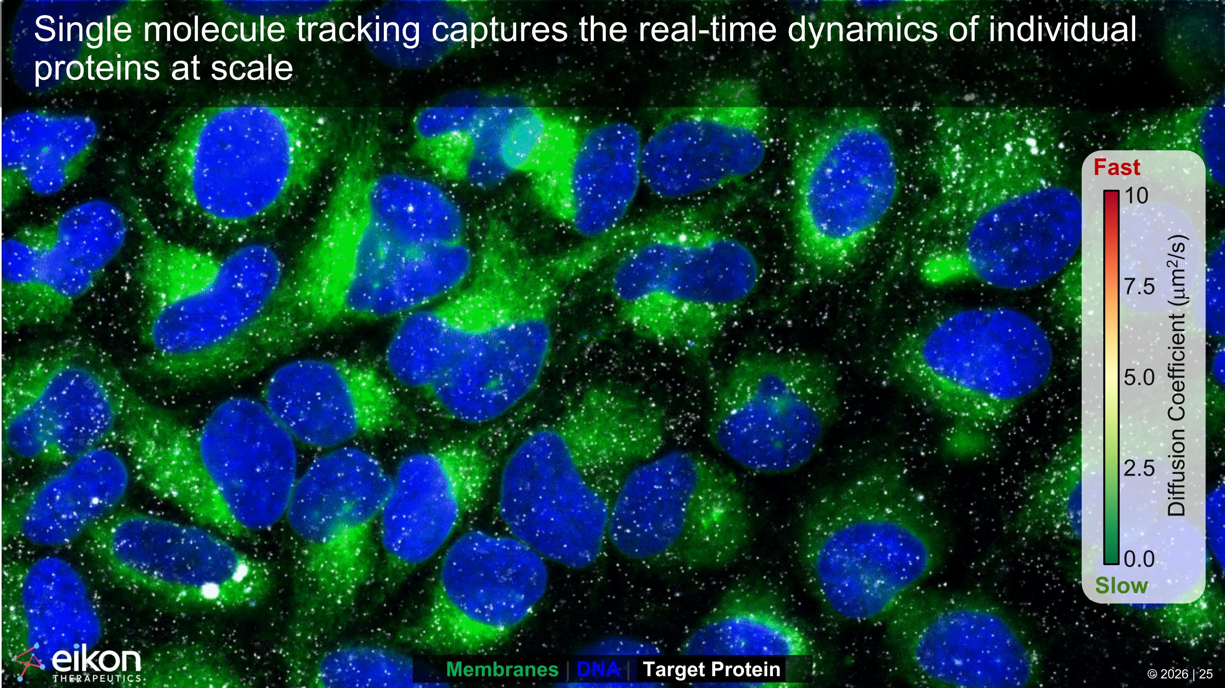
Single molecule tracking captures the real-time dynamics of individual proteins at scale 0.0 2.5 5.0 7.5 10 Fast Slow Diffusion Coefficient (mm2/s) Membranes | DNA | Target Protein © 2026 | 25

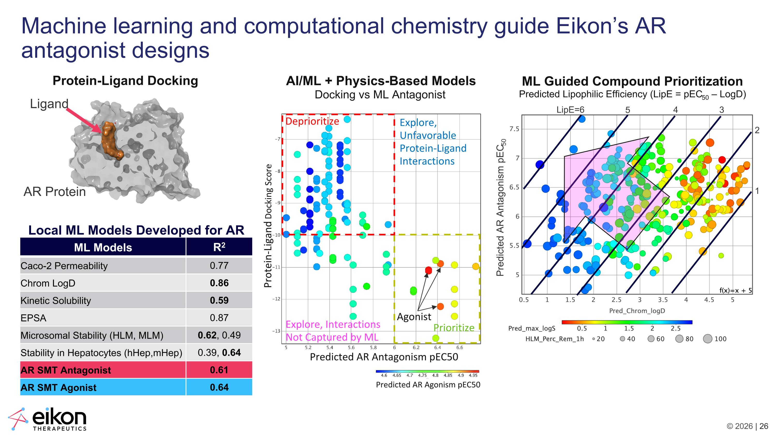
AI/ML + Physics-Based Models Docking vs ML Antagonist Deprioritize Prioritize Predicted AR Antagonism pIC50 Predicted AR Agonism pEC50 Predicted AR Antagonism pEC50 Protein-Ligand Docking Score Agonist Explore, Interactions ?Not Captured by ML Explore, ?Unfavorable ?Protein-Ligand ?Interactions ML Guided Compound Prioritization Predicted Lipophilic Efficiency (LipE = pEC50 – LogD) LipE=6 5 4 3 2 1 Machine learning and computational chemistry guide Eikon’s AR antagonist designs Protein-Ligand Docking Predicted AR Antagonism pEC50 Ligand AR Protein ML Models R2 Caco-2 Permeability 0.77 Chrom LogD 0.86 Kinetic Solubility 0.59 EPSA 0.87 Microsomal Stability (HLM, MLM) 0.62, 0.49 Stability in Hepatocytes (hHep,mHep) 0.39, 0.64 AR SMT Antagonist 0.61 AR SMT Agonist 0.64 Local ML Models Developed for AR

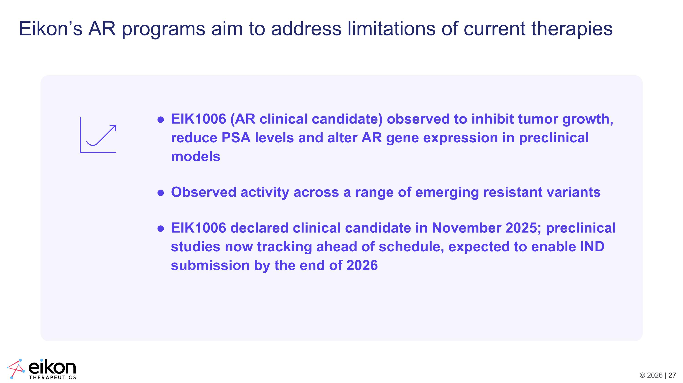
Eikon’s AR programs aim to address limitations of current therapies EIK1006 (AR clinical candidate) observed to inhibit tumor growth, reduce PSA levels and alter AR gene expression in preclinical models Observed activity across a range of emerging resistant variants EIK1006 declared clinical candidate in November 2025; preclinical studies now tracking ahead of schedule, expected to enable IND submission by the end of 2026


Conclusion

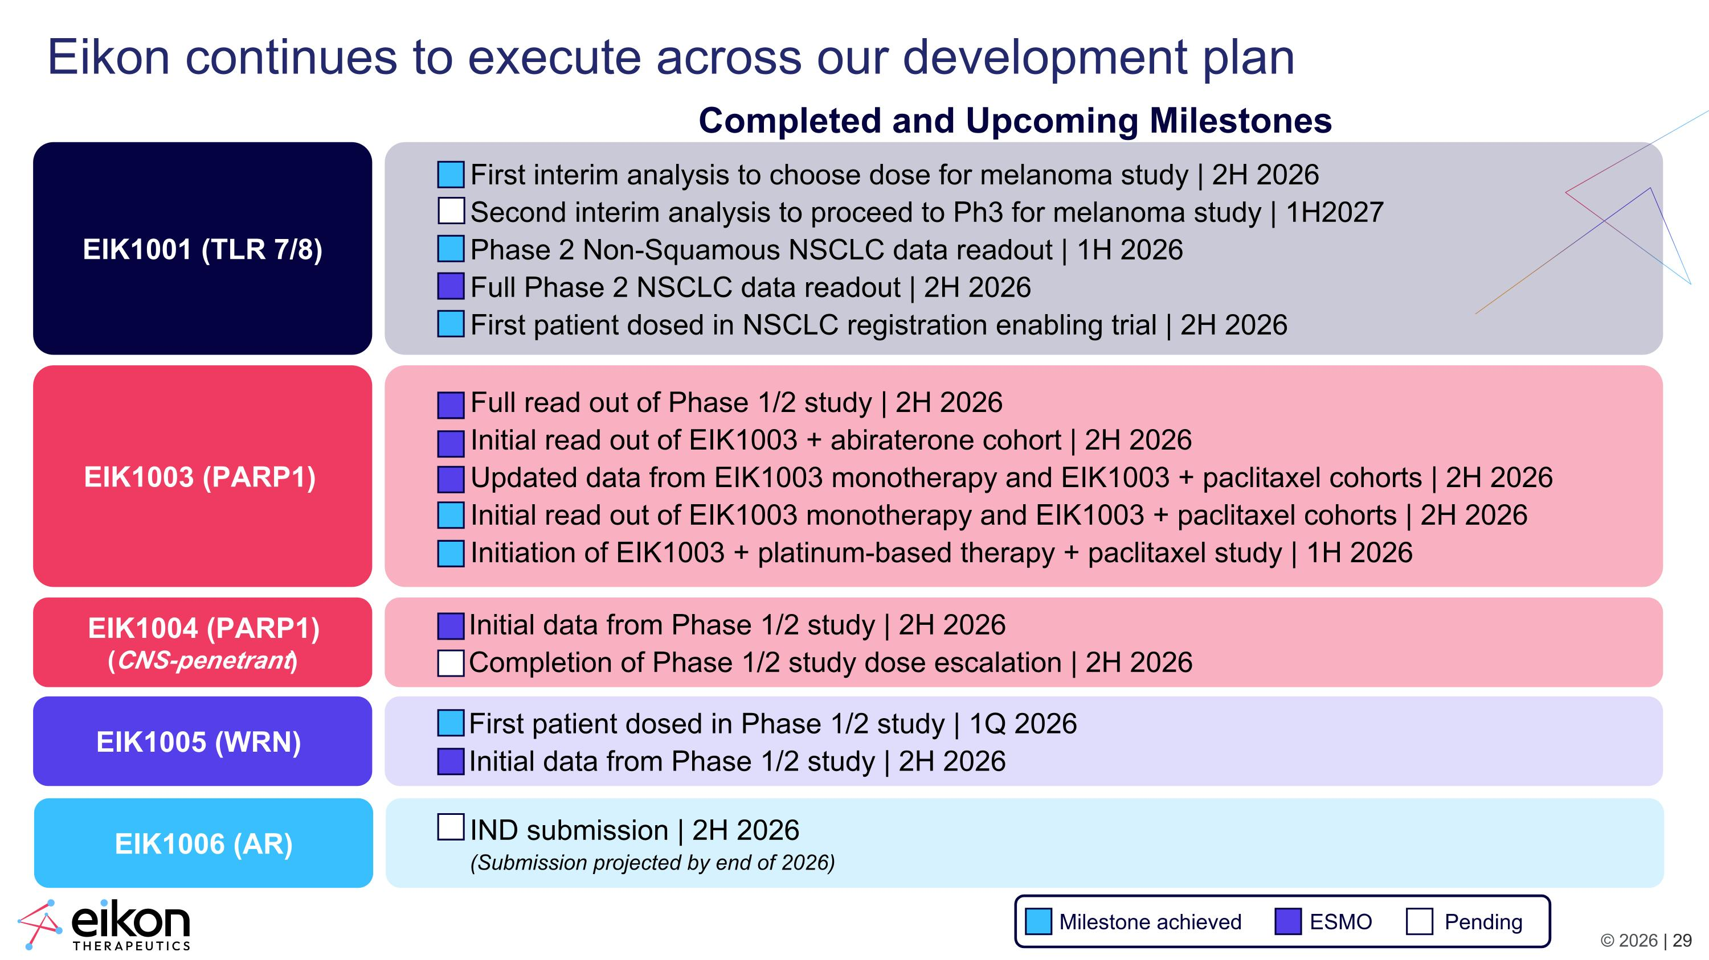
Eikon continues to execute across our development plan EIK1001 (TLR 7/8) EIK1003 (PARP1) EIK1004 (PARP1) (CNS-penetrant) EIK1005 (WRN) First interim analysis to choose dose for melanoma study | 2H 2026 Second interim analysis to proceed to Ph3 for melanoma study | 1H2027 Phase 2 Non-Squamous NSCLC data readout | 1H 2026 Full Phase 2 NSCLC data readout | 2H 2026 First patient dosed in NSCLC registration enabling trial | 2H 2026 Full read out of Phase 1/2 study | 2H 2026 Initial read out of EIK1003 + abiraterone cohort | 2H 2026 Updated data from EIK1003 monotherapy and EIK1003 + paclitaxel cohorts | 2H 2026 Initial read out of EIK1003 monotherapy and EIK1003 + paclitaxel cohorts | 2H 2026 Initiation of EIK1003 + platinum-based therapy + paclitaxel study | 1H 2026 Initial data from Phase 1/2 study | 2H 2026 Completion of Phase 1/2 study dose escalation | 2H 2026 First patient dosed in Phase 1/2 study | 1Q 2026 Initial data from Phase 1/2 study | 2H 2026 EIK1006 (AR) IND submission | 2H 2026?(Submission projected by end of 2026) Completed and Upcoming Milestones Milestone achieved ESMO Pending

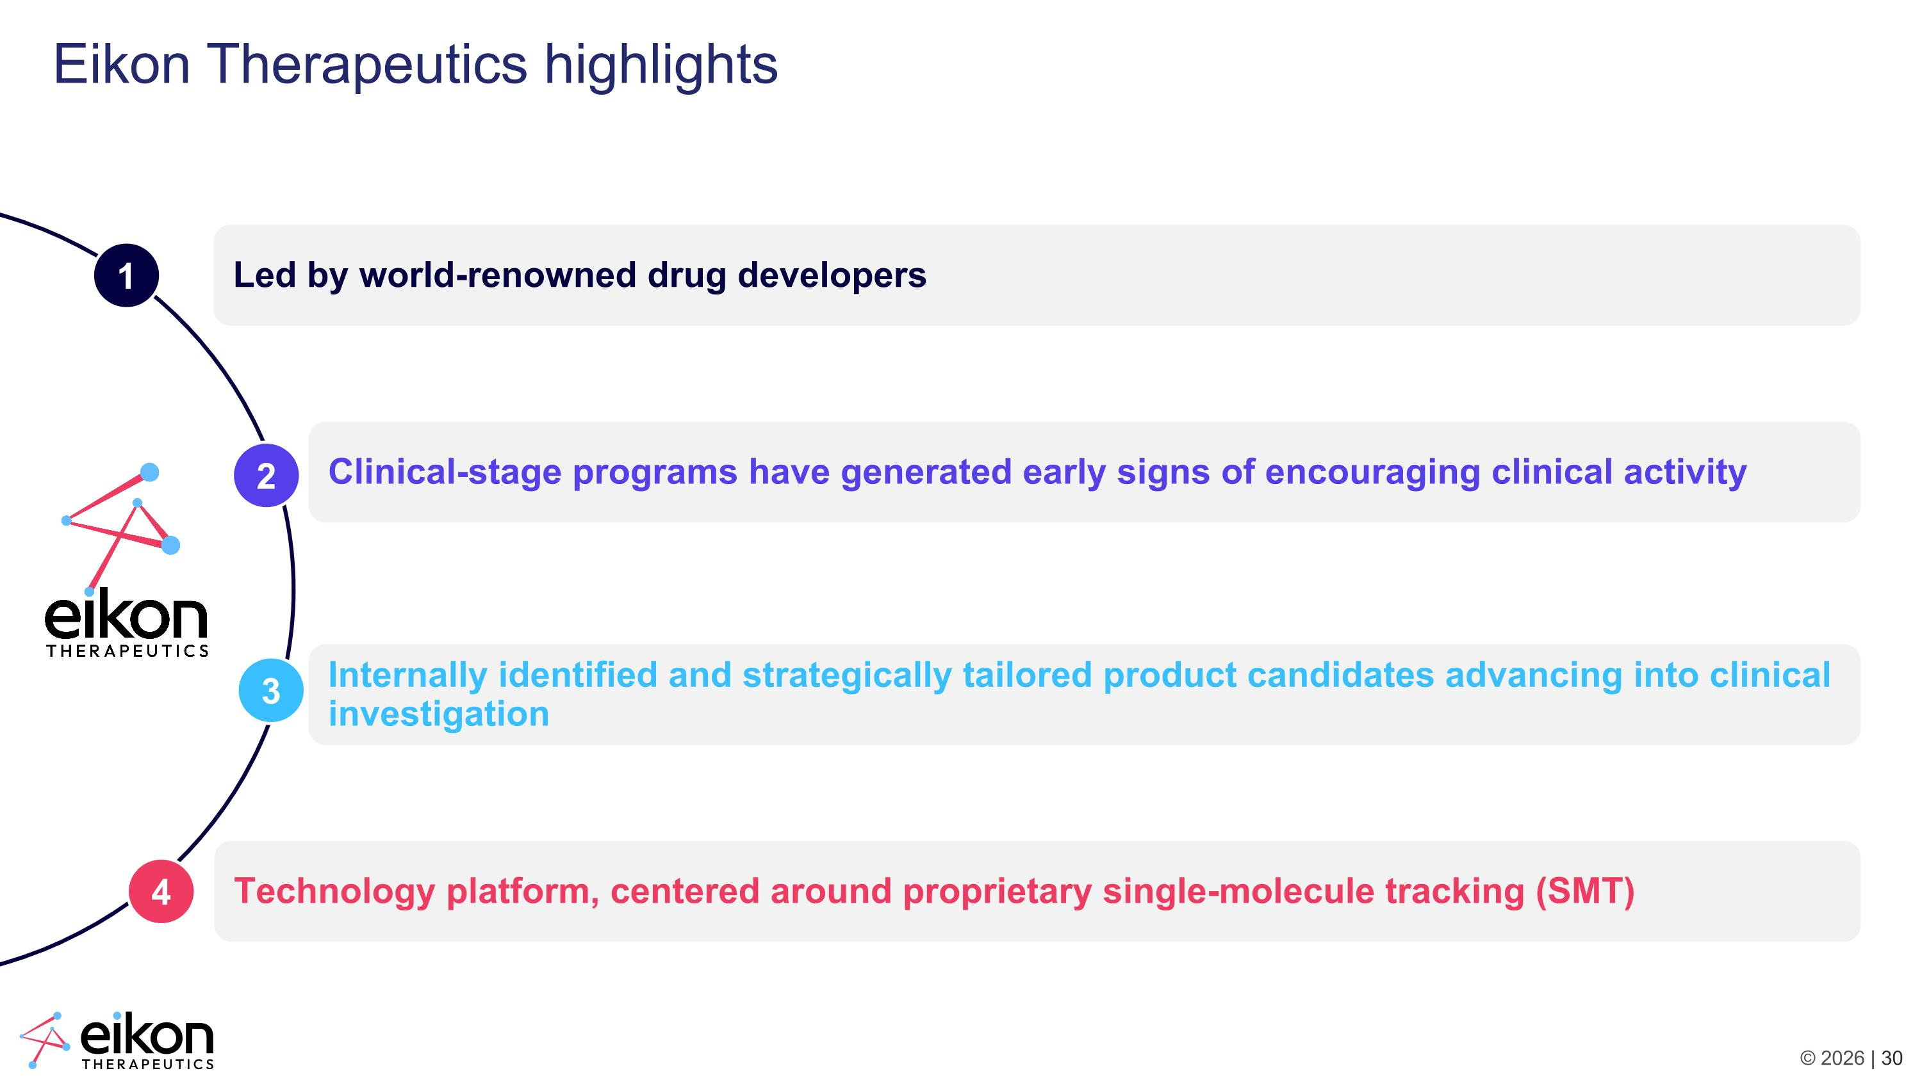
Led by world-renowned drug developers Eikon Therapeutics highlights Technology platform, centered around proprietary single-molecule tracking (SMT) Clinical-stage programs have generated early signs of encouraging clinical activity Internally identified and strategically tailored product candidates advancing into clinical investigation 1 2 3 4

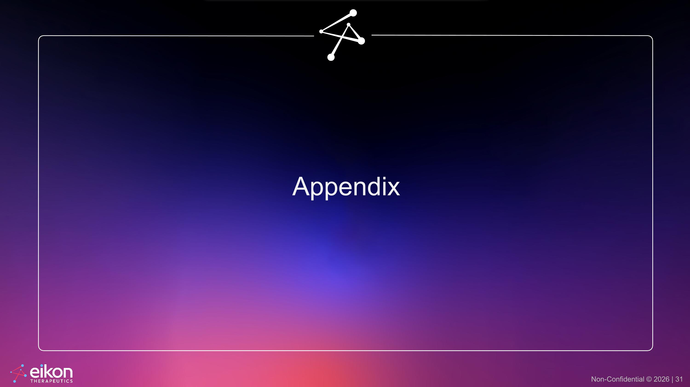
Appendix

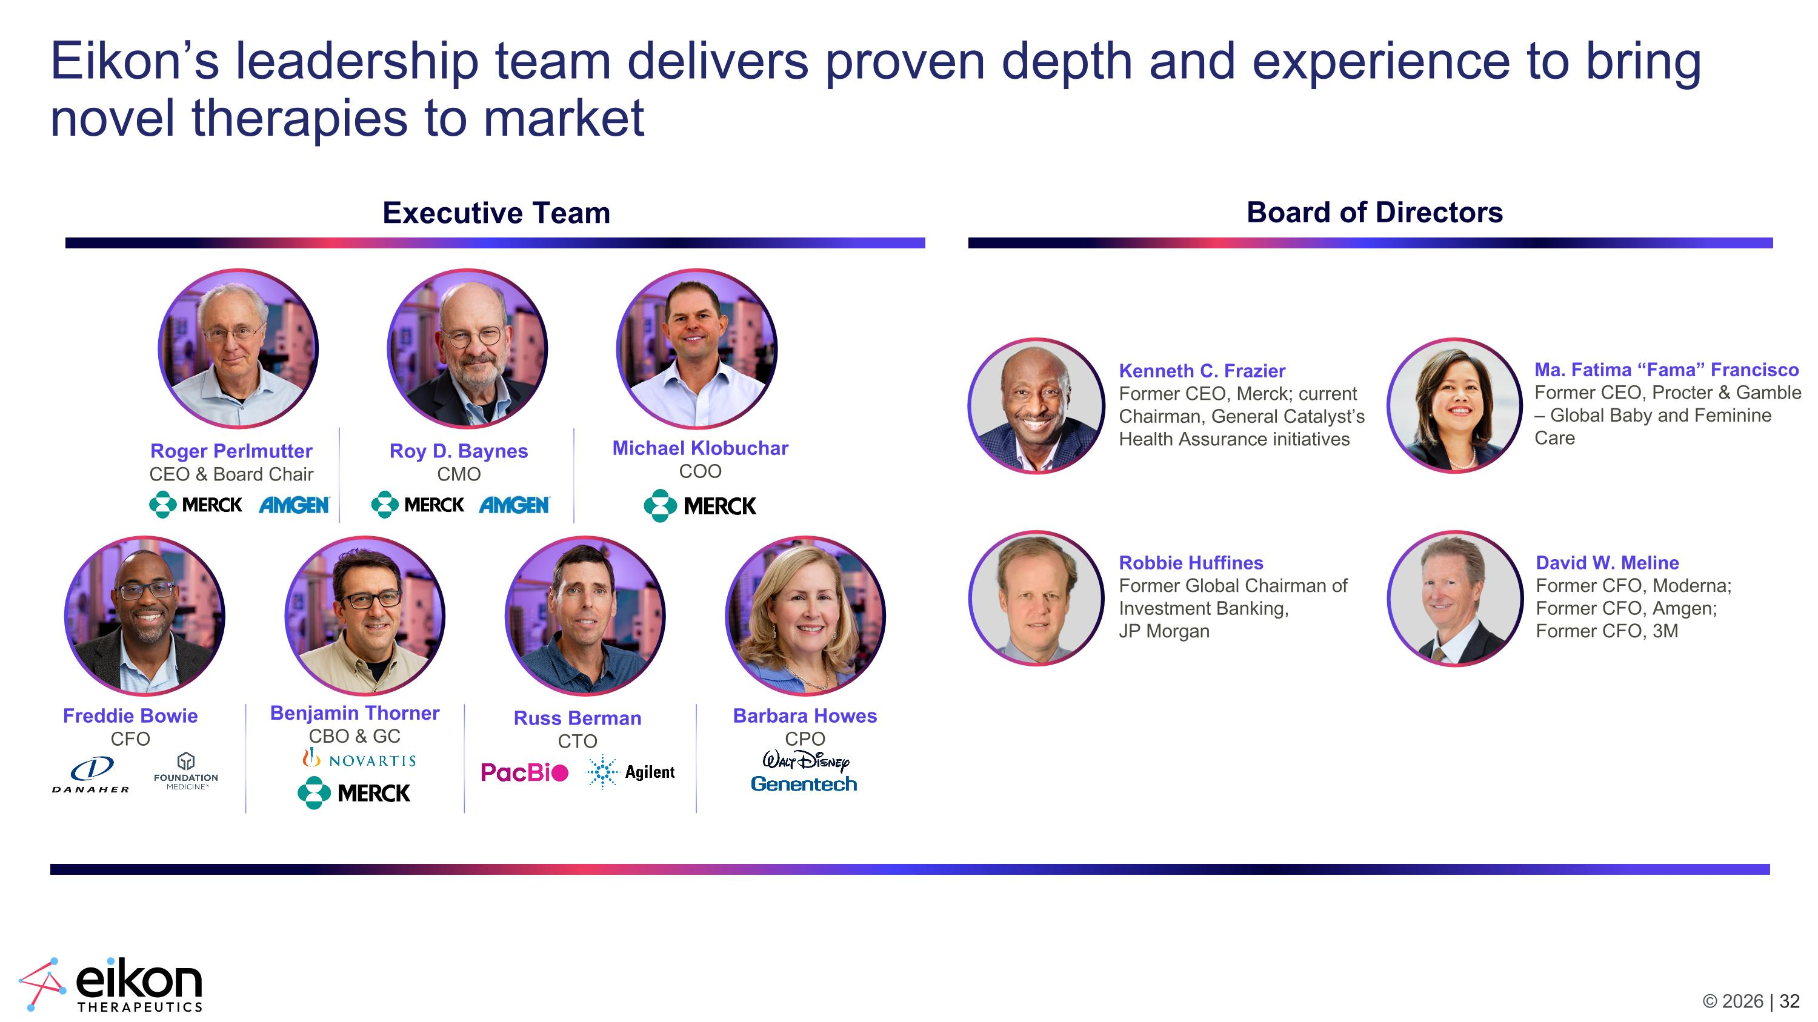
Eikon’s leadership team delivers proven depth and experience to bring novel therapies to market Roger Perlmutter CEO & Board Chair Roy D. Baynes CMO Freddie Bowie CFO Barbara Howes CPO Benjamin Thorner CBO & GC Russ Berman CTO Michael Klobuchar COO Executive Team Board of Directors Kenneth C. Frazier Former CEO, Merck; current Chairman, General Catalyst’s Health Assurance initiatives Robbie Huffines?Former Global Chairman of Investment Banking, JP Morgan David W. Meline?Former CFO, Moderna; Former CFO, Amgen; Former CFO, 3M Ma. Fatima “Fama” Francisco Former CEO, Procter & Gamble – Global Baby and Feminine Care



