UNITED STATES
SECURITIES AND EXCHANGE COMMISSION
WASHINGTON, D.C. 20549

FORM 8-K

CURRENT REPORT
Pursuant to Section 13 or 15(d) of the Securities Exchange Act of 1934
Date of Report (Date of earliest event reported): May 11, 2026

EIKON THERAPEUTICS, INC.
(Exact name of Registrant as Specified in Its Charter)

Delaware |  |  | 001-43085 | 84-2807586
(State or Other Jurisdiction  of Incorporation) |  |  | (Commission File Number) | (IRS Employer  Identification No.)
230 Harriet Tubman Way
Millbrae, California |  |  |  | 94030
(Address of Principal Executive Offices) |  |  |  | (Zip Code)

Registrant’s Telephone Number, Including Area Code: (341) 777-0566

Not Applicable
(Former Name or Former Address, if Changed Since Last Report)

Check the appropriate box below if the Form 8-K filing is intended to simultaneously satisfy the filing obligation of the registrant under any of the following provisions:
☐Written communications pursuant to Rule 425 under the Securities Act (17 CFR 230.425)
☐Soliciting material pursuant to Rule 14a-12 under the Exchange Act (17 CFR 240.14a-12)
☐Pre-commencement communications pursuant to Rule 14d-2(b) under the Exchange Act (17 CFR 240.14d-2(b))
☐Pre-commencement communications pursuant to Rule 13e-4(c) under the Exchange Act (17 CFR 240.13e-4(c))
Securities registered pursuant to Section 12(b) of the Act:
Title of each class |  | Trading  Symbol(s) |  | Name of each exchange on which registered
Common Stock, $0.0001 par value per share |  | EIKN |  | The Nasdaq Stock Market LLC
Indicate by check mark whether the registrant is an emerging growth company as defined in Rule 405 of the Securities Act of 1933 (§ 230.405 of this chapter) or Rule 12b-2 of the Securities Exchange Act of 1934 (§ 240.12b-2 of this chapter).
Emerging growth company ☒
If an emerging growth company, indicate by check mark if the registrant has elected not to use the extended transition period for complying with any new or revised financial accounting standards provided pursuant to Section 13(a) of the Exchange Act. ☐

Item 2.02 Results of Operations and Financial Condition.
On May 11, 2026, Eikon Therapeutics, Inc. (the "Company") issued a press release announcing clinical and corporate updates and its financial results for the quarter ended March 31, 2026 (the “Press Release”). A copy of the Press Release is furnished as Exhibit 99.1 to this Current Report on Form 8-K and is incorporated herein by reference.

Item 7.01 Regulation FD Disclosure.

On May 11, 2026, the Company updated its corporate presentation. A copy of the updated presentation is furnished as Exhibit 99.2 to this Current Report on Form 8-K and is incorporated herein by reference.
The information in Items 2.02 and 7.01, including Exhibits 99.1 and 99.2 hereto, is being “furnished” and shall not be deemed to be “filed” for purposes of Section 18 of the Securities Exchange Act of 1934, as amended (the “Exchange Act”), or otherwise subject to the liabilities of that section or Section 11 and 12(a)(2) of the Securities Act of 1933, as amended (the “Securities Act”). The information in Items 2.02 and 7.01, including Exhibits 99.1 and 99.2 hereto, shall not be incorporated by reference into any registration statement or other document pursuant to the Securities Act or into any filing or other document pursuant to the Exchange Act, except as otherwise expressly stated in any such filing.

Item 9.01 Financial Statements and Exhibits.
(d) Exhibits

Exhibit  Number |  | Description
99.1 |  | Press Release dated May 11, 2026.
99.2 |  | Eikon Therapeutics, Inc. Corporate Presentation, dated May 11, 2026.
104 |  | Cover Page Interactive Data File (embedded within the Inline XBRL document).

SIGNATURES
Pursuant to the requirements of the Securities Exchange Act of 1934, the registrant has duly caused this report to be signed on its behalf by the undersigned hereunto duly authorized.
 |  |  | EIKON THERAPEUTICS, INC.
Date: | May 11, 2026 | By: | /s/ Roger M. Perlmutter, M.D., Ph.D.
Roger M. Permutter, M.D., Ph.D.
Chief Executive Officer

Exhibit 99.1

Eikon Therapeutics Reports First Quarter 2026 Financial Results and Provides Clinical Updates

•
Maintained strong financial position with $596 million in cash, cash equivalents and marketable securities as of March 31, 2026

•
Continued execution across the oncology pipeline, with a strategic focus on three priority programs: EIK1001, a Toll-like receptor 7/8 (TLR7/8) agonist, EIK1003, a next-generation, highly selective PARP1 inhibitor, and EIK1005, a WRN helicase inhibitor

•
Six abstracts accepted for the American Society of Clinical Oncology (ASCO) annual meeting highlighting new data from the company’s lead programs including new safety, tolerability, and efficacy data

•
Publication of a manuscript in the Journal of Medicinal Chemistry on the use of single molecule tracking (SMT) to advance chemical matter for discovery programs in the absence of robust biochemical assays

•
Roger M. Perlmutter, Board Chair and CEO, to participate in the Bank of America Securities 2026 Global Healthcare Conference in Las Vegas, May 12, 2026

MILLBRAE, Calif., May 11, 2026 -- Eikon Therapeutics, Inc. (Nasdaq: EIKN) (“Eikon”), a late-stage clinical biopharmaceutical company dedicated to developing innovative medicines to address serious unmet medical needs, today reported first quarter 2026 financial results and provided updates on its lead clinical programs.

“We made meaningful progress in the first quarter advancing our oncology programs and expanding the clinical evidence supporting their potential,” said Roger M. Perlmutter, M.D., Ph.D., Chief Executive Officer and Board Chair of Eikon Therapeutics. “We are particularly encouraged by the breadth of data emerging across our pipeline, which will be featured at the ASCO annual meeting, and we believe these programs are well positioned to address important unmet needs in oncology. With a strong balance sheet, we remain focused on disciplined execution as we advance toward additional clinical milestones this year.”

Clinical Updates
Eikon continues to advance its lead programs and reports the following updates through the end of the first quarter of 2026:

•
EIK1001 is a systemically administered dual-agonist of Toll-like receptors 7 and 8 designed to stimulate both innate and adaptive immune responses. Phase 1 studies have previously shown that EIK1001 exhibits single-agent activity in patients with advanced malignancy. This mechanism may complement the antitumor immune response engendered by PD-(L)1 blockade. The program continues to advance across multiple clinical trials in melanoma and non-small cell lung cancer ("NSCLC"). Three abstracts have been accepted for presentation at the American Society of Clinical Oncology ("ASCO") annual meeting, including an updated data set from a now fully enrolled Phase 2 trial evaluating EIK1001 in combination with pembrolizumab and chemotherapy for NSCLC. The updated data set includes a full interim data readout of the non-squamous cohort and a partial interim data readout of the squamous cohort. In addition, we expect to make a Trial-in-Progress presentation to highlight an ongoing Phase 2/3 trial of EIK1001 in combination with pembrolizumab for advanced melanoma, as well as the initiation of a Phase 2/3 trial in combination with pembrolizumab and chemotherapy for stage 4 NSCLC.

•
EIK1003 is a next-generation, highly selective PARP1 inhibitor that has been observed to leave PARP2 signaling intact. PARP2 inhibition may be a key driver of the hematological toxicity associated with first

generation, non-selective PARP inhibitors. The program is advancing through an ongoing Phase 1/2 trial in patients with breast, ovarian, prostate, or pancreatic cancer. An abstract has been accepted for presentation at the ASCO annual meeting, including updated data from Cohort 1A evaluating EIK1003 as a monotherapy and Cohort 1C evaluating EIK1003 in combination with paclitaxel in patients with platinum-resistant ovarian cancer, or breast cancer patients who are either Her-2 negative, ER+, and hormonal therapy-experienced, or ER- and chemotherapy-experienced. The dose escalation portion of the trial has been completed for Cohorts 1A, 1B (in prostate cancer patients in combination with the novel hormonal agent, abiraterone, and prednisone), and 1C, with backfill nearing completion. Separately, the first patient has been dosed in a Phase 2 dose optimization trial. In addition, global site selection has been initiated for Cohort 1D, which will evaluate EIK1003 in combination with paclitaxel and platinum-based chemotherapeutic agents in patients with breast or ovarian cancer.

•
EIK1005 is a WRN helicase inhibitor with demonstrated in vitro activity in MSI-high cancer cells. EIK1005 was optimized using Eikon’s technology platform, which includes its imaging instruments that permit single molecule tracking in living cells. The program has advanced into clinical development, with a Phase 1/2 trial underway in patients with advanced solid tumors, which began dosing in February 2026. Two abstracts have been accepted for presentation or publication at the ASCO annual meeting, including data on pharmacokinetics and pharmacodynamics in healthy volunteers and resulting dose modeling, as well as a Trial-in-Progress presentation for the ongoing Phase 1/2 trial.

First Quarter 2026 Financial Results

Cash Position: As of March 31, 2026, Eikon had cash, cash equivalents, and marketable securities of $596.0 million. Eikon expects its current cash, cash equivalents, and marketable securities, to fund operations into the second half of 2027.

Research and Development (“R&D”) expenses: R&D expenses were $70.0 million for the first quarter of 2026 compared to $56.6 million for the first quarter of 2025, an increase of $13.5 million, or 24%. The increase was primarily due to accelerating clinical trial activity and a $5.0 million milestone payment to Impact Therapeutics (Shanghai) Inc. in the first quarter of 2026 for advancement of EIK1003 into Phase 2 development.

General and Administrative (“G&A”) expenses: G&A expenses were $17.3 million for the first quarter of 2026 compared to $14.8 million for the first quarter of 2025, an increase of $2.5 million, or 17%. The increase was primarily due to higher depreciation expense following the occupation of Eikon’s Millbrae headquarters in April 2025 and higher professional fees, insurance expenses, and recruitment fees.

Net Loss: Net loss attributable to common stockholders was $83.0 million for the first quarter of 2026, as compared to $74.5 million for the prior-year period.

About Eikon Therapeutics
Eikon is a late-stage clinical biopharmaceutical company dedicated to building a global, fully-integrated organization developing innovative medicines to address serious unmet medical needs. Eikon’s initial focus is oncology, where it is advancing a pipeline of drug candidates that could eventually become lifesaving medicines. Eikon deploys its technology platform, including its proprietary single molecule tracking system, to develop internally-derived novel therapies, while also leveraging the deep expertise of its management team to in-license promising assets. Eikon’s vision is to become a generational leader, by purposefully integrating traditional biology research with advanced engineering to develop better medicines faster. For more information, visit www.eikontx.com.
Forward-Looking/Safe Harbor Statements
This press release contains forward-looking statements within the meaning of the “safe harbor” provisions of the Private Securities Litigation Reform Act of 1995. All statements in this press release that are not historical facts are hereby identified as forward-looking statements for this purpose. These statements may be identified by words such as “aims,” “anticipates,” “believes,” “could,” “estimates,” “expects,” “forecasts,” “goal,” “intends,” “may,” “plans,” “possible,” “potential,” “seeks,” “will” and variations of these words or similar expressions that are intended to identify forward-looking statements, although not all forward-looking statements contain these words.

Forward-looking statements in this press release include, but are not limited to, statements regarding: the therapeutic potential of Eikon’s product candidates; the timing for anticipated data readouts; expected milestones and business objectives for 2026 and beyond, including Eikon’s anticipated presentations at the ASCO annual meeting; the anticipated cash runway into the second half of 2027; and other statements regarding Eikon’s future operations, financial performance, financial position, prospects, objectives, strategies and other future events.

These forward-looking statements are based upon management’s current expectations and assumptions, and are subject to a number of risks, uncertainties and other factors that could cause actual results and events to differ materially and adversely from those indicated by such forward-looking statements including, among others: our limited operating history; our significant net losses incurred since inception and the likelihood of incurring additional losses for the foreseeable future; our need for substantial additional funding; the early stage of development of many of our product candidates and the possibility that our product candidates may fail in development; our dependence on the success of our current product candidates; our ability to leverage our technology platform to enable more informed drug research and development; legal and regulatory risks; intellectual property-related risks; and those risks, uncertainties and other factors discussed under the caption “Risk Factors” and elsewhere in Eikon’s Quarterly Report on Form 10-Q for the quarter ended March 31, 2026, filed with the Securities and Exchange Commission (“SEC”) on May 11, 2026, and in other public filings with the SEC in the future.

As a result, you should not place undue reliance on any forward-looking statements. The forward-looking statements made in this press release speak only as of the date of this press release, and Eikon undertakes no obligation to update such forward-looking statements, whether as a result of new information, future developments or otherwise, except as required by law.

Contacts:

Investors
Alfred “Freddie” Bowie, Ph.D., CFO
ir@eikontx.com

Media
Colin Sanford
colin@bioscribe.com

Eikon Therapeutics, Inc.
Condensed Statements of Operations and Comprehensive Loss
(in thousands, except share and per share amounts)
(Unaudited)

 |  | Three Months Ended March 31,
 |  | 2026 |  |  |  | 2025
Operating expenses:
Research and development |  | $ | 70,047 |  |  | $ | 56,587
General and administrative |  |  | 17,290 |  |  |  | 14,796
Total operating expenses |  |  | 87,337 |  |  |  | 71,383
Loss from operations |  |  | (87,337 | ) |  |  | (71,383 | )
Interest income (expense), net |  |  | 4,380 |  |  |  | 3,160
Other income (expense), net |  |  | (1 | ) |  |  | (20 | )
Net loss and comprehensive loss |  |  | (82,958 | ) |  |  | (68,243 | )
Impact of preferred stock extinguishments and modifications |  |  | — |  |  |  | (6,300 | )
Net loss attributable to common stockholders |  | $ | (82,958 | ) |  | $ | (74,543 | )
Net loss per share attributable to common stockholders, basic and diluted |  | $ | (2.46 | ) |  | $ | (26.91 | )
Weighted-average shares of common stock outstanding used in computing  net loss per share attributable to common stockholders, basic and diluted |  |  | 33,700,550 |  |  |  | 2,770,352

Eikon Therapeutics, Inc.
Condensed Balance Sheet Data
(in thousands)
(Unaudited)

 |  | March 31,  2026 |  |  |  | December 31,  2025
Cash, cash equivalents and marketable securities |  | $ | 596,010 |  |  | $ | 335,975
Total assets |  |  | 850,826 |  |  |  | 594,734
Total liabilities |  |  | 300,155 |  |  |  | 312,298
Total stockholders’ equity (deficit) |  |  | 550,671 |  |  |  | (879,034 | )

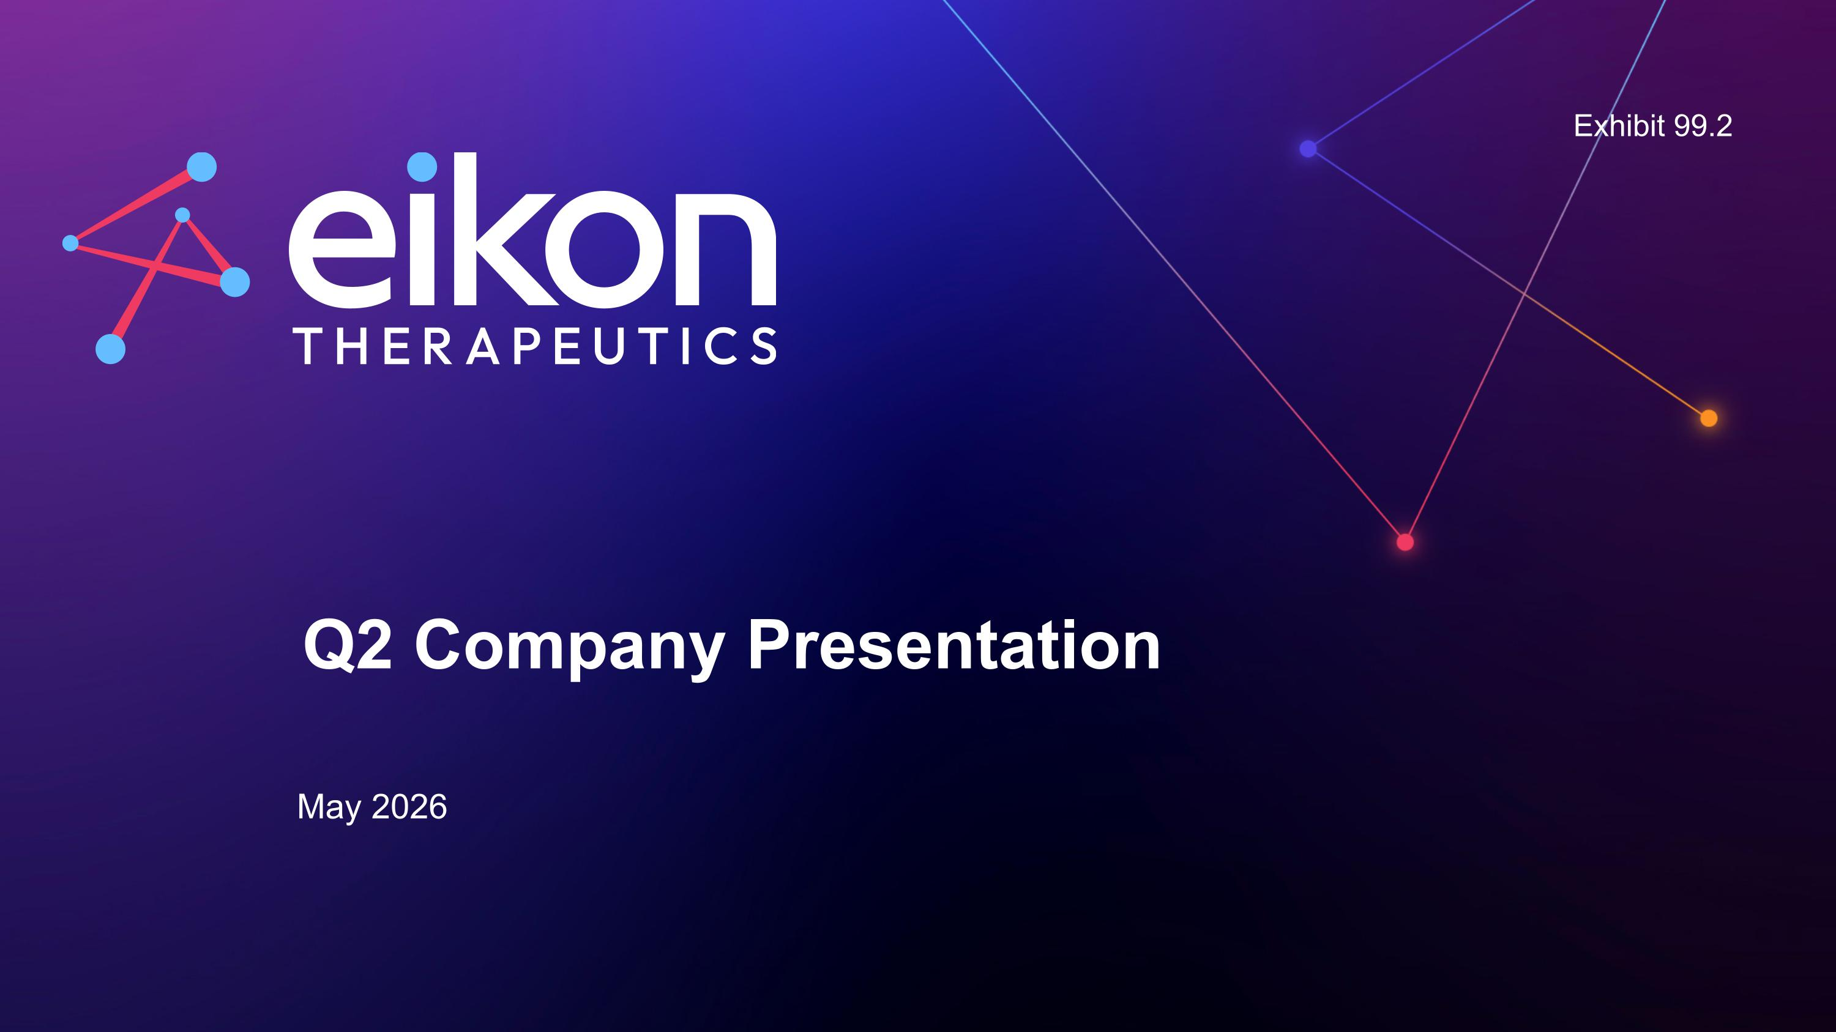
Q2 Company Presentation May 2026 Exhibit 99.2

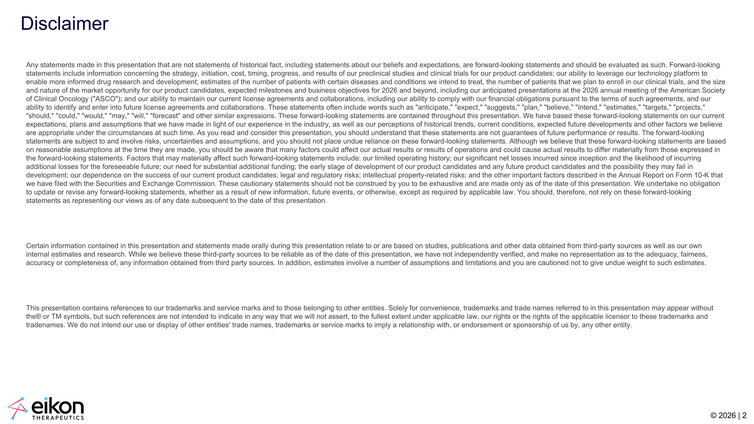
Disclaimer Any statements made in this presentation that are not statements of historical fact, including statements about our beliefs and expectations, are forward-looking statements and should be evaluated as such. Forward-looking statements include information concerning the strategy, initiation, cost, timing, progress, and results of our preclinical studies and clinical trials for our product candidates; our ability to leverage our technology platform to enable more informed drug research and development; estimates of the number of patients with certain diseases and conditions we intend to treat, the number of patients that we plan to enroll in our clinical trials, and the size and nature of the market opportunity for our product candidates, expected milestones and business objectives for 2026 and beyond, including our anticipated presentations at the 2026 annual meeting of the American Society of Clinical Oncology ("ASCO"); and our ability to maintain our current license agreements and collaborations, including our ability to comply with our financial obligations pursuant to the terms of such agreements, and our ability to identify and enter into future license agreements and collaborations. These statements often include words such as "anticipate," "expect," "suggests," "plan," "believe," "intend," "estimates," "targets," "projects," "should," "could," "would," "may," "will," "forecast" and other similar expressions. These forward-looking statements are contained throughout this presentation. We have based these forward-looking statements on our current expectations, plans and assumptions that we have made in light of our experience in the industry, as well as our perceptions of historical trends, current conditions, expected future developments and other factors we believe are appropriate under the circumstances at such time. As you read and consider this presentation, you should understand that these statements are not guarantees of future performance or results. The forward-looking statements are subject to and involve risks, uncertainties and assumptions, and you should not place undue reliance on these forward-looking statements. Although we believe that these forward-looking statements are based on reasonable assumptions at the time they are made, you should be aware that many factors could affect our actual results or results of operations and could cause actual results to differ materially from those expressed in the forward-looking statements. Factors that may materially affect such forward-looking statements include: our limited operating history; our significant net losses incurred since inception and the likelihood of incurring additional losses for the foreseeable future; our need for substantial additional funding; the early stage of development of our product candidates and any future product candidates and the possibility they may fail in development; our dependence on the success of our current product candidates; legal and regulatory risks; intellectual property-related risks; and the other important factors described in the Annual Report on Form 10-K that we have filed with the Securities and Exchange Commission. These cautionary statements should not be construed by you to be exhaustive and are made only as of the date of this presentation. We undertake no obligation to update or revise any forward-looking statements, whether as a result of new information, future events, or otherwise, except as required by applicable law. You should, therefore, not rely on these forward-looking statements as representing our views as of any date subsequent to the date of this presentation. Certain information contained in this presentation and statements made orally during this presentation relate to or are based on studies, publications and other data obtained from third-party sources as well as our own internal estimates and research. While we believe these third-party sources to be reliable as of the date of this presentation, we have not independently verified, and make no representation as to the adequacy, fairness, accuracy or completeness of, any information obtained from third party sources. In addition, estimates involve a number of assumptions and limitations and you are cautioned not to give undue weight to such estimates. This presentation contains references to our trademarks and service marks and to those belonging to other entities. Solely for convenience, trademarks and trade names referred to in this presentation may appear without the® or TM symbols, but such references are not intended to indicate in any way that we will not assert, to the fullest extent under applicable law, our rights or the rights of the applicable licensor to these trademarks and tradenames. We do not intend our use or display of other entities' trade names, trademarks or service marks to imply a relationship with, or endorsement or sponsorship of us by, any other entity.

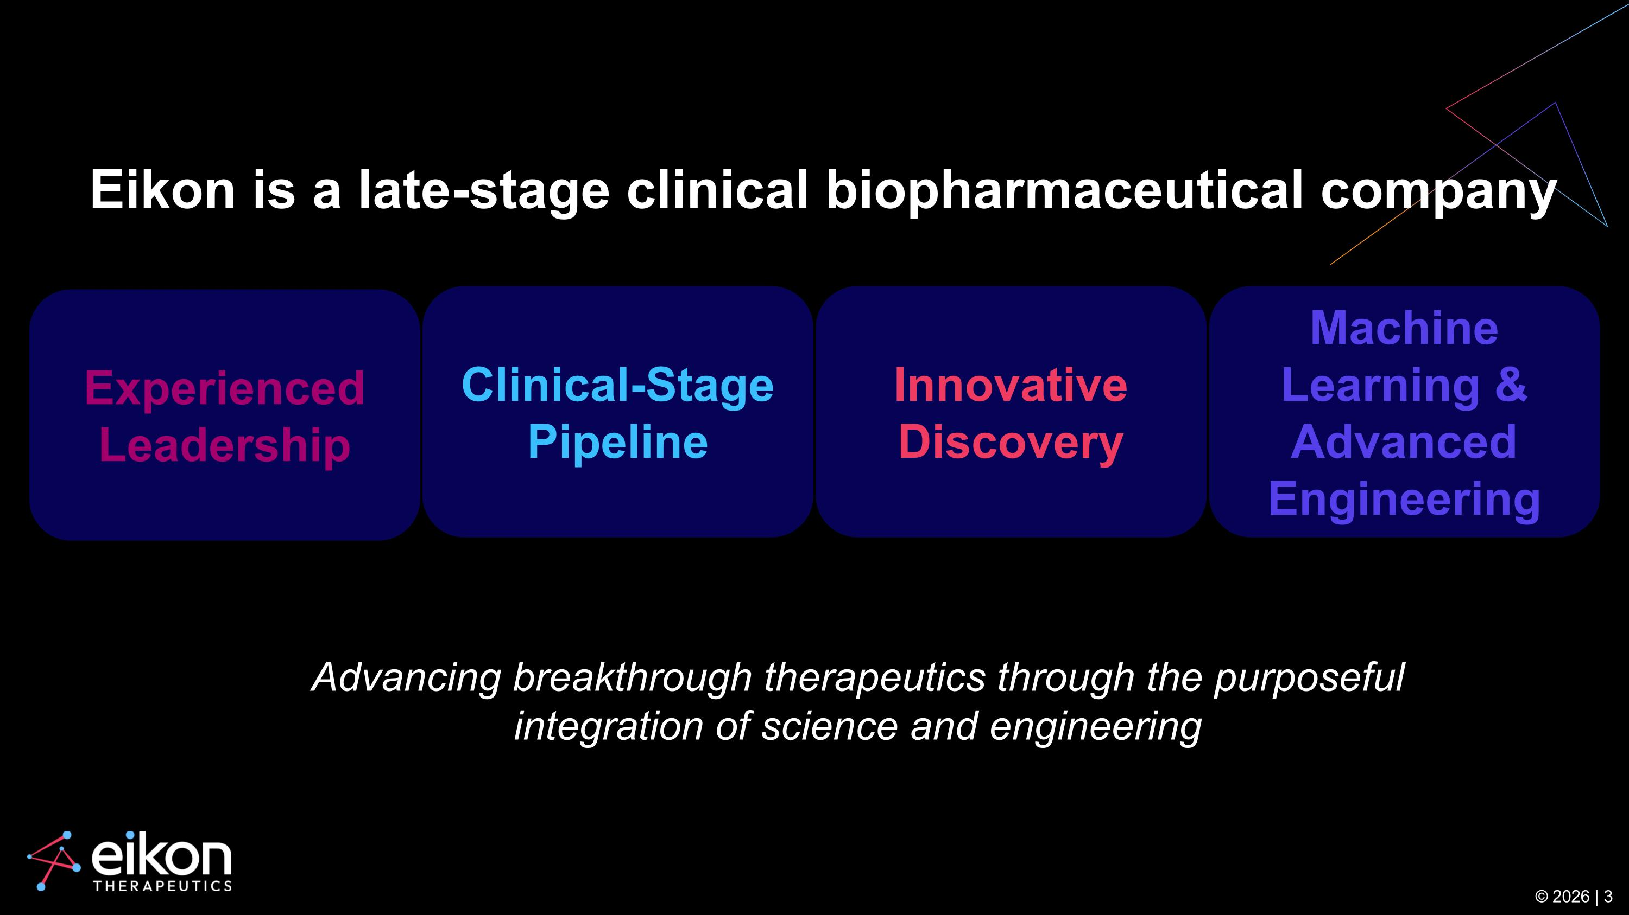
Advancing breakthrough therapeutics through the purposeful integration of science and engineering © 2026 | 3 Innovative Discovery Machine Learning & Advanced Engineering Experienced Leadership Clinical-Stage Pipeline Eikon is a late-stage clinical biopharmaceutical company

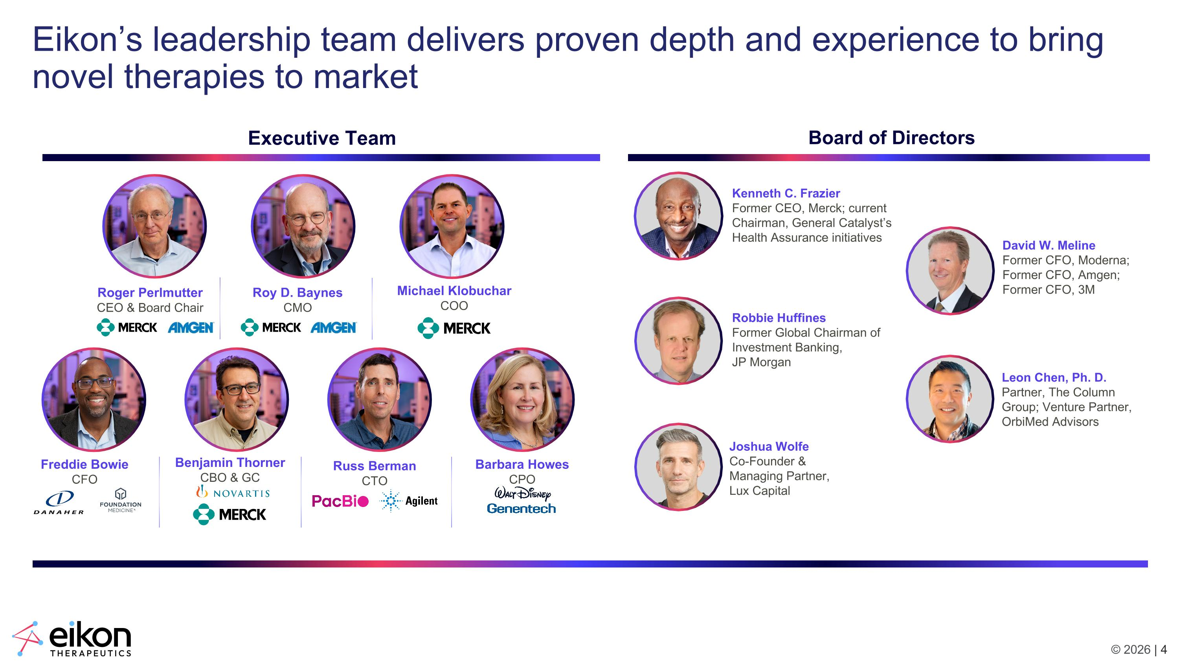
Eikon’s leadership team delivers proven depth and experience to bring novel therapies to market Roger Perlmutter CEO & Board Chair Roy D. Baynes CMO Freddie Bowie CFO Barbara Howes CPO Benjamin Thorner CBO & GC Russ Berman CTO Michael Klobuchar COO Executive Team Board of Directors Kenneth C. Frazier Former CEO, Merck; current Chairman, General Catalyst’s Health Assurance initiatives Leon Chen, Ph. D.?Partner, The Column Group; Venture Partner, OrbiMed Advisors Robbie Huffines?Former Global Chairman of Investment Banking, JP Morgan Joshua Wolfe?Co-Founder & Managing Partner, Lux Capital David W. Meline?Former CFO, Moderna; Former CFO, Amgen; Former CFO, 3M

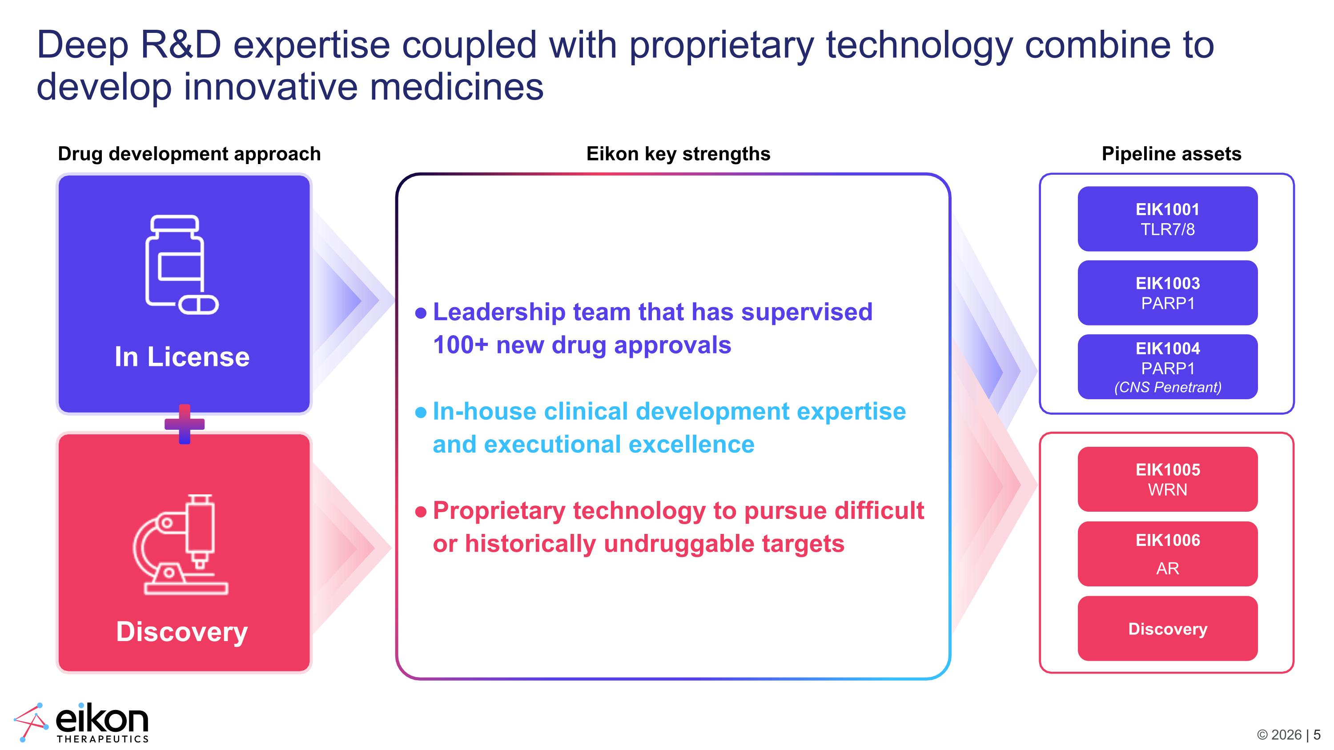
Deep R&D expertise coupled with proprietary technology combine to develop innovative medicines Eikon key strengths Leadership team that has supervised 100+ new drug approvals In-house clinical development expertise and executional excellence Proprietary technology to pursue difficult or historically undruggable targets Drug development approach EIK1005 WRN EIK1003 PARP1 EIK1001 TLR7/8 EIK1004 PARP1 (CNS Penetrant) EIK1006 AR Discovery Pipeline assets In License Discovery

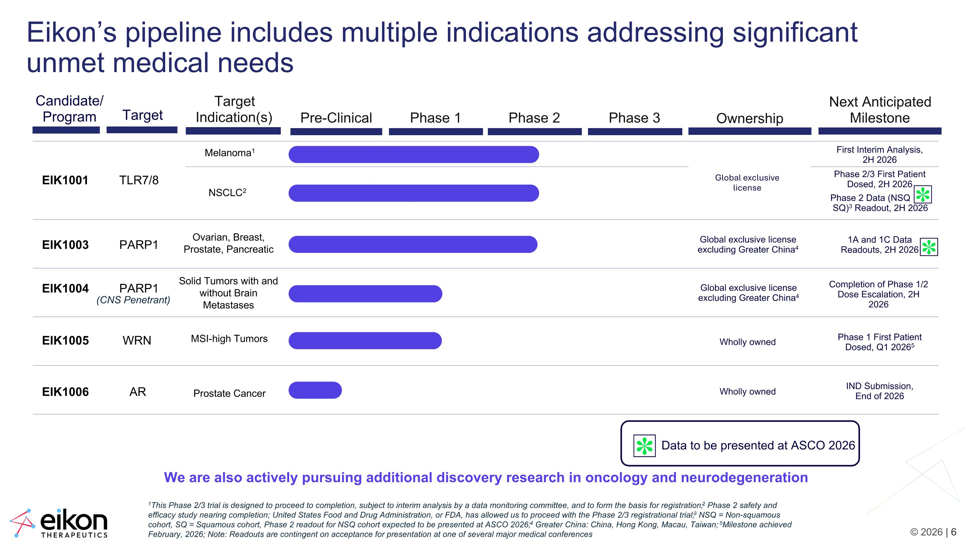
1This Phase 2/3 trial is designed to proceed to completion, subject to interim analysis by a data monitoring committee, and to form the basis for registration; 2 Phase 2 safety and efficacy study nearing completion; United States Food and Drug Administration, or FDA, has allowed us to proceed with the Phase 2/3 registrational trial; 3 NSQ = Non-squamous cohort, SQ = Squamous cohort, Phase 2 readout for NSQ cohort expected to be presented at ASCO 2026; 4 Greater China: China, Hong Kong, Macau, Taiwan; 5Milestone achieved February, 2026; Note: Readouts are contingent on acceptance for presentation at one of several major medical conferences Eikon’s pipeline includes multiple indications addressing significant unmet medical needs We are also actively pursuing additional discovery research in oncology and neurodegeneration Melanoma1 NSCLC2 EIK1005 WRN EIK1003 PARP1 EIK1001 TLR7/8 Candidate/ Program Pre-Clinical Phase 1 Phase 2 Phase 3 Target Indication(s) Ownership Next Anticipated Milestone EIK1004 PARP1 (CNS Penetrant) Wholly owned Ovarian, Breast, Prostate, Pancreatic Solid Tumors with and without Brain Metastases MSI-high Tumors Global exclusive license excluding Greater China4 Global exclusive license excluding Greater China4 Target EIK1006 AR Wholly owned Prostate Cancer Phase 2/3 First Patient Dosed, 2H 2026 First Interim Analysis, 2H 2026 Phase 1 First Patient Dosed, Q1 20265 IND Submission, End of 2026 1A and 1C Data Readouts, 2H 2026 Completion of Phase 1/2 Dose Escalation, 2H 2026 Phase 2 Data (NSQ ?SQ)3 Readout, 2H 2026 Global exclusive license Data to be presented at ASCO 2026 ✽ ✽ ✽

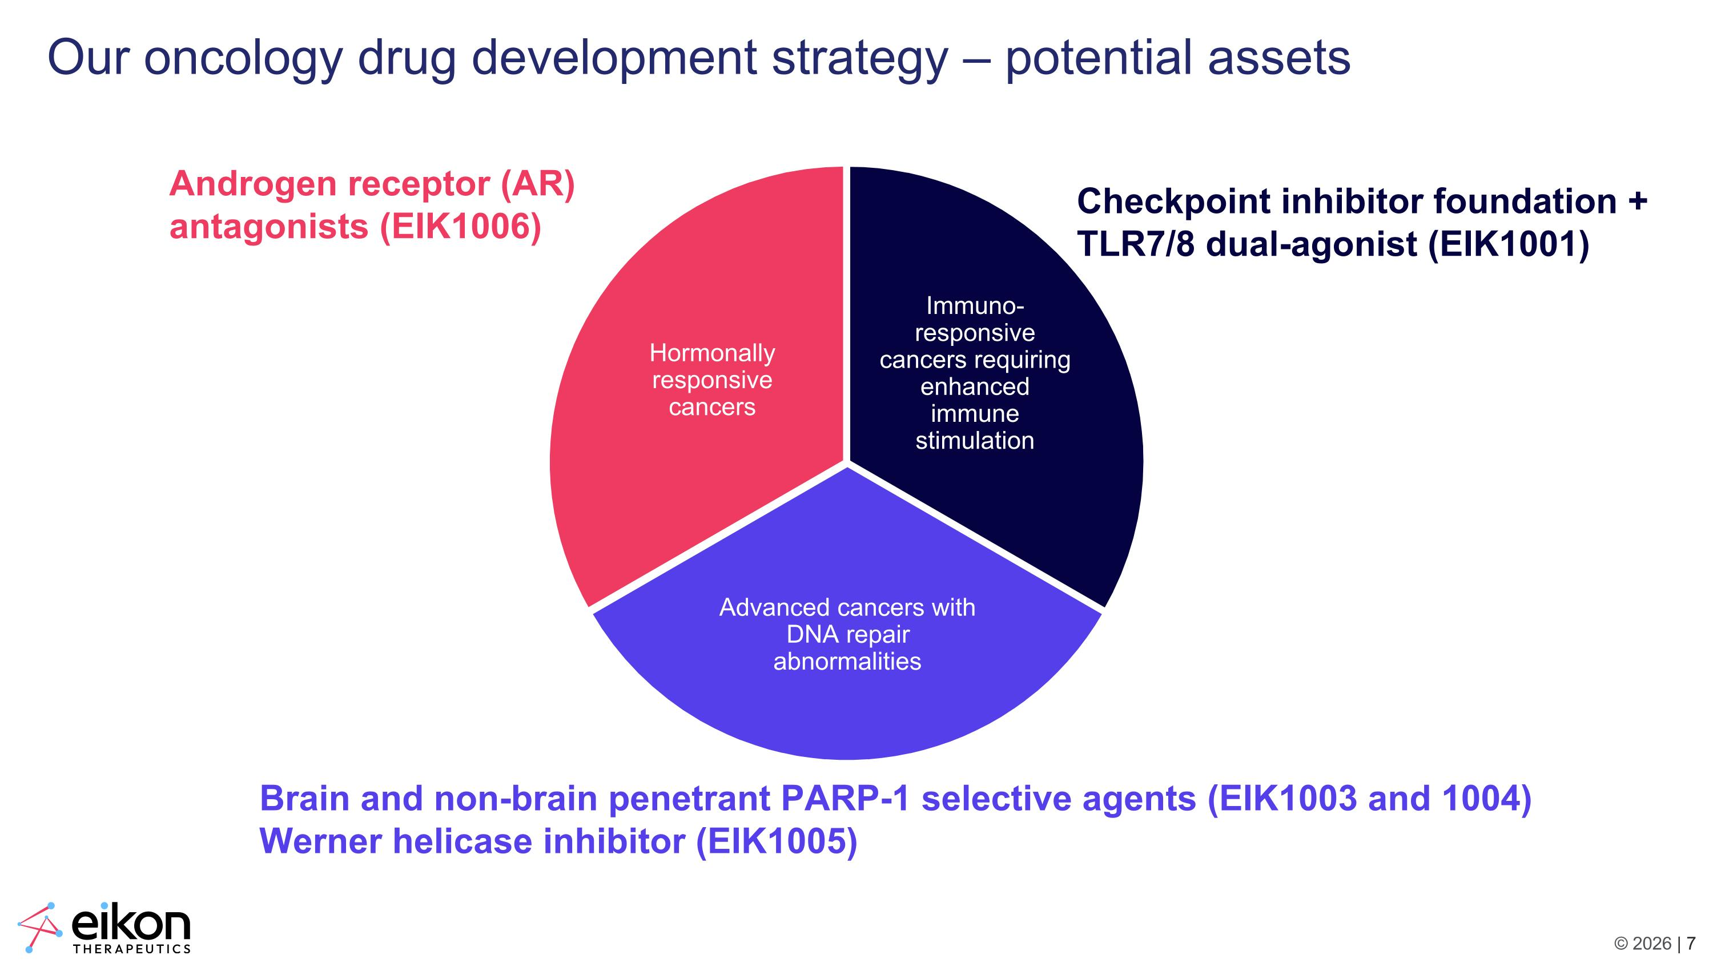
Our oncology drug development strategy – potential assets Immuno-responsive cancers requiring enhanced immune stimulation Advanced cancers with DNA repair abnormalities Hormonally responsive cancers Androgen receptor (AR) antagonists (EIK1006) Checkpoint inhibitor foundation + TLR7/8 dual-agonist (EIK1001) Brain and non-brain penetrant PARP-1 selective agents (EIK1003 and 1004) Werner helicase inhibitor (EIK1005)

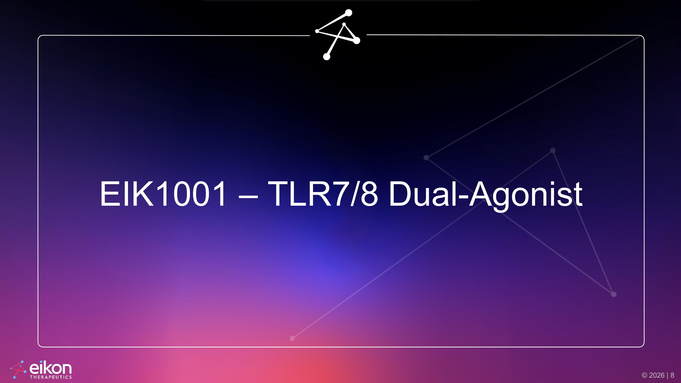
EIK1001 – TLR7/8 Dual-Agonist

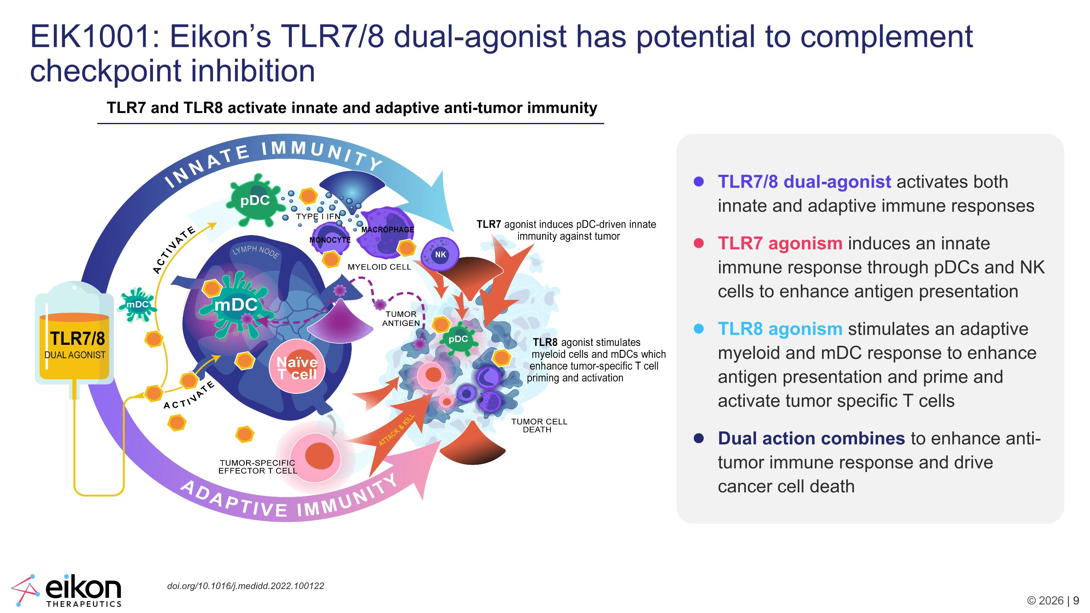
EIK1001: Eikon’s TLR7/8 dual-agonist has potential to complement checkpoint inhibition TLR7 and TLR8 activate innate and adaptive anti-tumor immunity TLR7/8 dual-agonist activates both innate and adaptive immune responses TLR7 agonism induces an innate immune response through pDCs and NK cells to enhance antigen presentation TLR8 agonism stimulates an adaptive myeloid and mDC response to enhance antigen presentation and prime and activate tumor specific T cells Dual action combines to enhance anti-tumor immune response and drive cancer cell death doi.org/10.1016/j.medidd.2022.100122

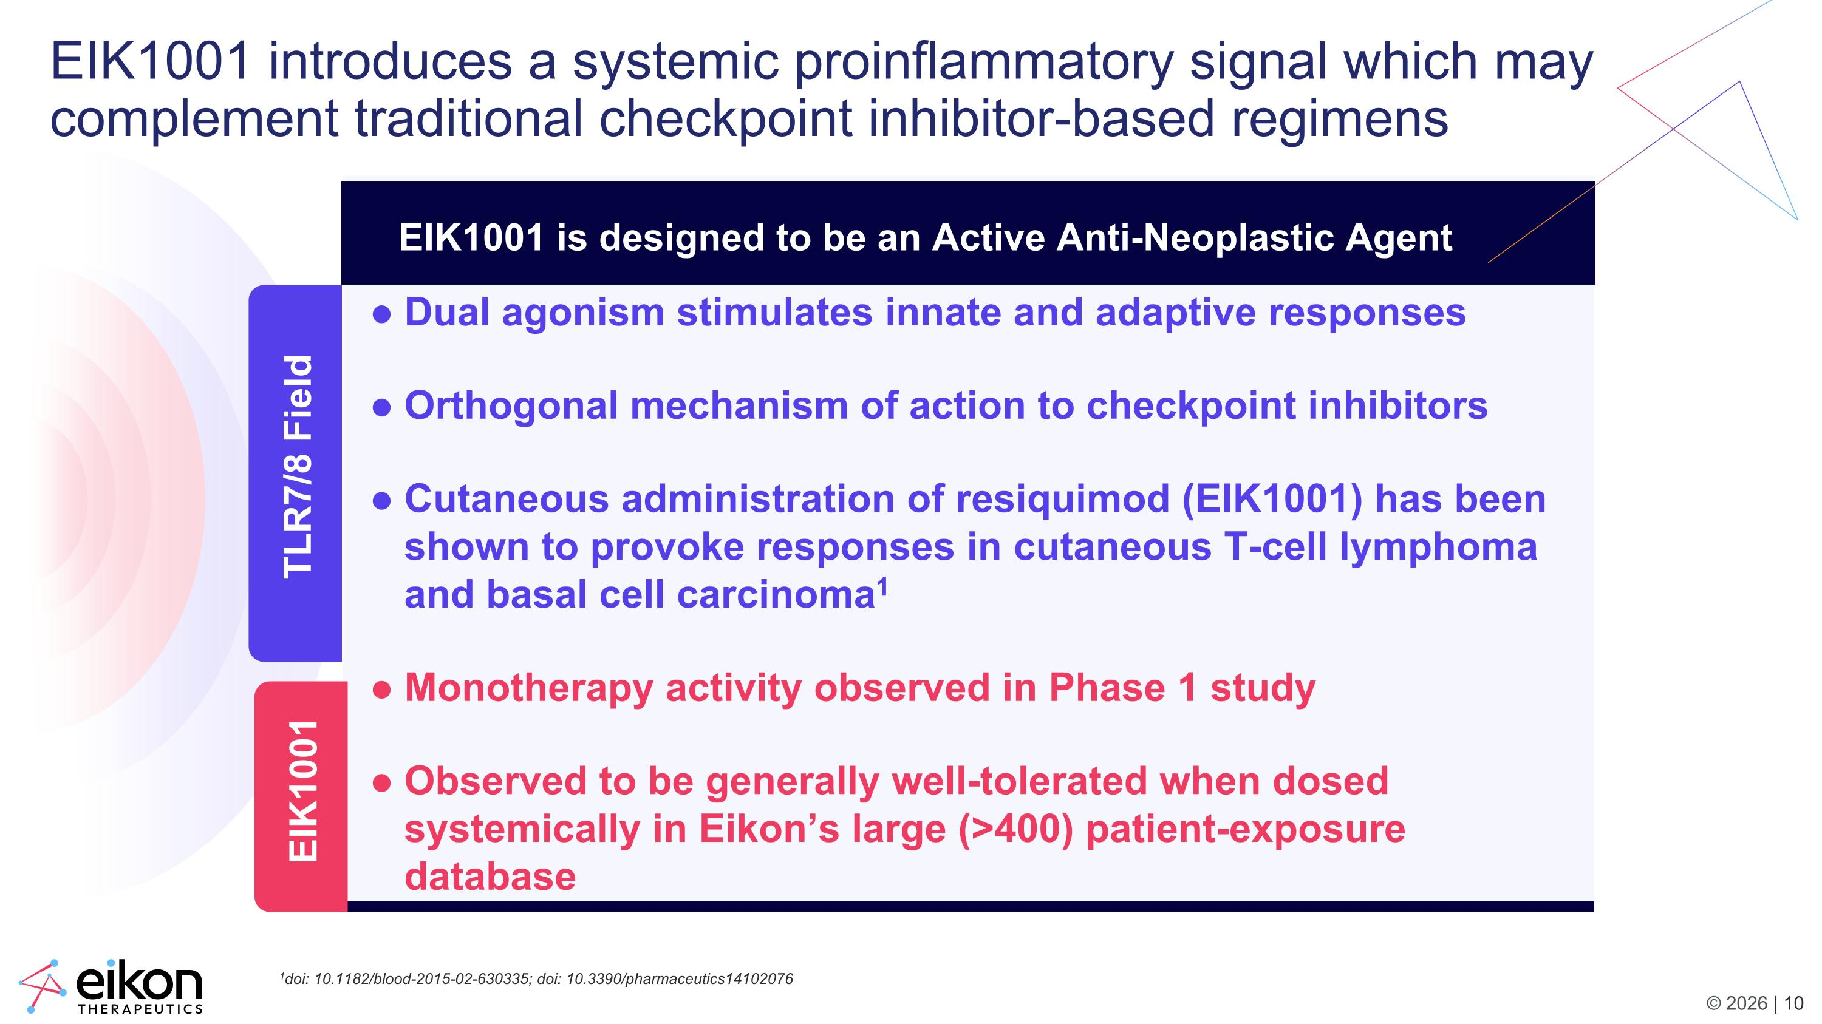
EIK1001 introduces a systemic proinflammatory signal which may complement traditional checkpoint inhibitor-based regimens Dual agonism stimulates innate and adaptive responses Orthogonal mechanism of action to checkpoint inhibitors Cutaneous administration of resiquimod (EIK1001) has been shown to provoke responses in cutaneous T-cell lymphoma and basal cell carcinoma1 Monotherapy activity observed in Phase 1 study Observed to be generally well-tolerated when dosed systemically in Eikon’s large (>400) patient-exposure database Differentiation of EIK1001 EIK1001 is designed to be an Active Anti-Neoplastic Agent EIK1001 TLR7/8 Field 1doi: 10.1182/blood-2015-02-630335; doi: 10.3390/pharmaceutics14102076

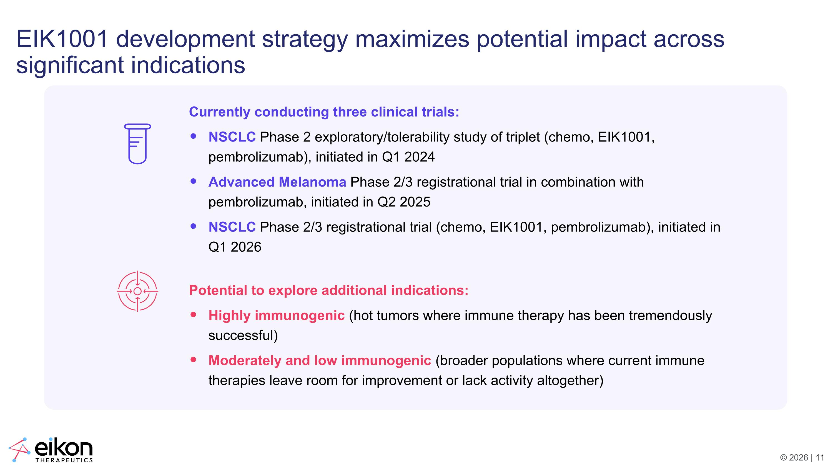
EIK1001 development strategy maximizes potential impact across significant indications Currently conducting three clinical trials: NSCLC Phase 2 exploratory/tolerability study of triplet (chemo, EIK1001, pembrolizumab), initiated in Q1 2024 Advanced Melanoma Phase 2/3 registrational trial in combination with pembrolizumab, initiated in Q2 2025 NSCLC Phase 2/3 registrational trial (chemo, EIK1001, pembrolizumab), initiated in Q1 2026 Potential to explore additional indications: Highly immunogenic (hot tumors where immune therapy has been tremendously successful) Moderately and low immunogenic (broader populations where current immune therapies leave room for improvement or lack activity altogether)

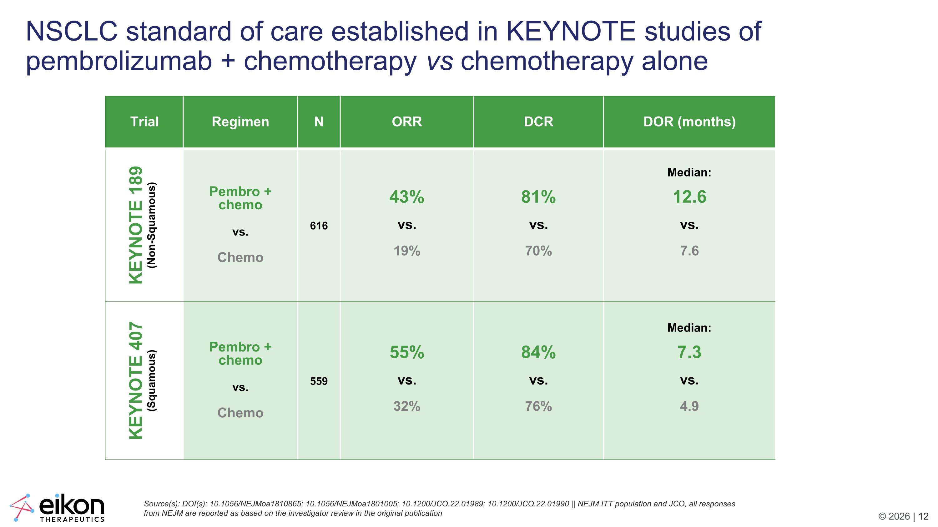
NSCLC standard of care established in KEYNOTE studies of pembrolizumab + chemotherapy vs chemotherapy alone Source(s): DOI(s): 10.1056/NEJMoa1810865; 10.1056/NEJMoa1801005; 10.1200/JCO.22.01989; 10.1200/JCO.22.01990 || NEJM ITT population and JCO, all responses from NEJM are reported as based on the investigator review in the original publication Trial​ Regimen​ N​ ORR​ DCR DOR (months) KEYNOTE 189 (Non-Squamous) Pembro + chemo vs. Chemo 616 43% vs. 19% 81% vs. 70% Median: 12.6 vs. 7.6 KEYNOTE 407 (Squamous) Pembro + chemo vs. Chemo 559 55% vs. 32% 84% vs. 76% Median: 7.3 vs. 4.9

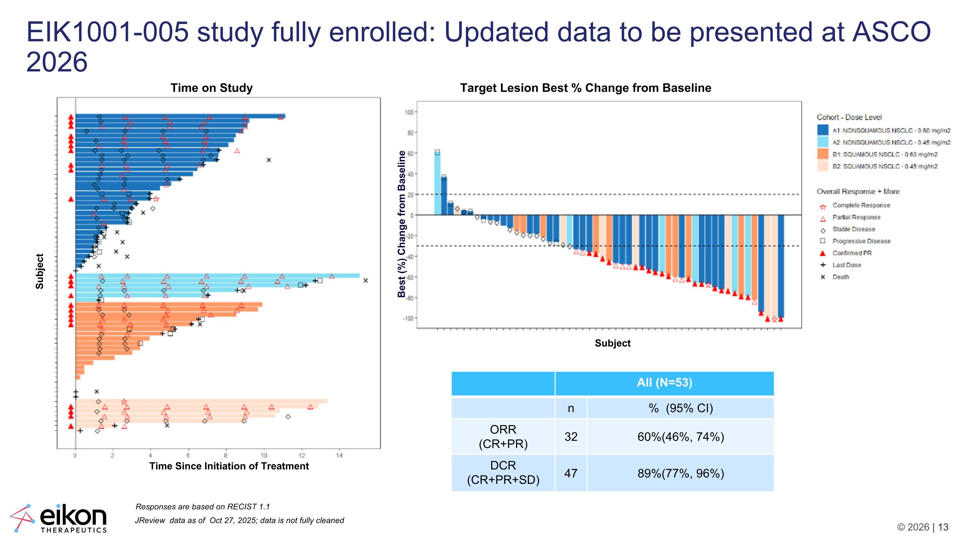
JReview data as of Oct 27, 2025; data is not fully cleaned All (N=53) n % (95% CI) ORR (CR+PR) 32 60%(46%, 74%) DCR (CR+PR+SD) 47 89%(77%, 96%) Responses are based on RECIST 1.1 Target Lesion Best % Change from Baseline Time on Study EIK1001-005 study fully enrolled: Updated data to be presented at ASCO 2026 Subject Subject Time Since Initiation of Treatment Best (%) Change from Baseline

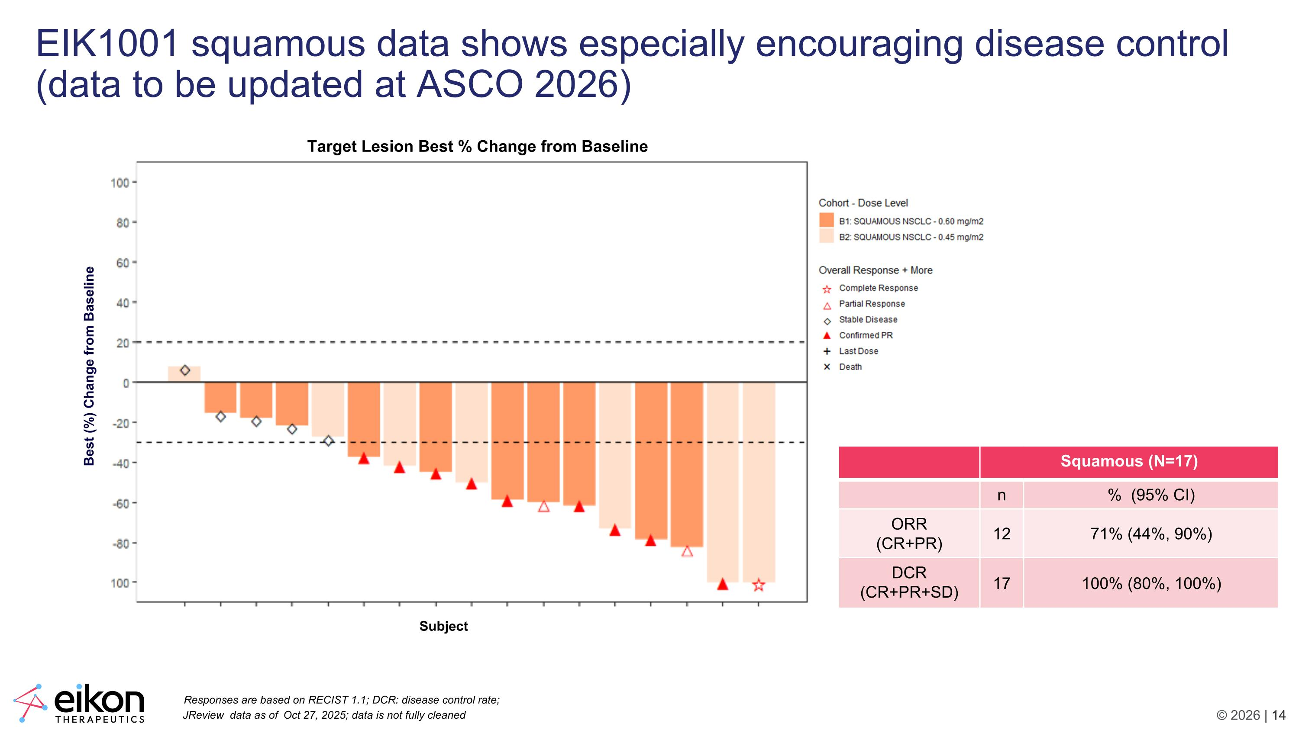
EIK1001 squamous data shows especially encouraging disease control (data to be updated at ASCO 2026) Squamous (N=17) n % (95% CI) ORR (CR+PR) 12 71% (44%, 90%) DCR (CR+PR+SD) 17 100% (80%, 100%) Subject Best (%) Change from Baseline Target Lesion Best % Change from Baseline JReview data as of Oct 27, 2025; data is not fully cleaned Responses are based on RECIST 1.1; DCR: disease control rate;

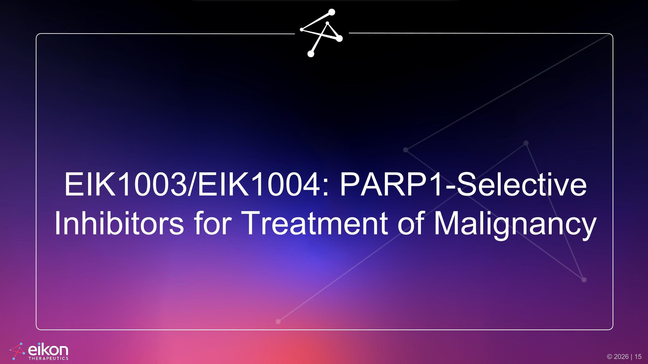
EIK1003/EIK1004: PARP1-Selective Inhibitors for Treatment of Malignancy

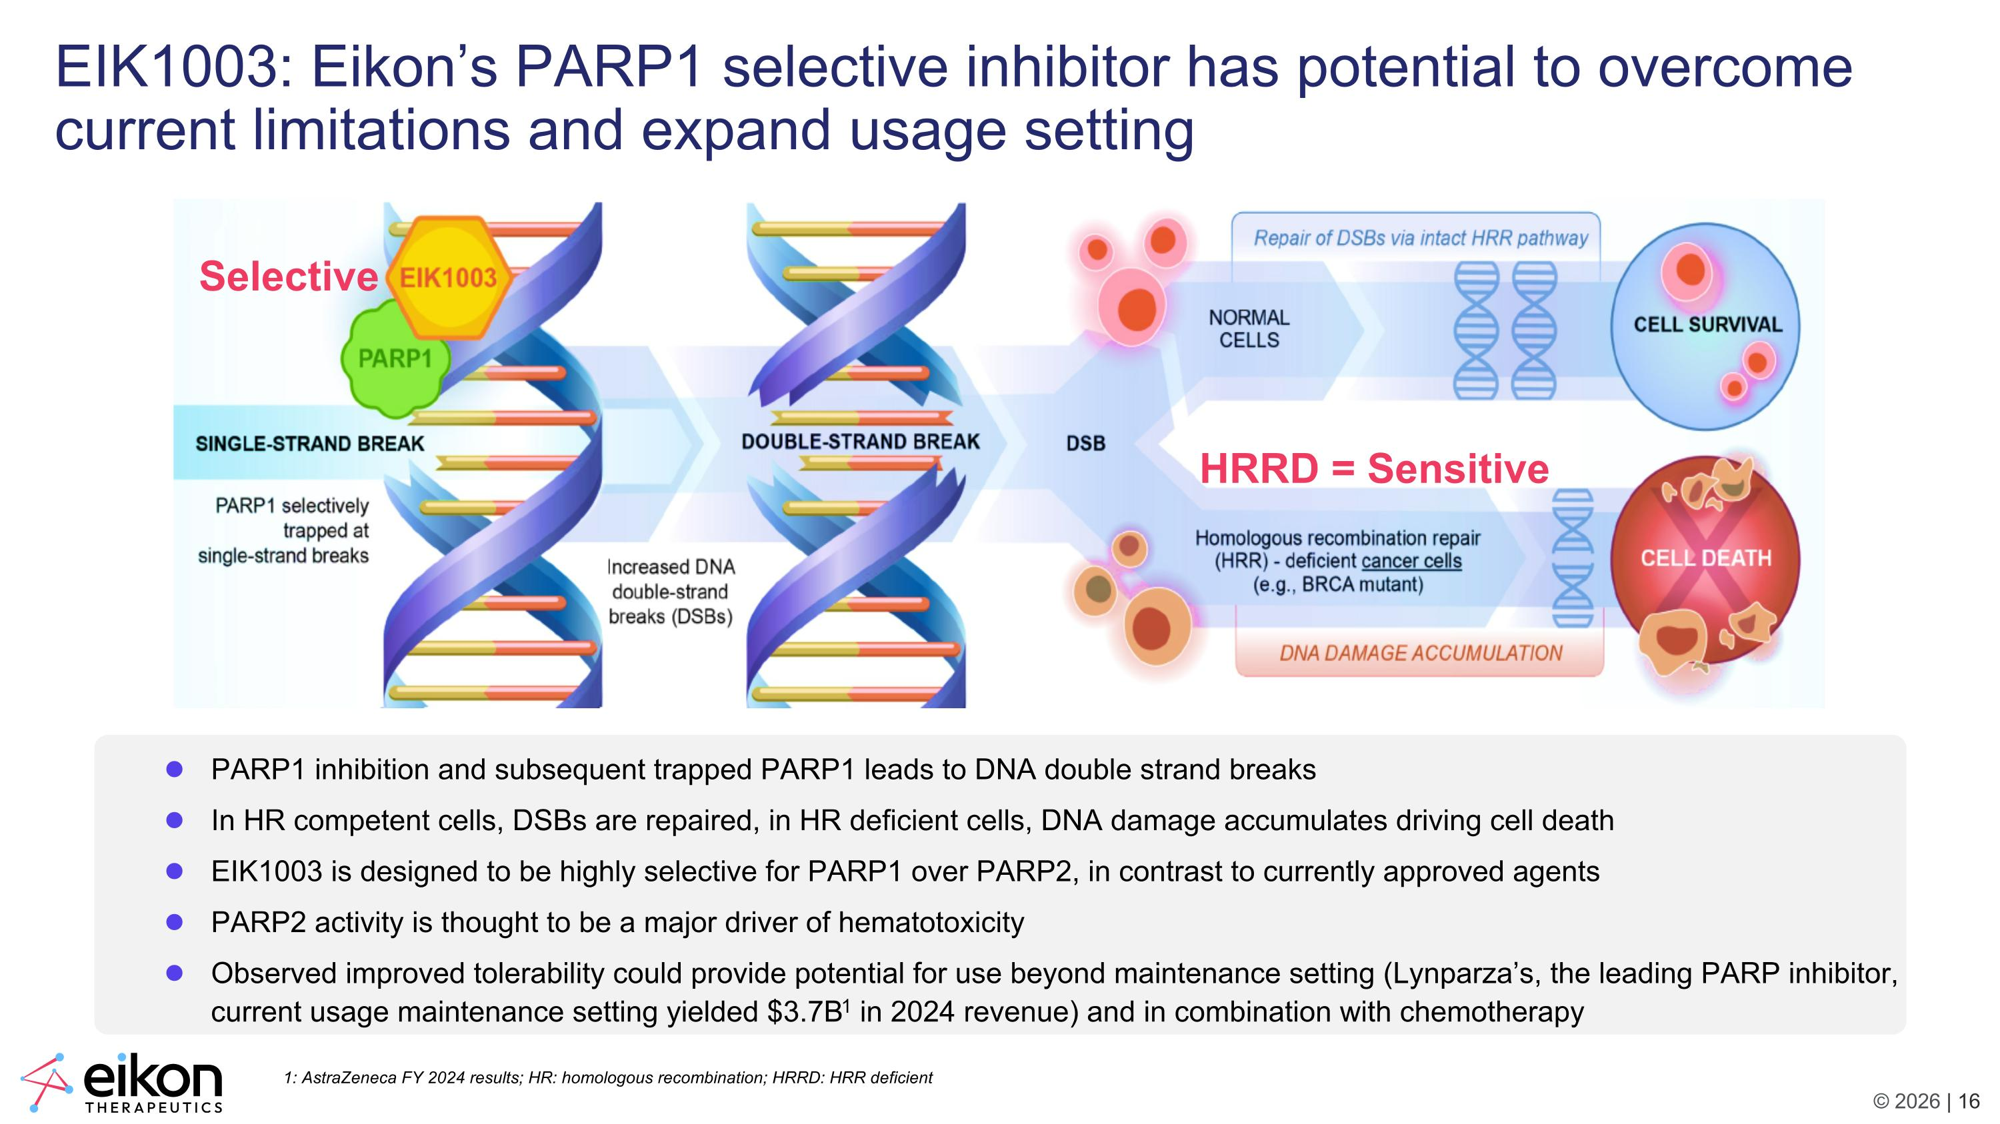
HRRD = Sensitive Selective EIK1003: Eikon’s PARP1 selective inhibitor has potential to overcome current limitations and expand usage setting PARP1 inhibition and subsequent trapped PARP1 leads to DNA double strand breaks In HR competent cells, DSBs are repaired, in HR deficient cells, DNA damage accumulates driving cell death EIK1003 is designed to be highly selective for PARP1 over PARP2, in contrast to currently approved agents PARP2 activity is thought to be a major driver of hematotoxicity Observed improved tolerability could provide potential for use beyond maintenance setting (Lynparza’s, the leading PARP inhibitor, current usage maintenance setting yielded $3.7B1 in 2024 revenue) and in combination with chemotherapy 1: AstraZeneca FY 2024 results; HR: homologous recombination; HRRD: HRR deficient

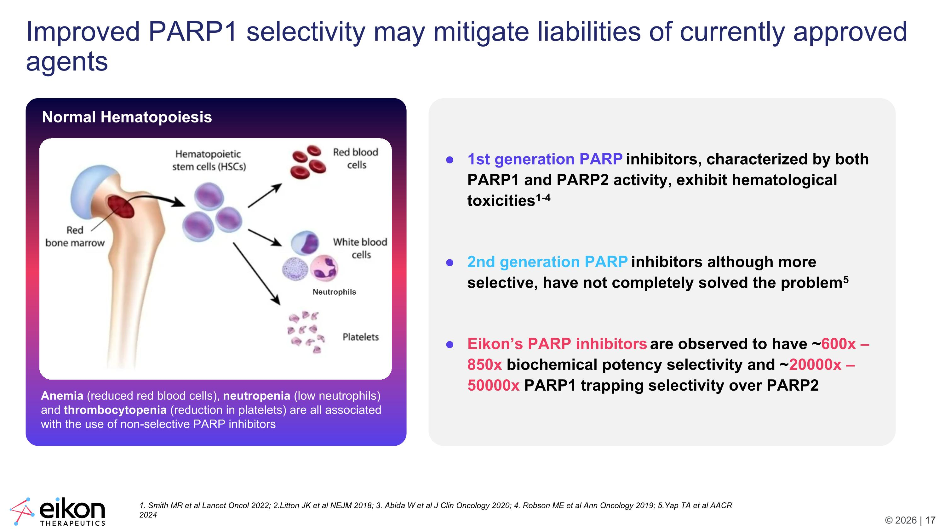
Improved PARP1 selectivity may mitigate liabilities of currently approved agents Normal Hematopoiesis Anemia (reduced red blood cells), neutropenia (low neutrophils) and thrombocytopenia (reduction in platelets) are all associated with the use of non-selective PARP inhibitors 1. Smith MR et al Lancet Oncol 2022; 2.Litton JK et al NEJM 2018; 3. Abida W et al J Clin Oncology 2020; 4. Robson ME et al Ann Oncology 2019; 5.Yap TA et al AACR 2024 Neutrophils 1st generation PARP inhibitors, characterized by both PARP1 and PARP2 activity, exhibit hematological toxicities1-4 2nd generation PARP inhibitors although more selective, have not completely solved the problem5 Eikon’s PARP inhibitors are observed to have ~600x – 850x biochemical potency selectivity and ~20000x – 50000x PARP1 trapping selectivity over PARP2

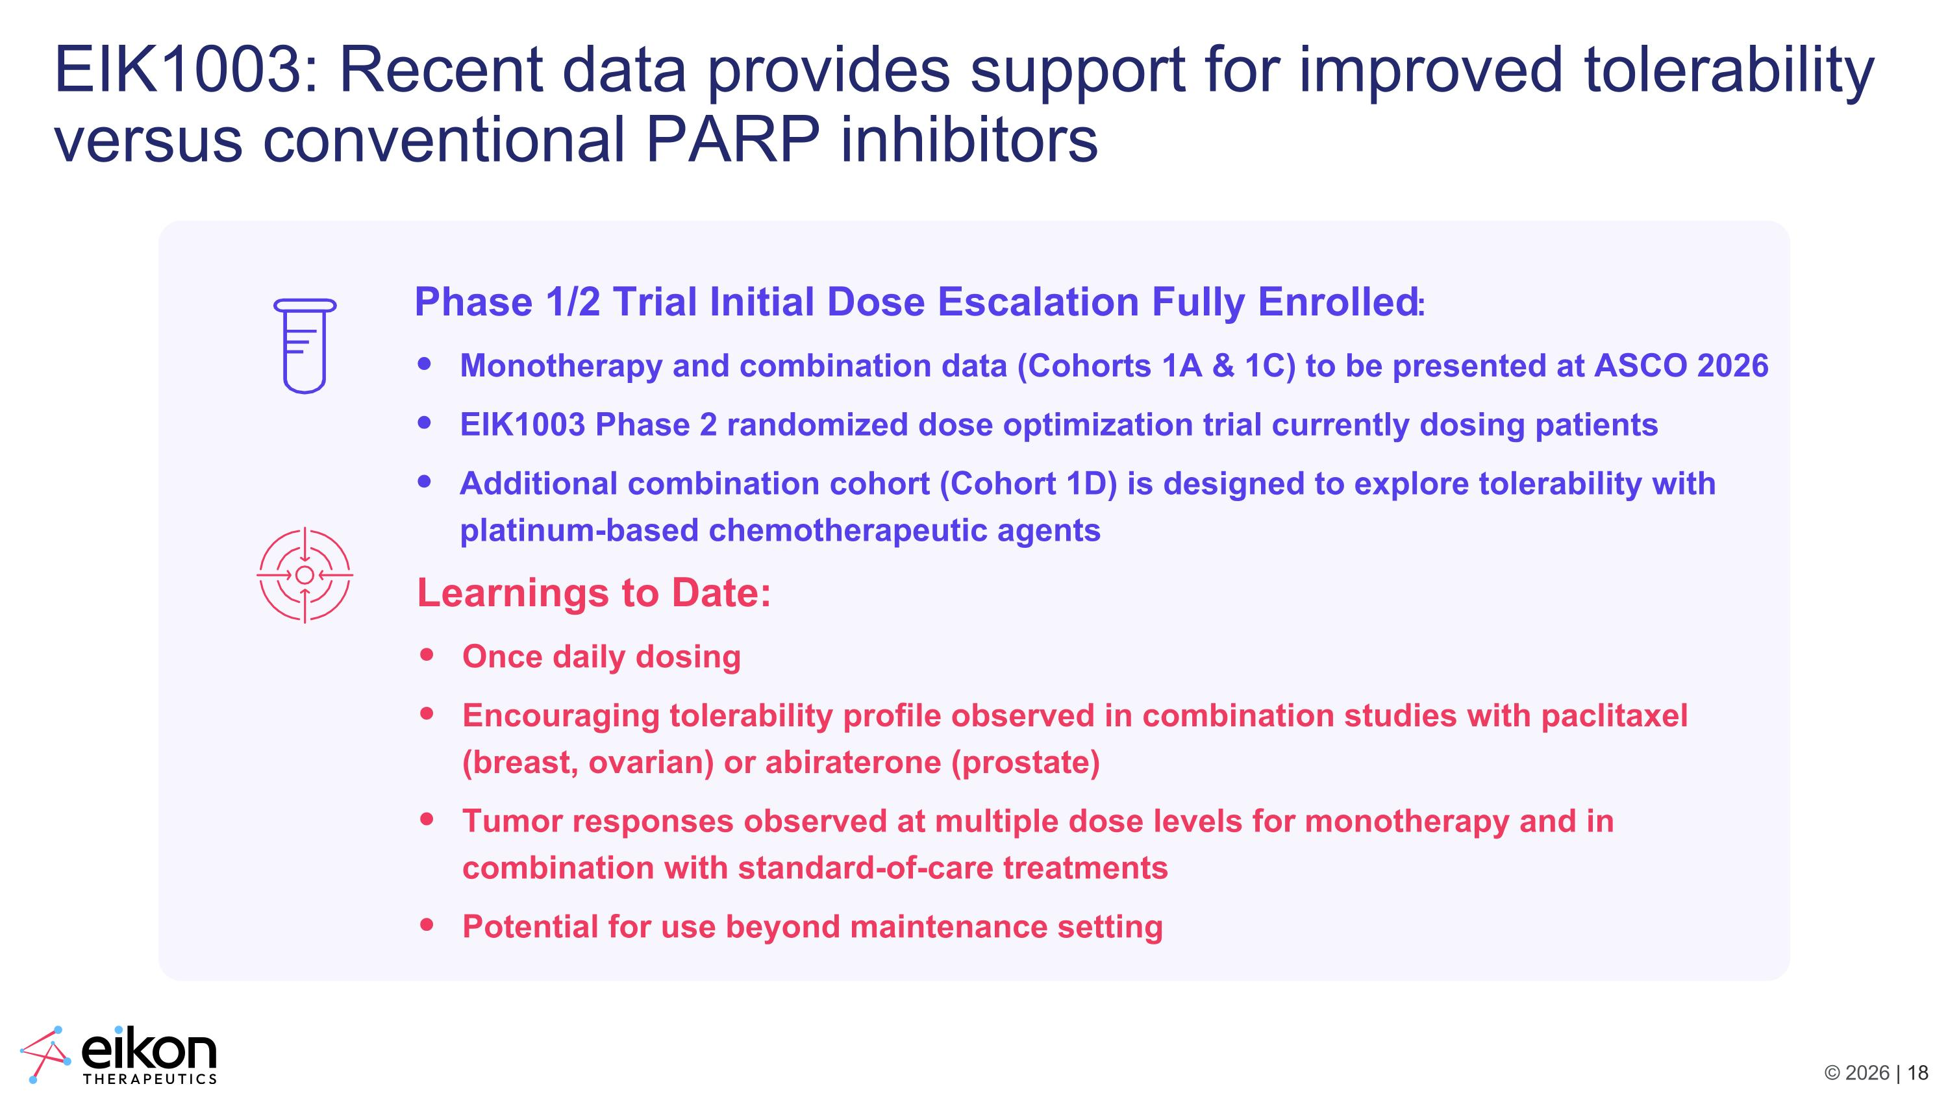
EIK1003: Recent data provides support for improved tolerability versus conventional PARP inhibitors Phase 1/2 Trial Initial Dose Escalation Fully Enrolled: Monotherapy and combination data (Cohorts 1A & 1C) to be presented at ASCO 2026 EIK1003 Phase 2 randomized dose optimization trial currently dosing patients Additional combination cohort (Cohort 1D) is designed to explore tolerability with platinum-based chemotherapeutic agents Learnings to Date: Once daily dosing Encouraging tolerability profile observed in combination studies with paclitaxel (breast, ovarian) or abiraterone (prostate) Tumor responses observed at multiple dose levels for monotherapy and in combination with standard-of-care treatments Potential for use beyond maintenance setting

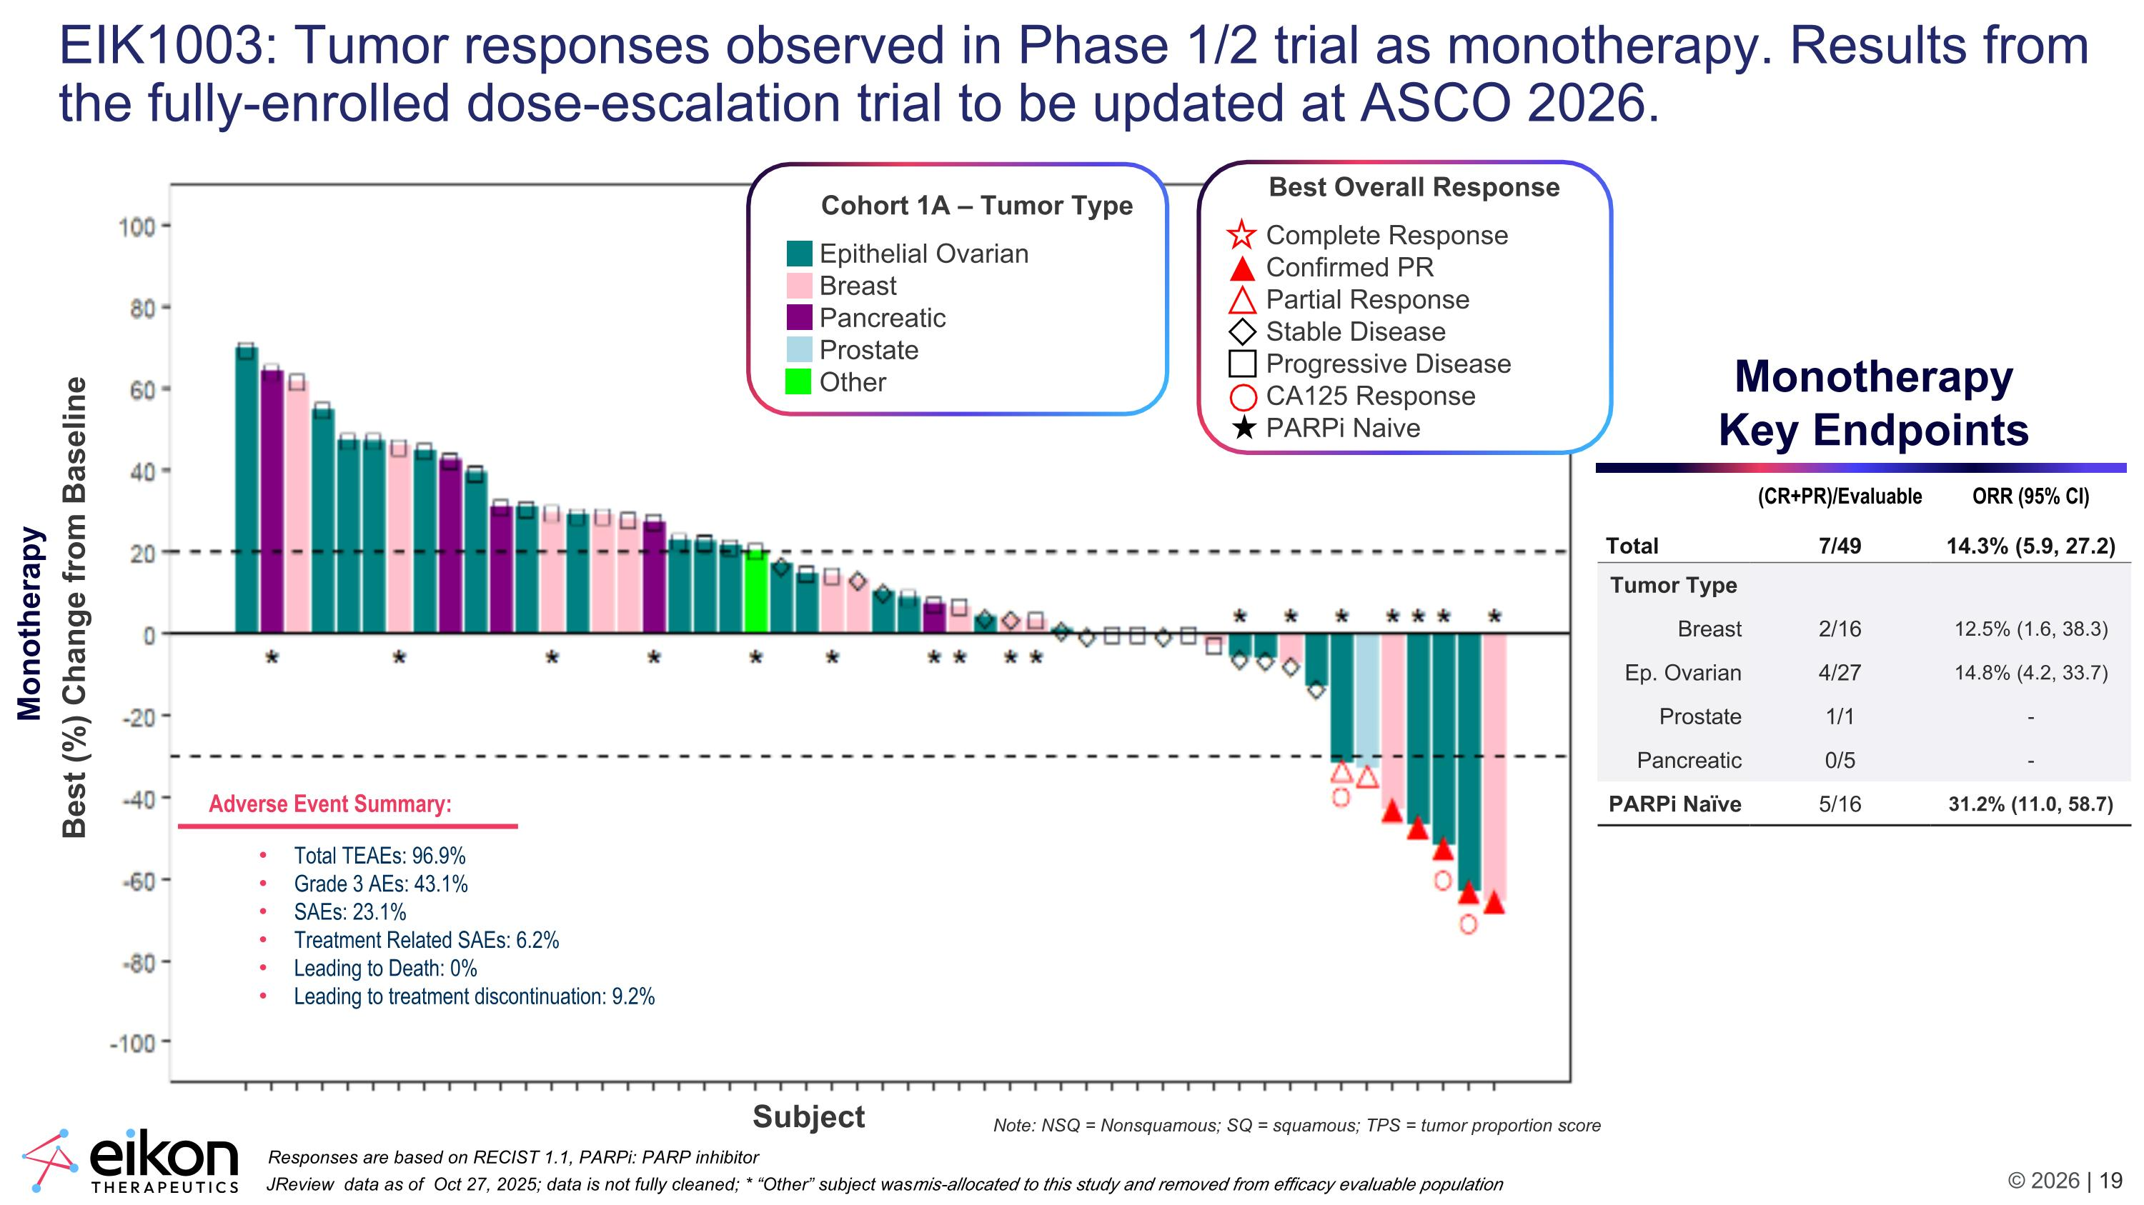
EIK1003: Tumor responses observed in Phase 1/2 trial as monotherapy. Results from the fully-enrolled dose-escalation trial to be updated at ASCO 2026. Monotherapy Key Endpoints Adverse Event Summary: Total TEAEs: 96.9% Grade 3 AEs: 43.1% SAEs: 23.1% Treatment Related SAEs: 6.2% Leading to Death: 0% Leading to treatment discontinuation: 9.2% (CR+PR)/Evaluable ORR (95% CI) Total 7/49 14.3% (5.9, 27.2) Tumor Type Breast 2/16 12.5% (1.6, 38.3) Ep. Ovarian 4/27 14.8% (4.2, 33.7) Prostate 1/1 - Pancreatic 0/5 - PARPi Naïve 5/16 31.2% (11.0, 58.7) Note: NSQ = Nonsquamous; SQ = squamous; TPS = tumor proportion score Best (%) Change from Baseline JReview data as of Oct 27, 2025; data is not fully cleaned; * “Other” subject was mis-allocated to this study and removed from efficacy evaluable population ​ Responses are based on RECIST 1.1, PARPi: PARP inhibitor Subject Cohort 1A – Tumor Type Epithelial Ovarian Breast Pancreatic Prostate Other Best Overall Response Complete Response Confirmed PR Partial Response Stable Disease Progressive Disease CA125 Response PARPi Naive Monotherapy

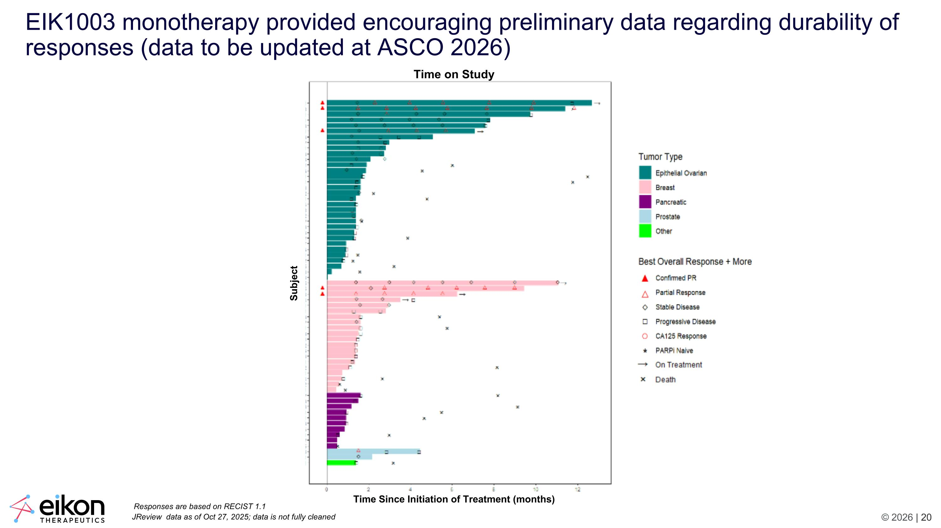
EIK1003 monotherapy provided encouraging preliminary data regarding durability of responses (data to be updated at ASCO 2026) JReview data as of Oct 27, 2025; data is not fully cleaned Responses are based on RECIST 1.1 Time on Study Subject Time Since Initiation of Treatment (months)

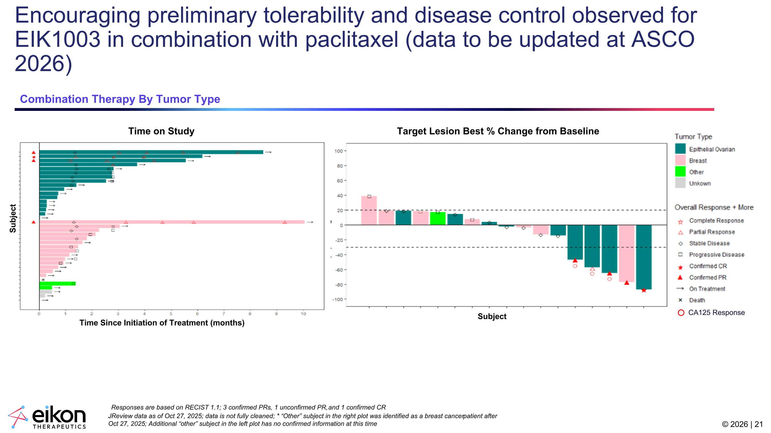
Encouraging preliminary tolerability and disease control observed for EIK1003 in combination with paclitaxel (data to be updated at ASCO 2026) JReview data as of Oct 27, 2025; data is not fully cleaned; * “Other” subject in the right plot was identified as a breast cancer patient after Oct 27, 2025; Additional “other” subject in the left plot has no confirmed information at this time Responses are based on RECIST 1.1; 3 confirmed PRs, 1 unconfirmed PR, and 1 confirmed CR Combination Therapy By Tumor Type Target Lesion Best % Change from Baseline Time on Study Subject Subject Best (%) Change from Baseline CA125 Response Time Since Initiation of Treatment (months)

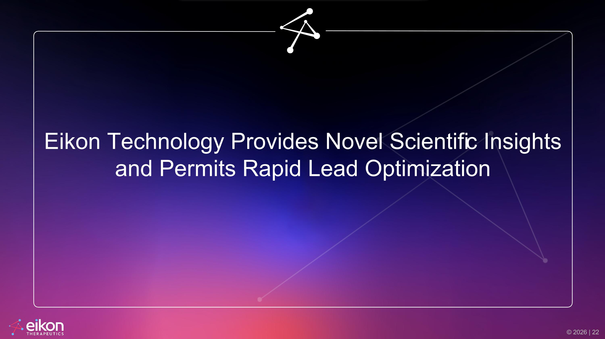
Eikon Technology Provides Novel Scientific Insights and Permits Rapid Lead Optimization

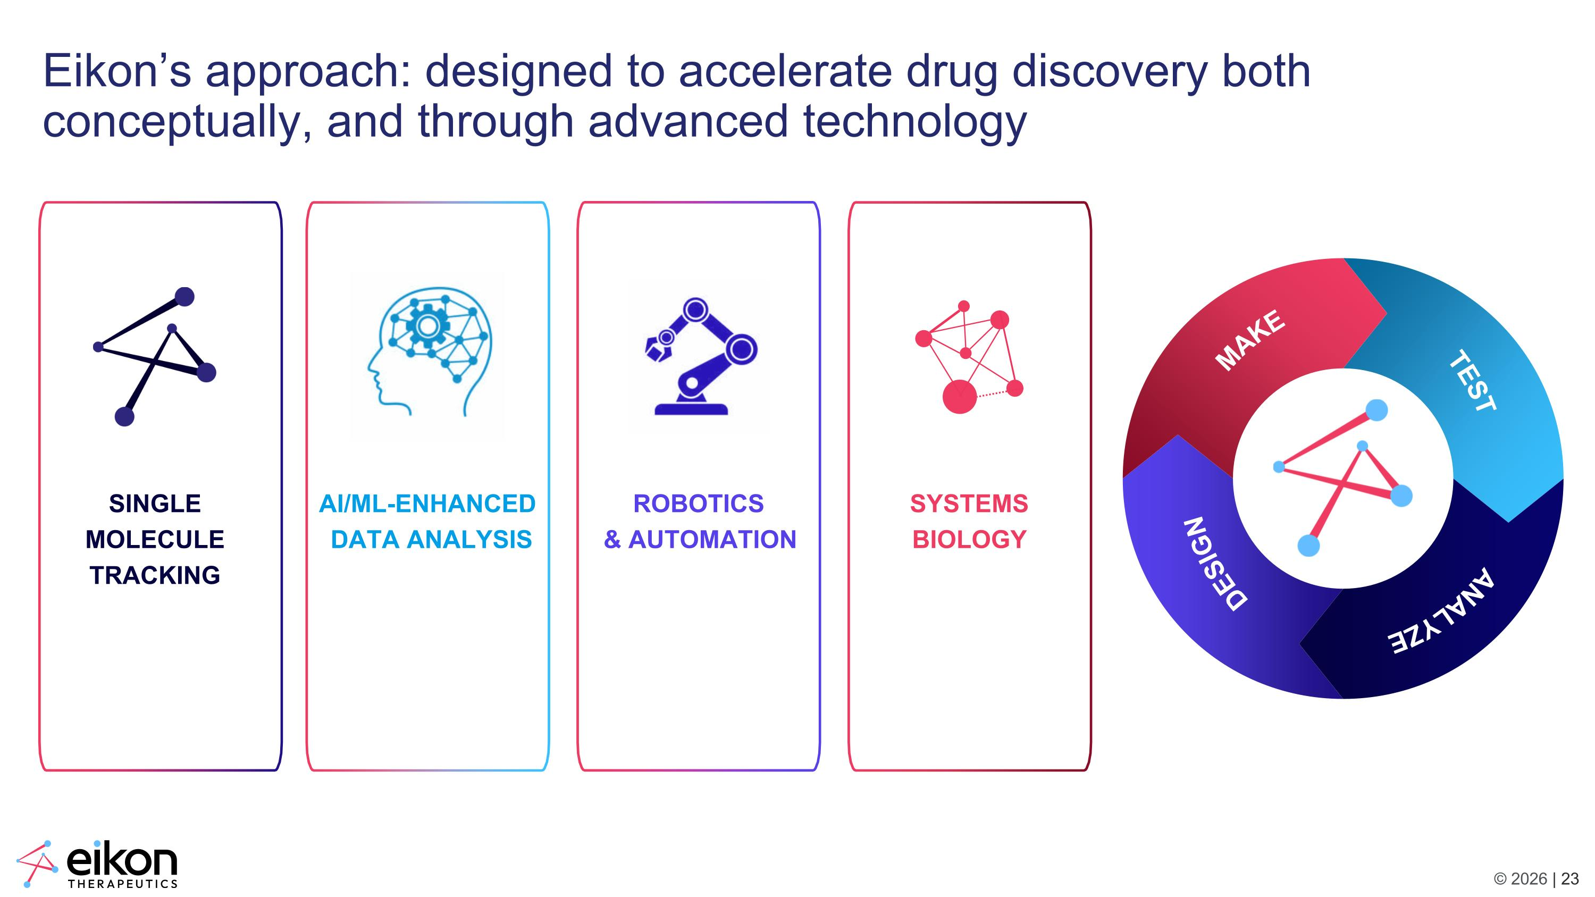
MAKE TEST ANALYZE DESIGN Eikon’s approach: designed to accelerate drug discovery both conceptually, and through advanced technology ROBOTICS & AUTOMATION SYSTEMS BIOLOGY SINGLE MOLECULE TRACKING AI/ML-ENHANCED DATA ANALYSIS

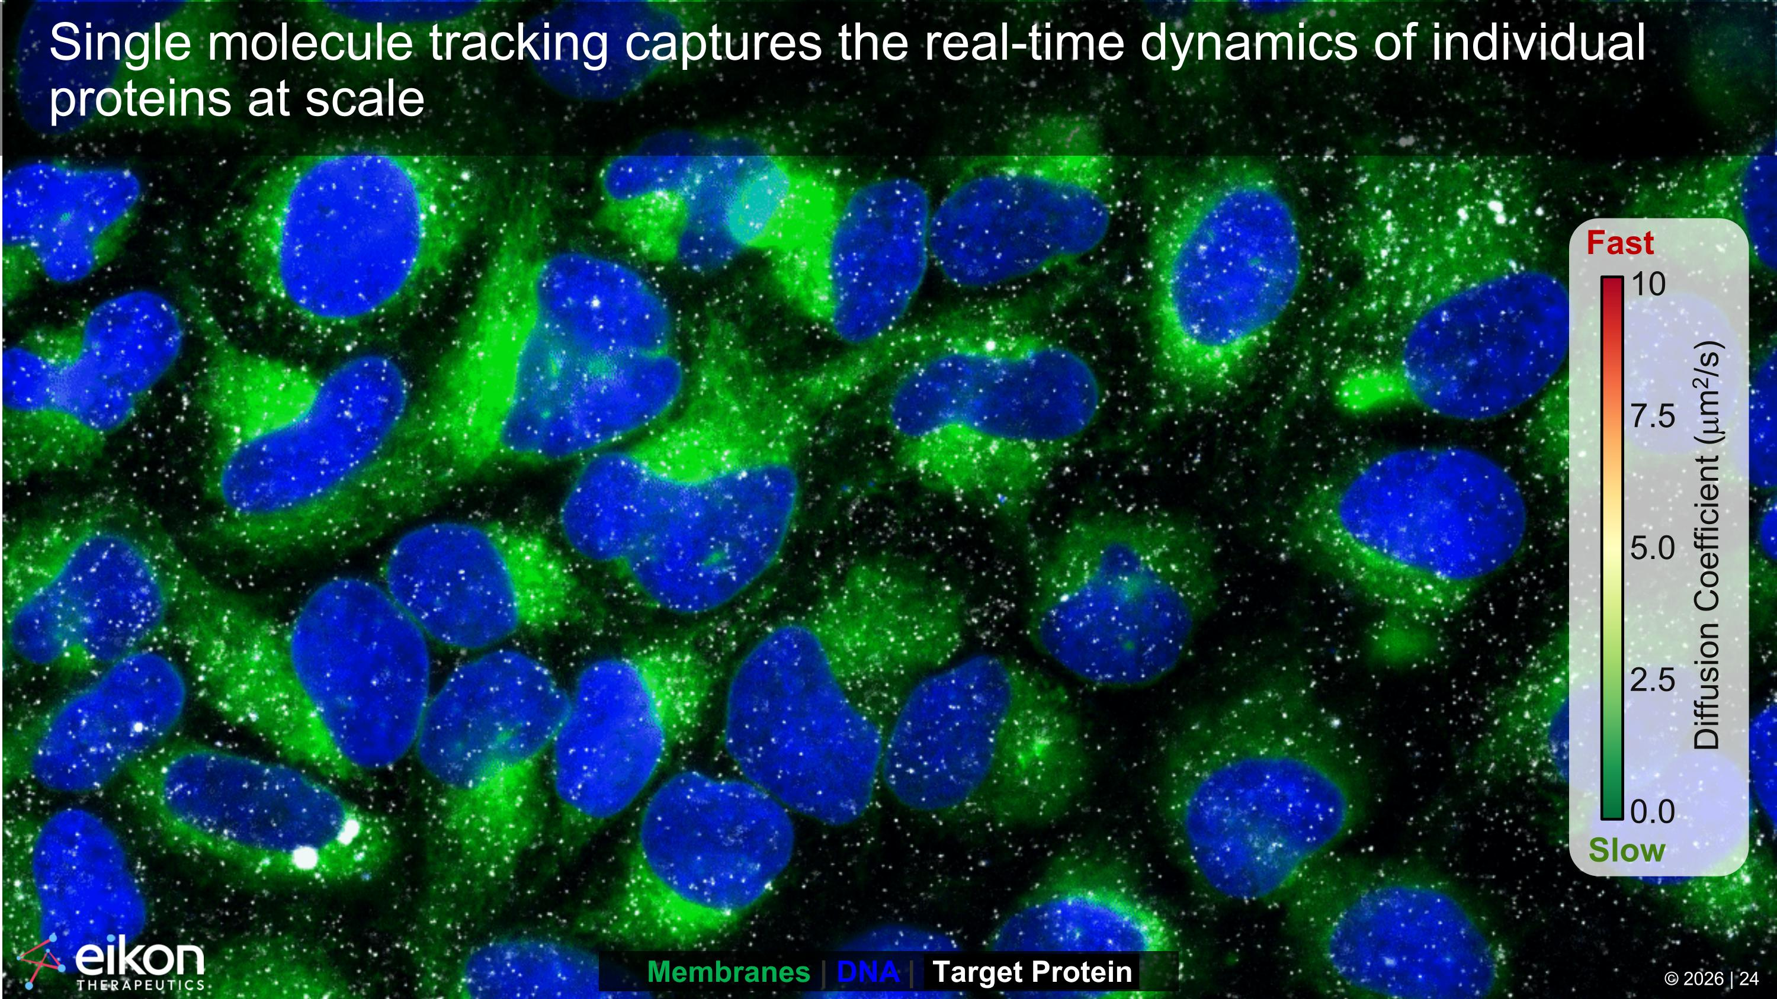
Single molecule tracking captures the real-time dynamics of individual proteins at scale 0.0 2.5 5.0 7.5 10 Fast Slow Diffusion Coefficient (mm2/s) Membranes | DNA | Target Protein © 2026 | 24

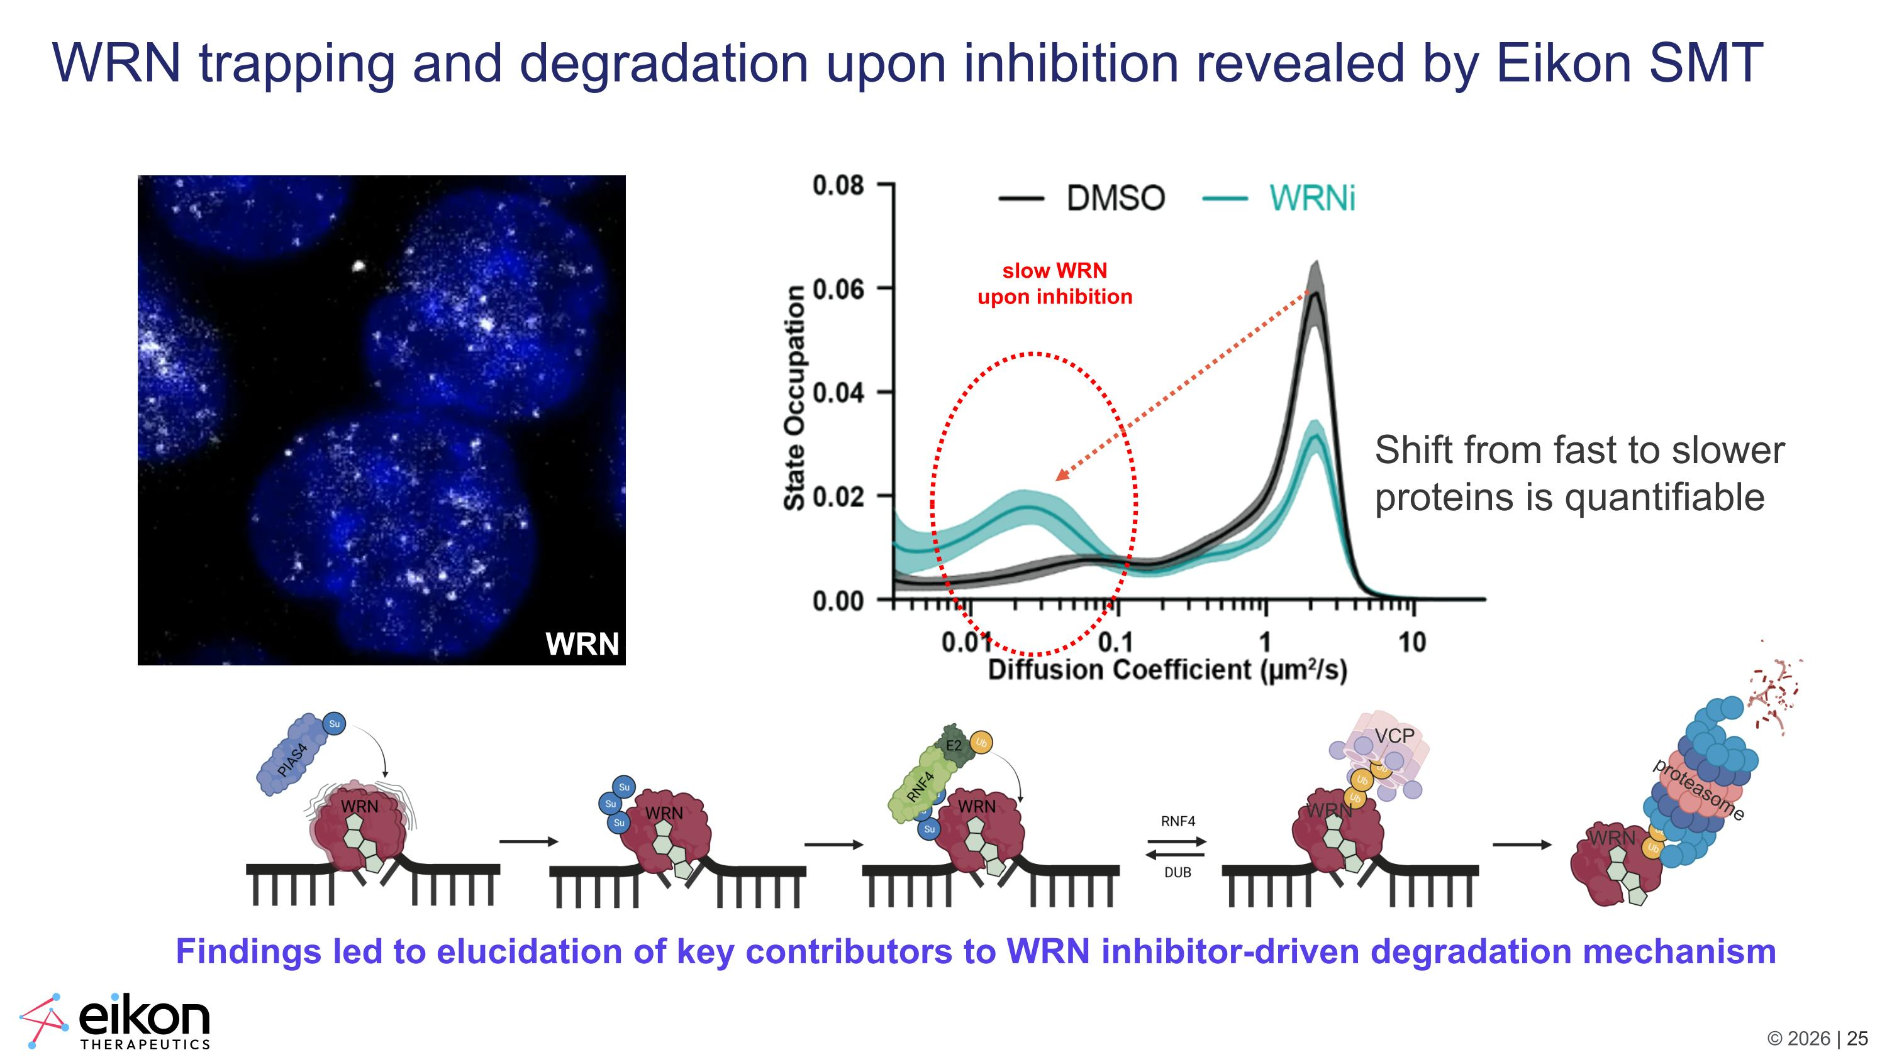
WRN trapping and degradation upon inhibition revealed by Eikon SMT VCP proteasome WRN WRN Findings led to elucidation of key contributors to WRN inhibitor-driven degradation mechanism slow WRN upon inhibition Shift from fast to slower proteins is quantifiable WRN

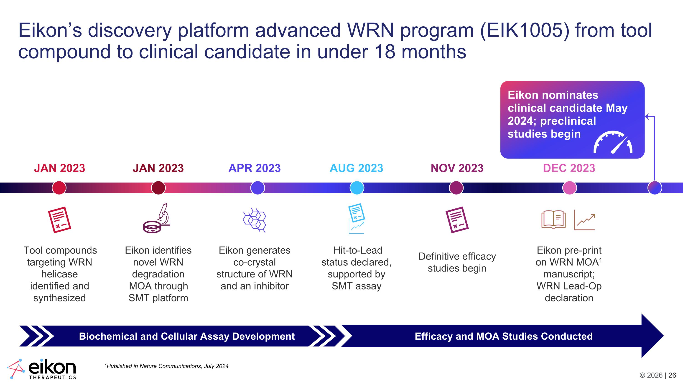
Eikon’s discovery platform advanced WRN program (EIK1005) from tool compound to clinical candidate in under 18 months JAN 2023 Tool compounds targeting WRN helicase identified and synthesized JAN 2023 Eikon identifies novel WRN degradation MOA through SMT platform APR 2023 Eikon generates co-crystal structure of WRN and an inhibitor AUG 2023 Hit-to-Lead status declared, supported by SMT assay NOV 2023 Definitive efficacy studies begin DEC 2023 Eikon pre-print on WRN MOA1 manuscript; WRN Lead-Op declaration Biochemical and Cellular Assay Development Efficacy and MOA Studies Conducted Eikon nominates clinical candidate May 2024; preclinical studies begin 1Published in Nature Communications, July 2024

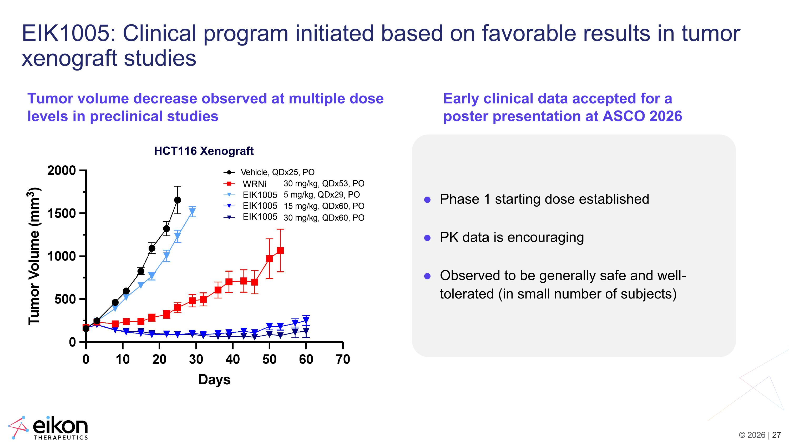
EIK1005: Clinical program initiated based on favorable results in tumor xenograft studies Phase 1 starting dose established PK data is encouraging Observed to be generally safe and well-tolerated (in small number of subjects) Tumor volume decrease observed at multiple dose levels in preclinical studies Early clinical data accepted for a poster presentation at ASCO 2026 HCT116 Xenograft WRNi EIK1005?EIK1005 EIK1005

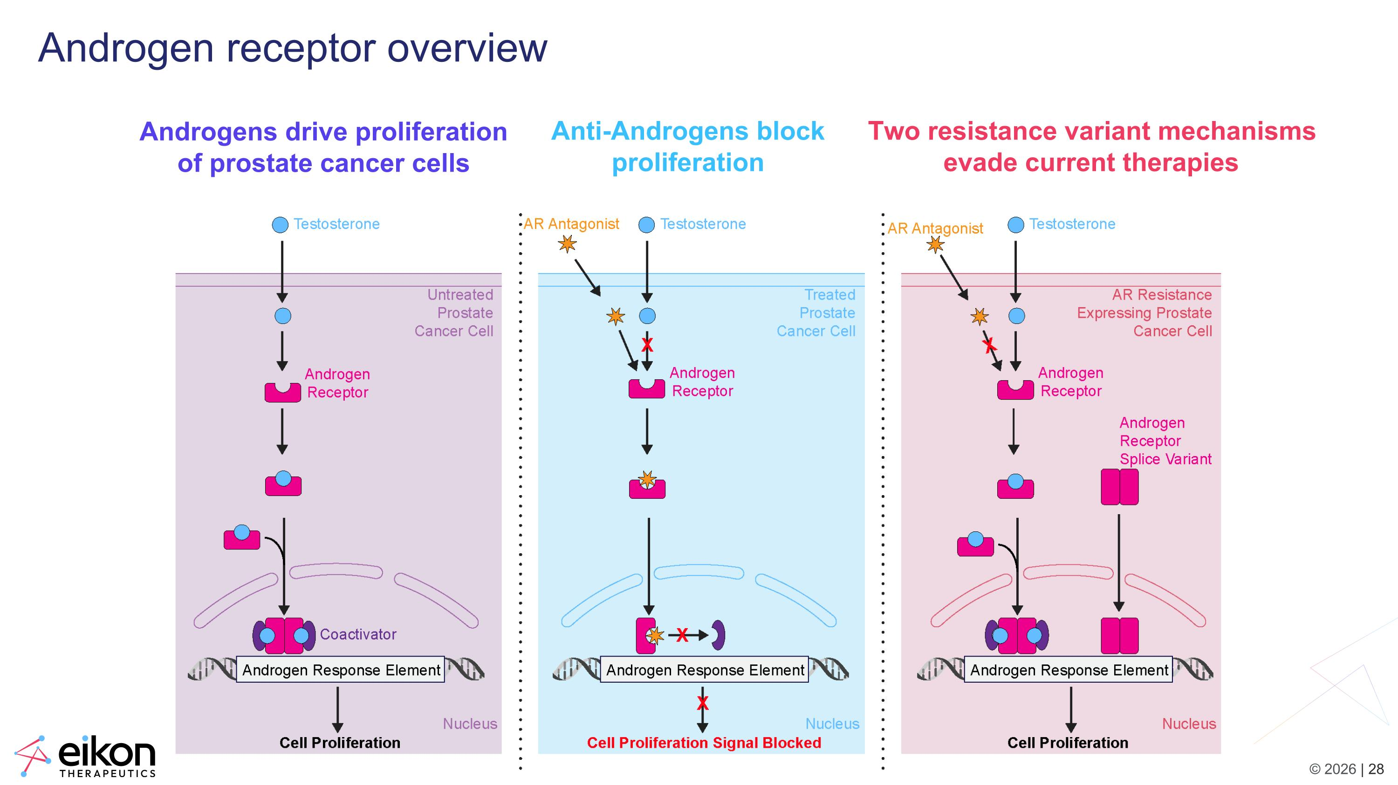
Androgen receptor overview Androgens drive proliferation of prostate cancer cells Anti-Androgens block proliferation Two resistance variant mechanisms evade current therapies

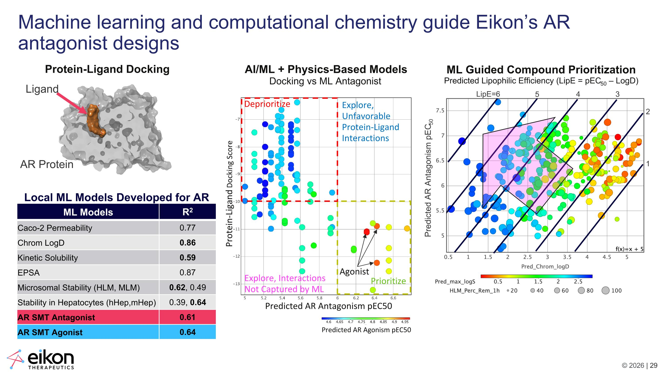
AI/ML + Physics-Based Models Docking vs ML Antagonist Deprioritize Prioritize Predicted AR Antagonism pIC50 Predicted AR Agonism pEC50 Predicted AR Antagonism pEC50 Protein-Ligand Docking Score Agonist Explore, Interactions ?Not Captured by ML Explore, ?Unfavorable ?Protein-Ligand ?Interactions ML Guided Compound Prioritization Predicted Lipophilic Efficiency (LipE = pEC50 – LogD) LipE=6 5 4 3 2 1 Machine learning and computational chemistry guide Eikon’s AR antagonist designs Protein-Ligand Docking Predicted AR Antagonism pEC50 Ligand AR Protein ML Models R2 Caco-2 Permeability 0.77 Chrom LogD 0.86 Kinetic Solubility 0.59 EPSA 0.87 Microsomal Stability (HLM, MLM) 0.62, 0.49 Stability in Hepatocytes (hHep,mHep) 0.39, 0.64 AR SMT Antagonist 0.61 AR SMT Agonist 0.64 Local ML Models Developed for AR

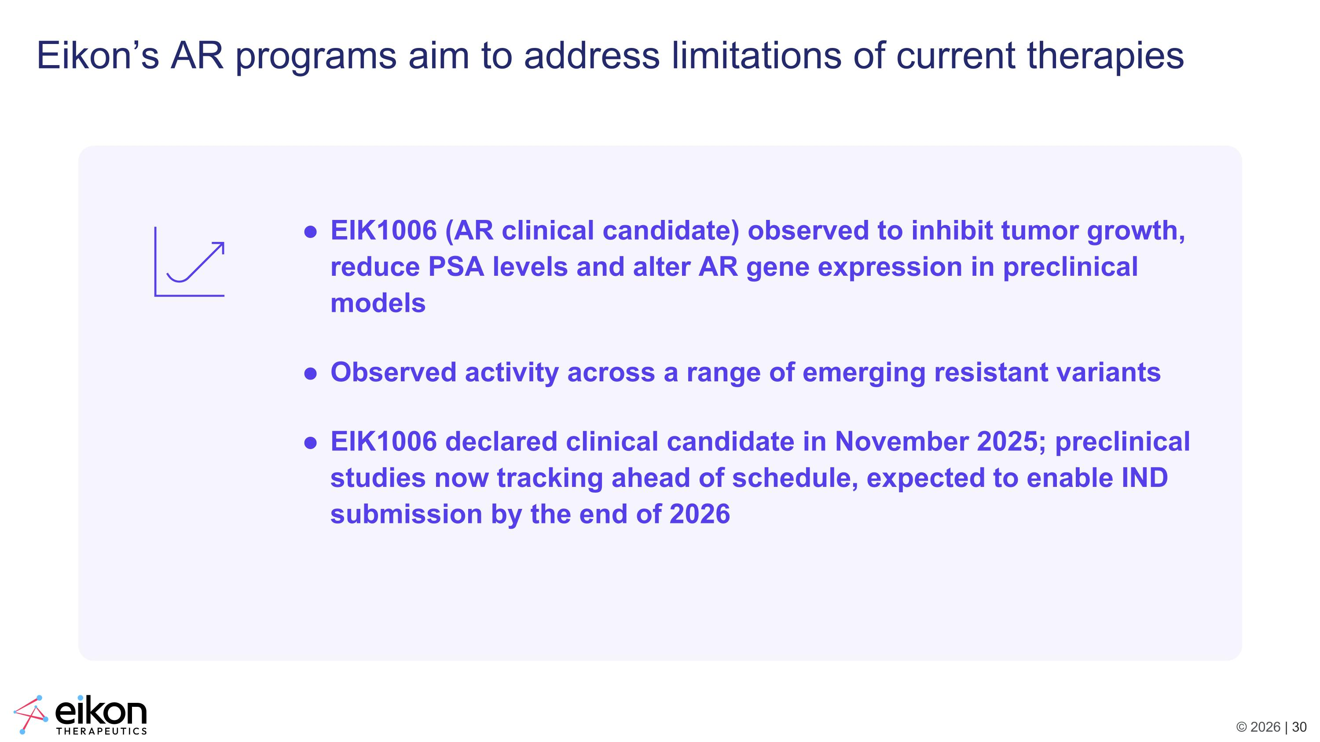
Eikon’s AR programs aim to address limitations of current therapies EIK1006 (AR clinical candidate) observed to inhibit tumor growth, reduce PSA levels and alter AR gene expression in preclinical models Observed activity across a range of emerging resistant variants EIK1006 declared clinical candidate in November 2025; preclinical studies now tracking ahead of schedule, expected to enable IND submission by the end of 2026


Conclusion

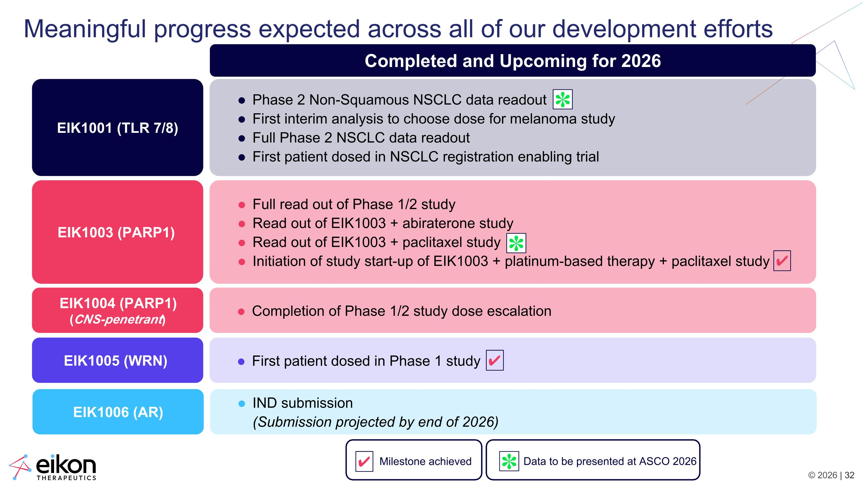
Meaningful progress expected across all of our development efforts EIK1001 (TLR 7/8) EIK1003 (PARP1) EIK1004 (PARP1) (CNS-penetrant) EIK1005 (WRN) Phase 2 Non-Squamous NSCLC data readout First interim analysis to choose dose for melanoma study Full Phase 2 NSCLC data readout First patient dosed in NSCLC registration enabling trial Full read out of Phase 1/2 study Read out of EIK1003 + abiraterone study Read out of EIK1003 + paclitaxel study Initiation of study start-up of EIK1003 + platinum-based therapy + paclitaxel study Completion of Phase 1/2 study dose escalation First patient dosed in Phase 1 study EIK1006 (AR) IND submission?(Submission projected by end of 2026) Data to be presented at ASCO 2026 Completed and Upcoming for 2026 ✔ Milestone achieved ✔ ✔ ✽ ✽ ✽

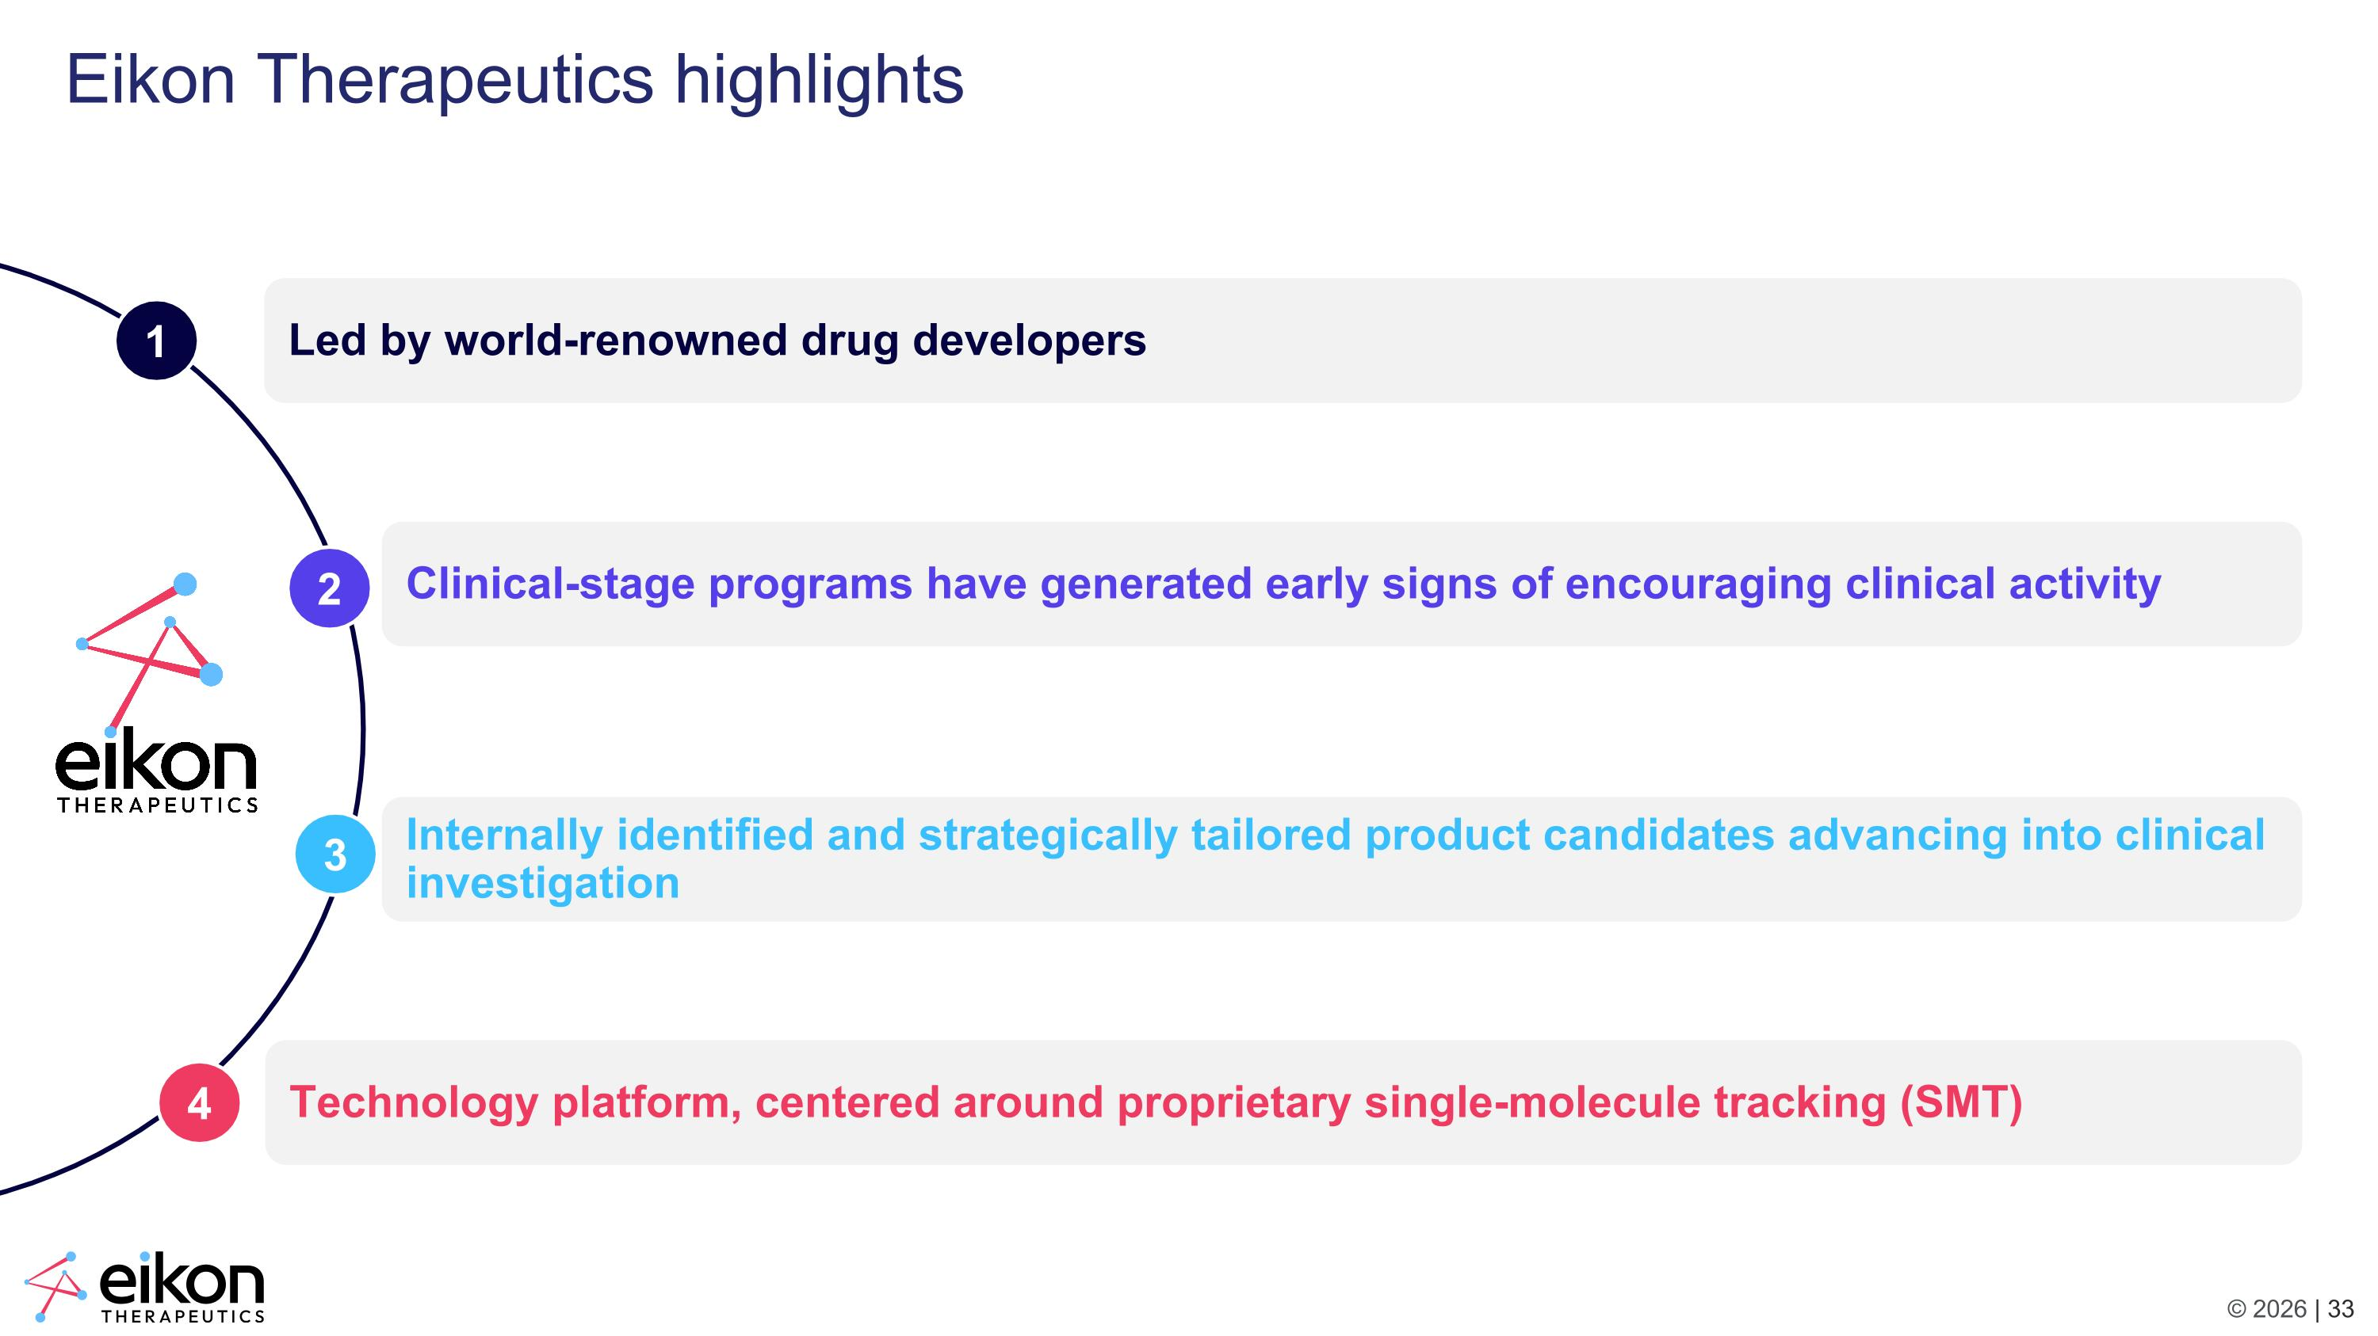
Led by world-renowned drug developers Eikon Therapeutics highlights Technology platform, centered around proprietary single-molecule tracking (SMT) Clinical-stage programs have generated early signs of encouraging clinical activity Internally identified and strategically tailored product candidates advancing into clinical investigation 1 2 3 4



